声明：本资料由 考试吧（Exam8.com） 收集整理，转载请注明出自 http://www.exam8.com
服务：面向较高学历人群，提供计算机类，外语类，学历类，资格类，会计类，工程类，医学类等七大类考试的全套考试信息服务及考前培训.

2008年浙江省丽水市中考英语试题
全卷满分为150分，考试时间为100分钟。
卷 一
说明：本卷有四大题，70小题，共100分。
（一）听力部分
一、听力（共15小题，计25分）
第一节：听小对话，选择图片。（每小题1分）
- What’s the girl’s favorite sport?
A. 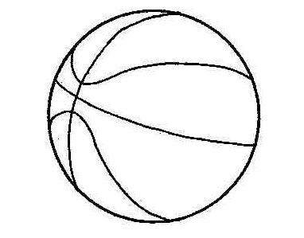 B.  C. 
2. What’s the man’s hobby?
- 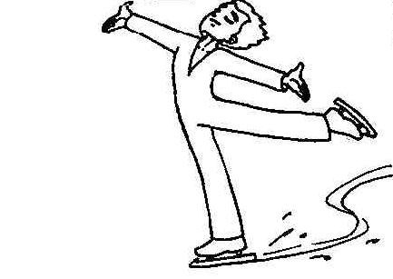 B. 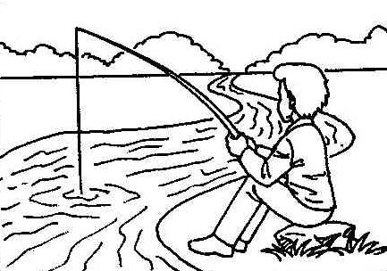 C. 
3. How is Linda going to the cinema tonight?
A. 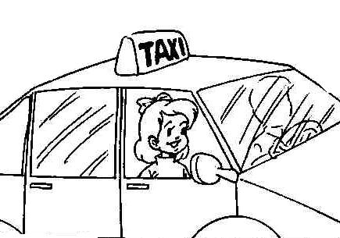 B. 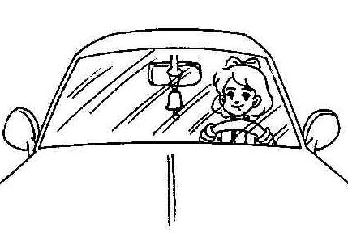 C. 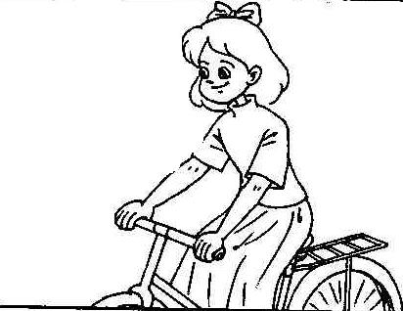

4. Why will the boy be late for the party?
A. 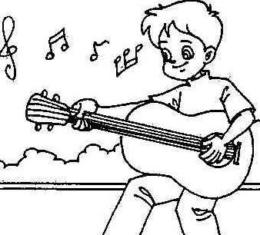 B. 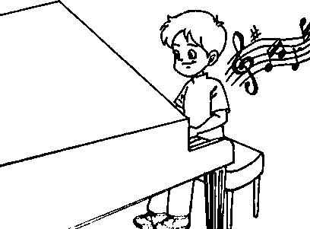 C. 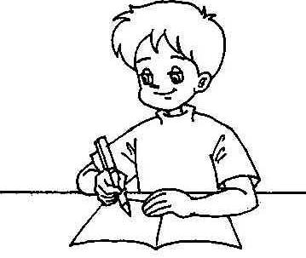
5. Where are the two speakers talking now?
-  B. 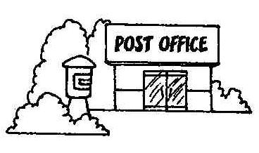 C. 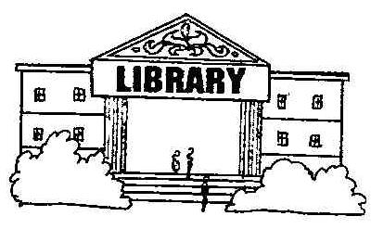
第二节：听小对话，回答问题。（每小题2分）
6. Which city will Judy probably visit?
A. Sydney. B. New York. C. Beijing.
7. How is the weather tonight?
A. Cloudy. B. Rainy. C. Snowy.
8. Which subject does Lily like best?
A. Science. B. Chinese. C. English.
9. Who will get the gift?
A. Ann. B. Ann’s mother. C. Ann’s father.
10. How often does the boy go to his hometown?
A. Twice a month. B. Twice a year. C. Once a year.
第三节：听独白，从A、B、C 三个选项中选择正确的选项，完成信息表。（每小题2分）
Information Form
From whom: 11
When bought: 12
Problems of the clothes:
1. The pants are 13 .
2. The shirt is too big for 14 .
3. Her daughter doesn’t like 15 .

11. A. Mary B. A newspaper C. A shop keeper
12. A. Two days ago B. Three days ago C. Five days ago
13. A. too short B. too big C. Too small
14. A. her son B. her husband C. her brother
15. A. yellow B. white C. red
（二）读写做部分
二、单项填空（共20小题，每小题1分，计20分）
从A、B、C、D四个选项中，选出可以填入空白处的最佳选项。
16. —Hi, Mike. Do you have ▲ brother?
—Oh, yeah, I have one.
A. a B. an C. the D. /
17. —Something to drink? —Yes, ▲ , please.
A. noodles B. milk shake C. apples D. beef
18. —What does your cousin do?
—You mean Jenny? ▲ a nurse.
A. I’m B. You’re C. He’s D. She’s
19. ▲ , Mandy. Everything will get better soon.
A. Cheer up B. Mix up C. Clean up D. Turn up
20. The 29th Olympic Games is coming soon. It will start ▲ August 8, in Beijing.
A. at B. in C. on D. for
21. I like music ▲ I can dance to. And you?
A. what B. who C. that D. when
22. —I am going to wear jeans to the party.
—If you do, the teachers ▲ let you in.
A. don’t B. didn’t C. haven’t D. won’t
23. We should use ▲ plastic bags to help the environment. Let’s say goodbye to them.
A. fewer B. more C. some D. less
24. I had a very unusual ▲ yesterday. I saw a UFO land in front of me.
A. decision B. test C. friend D. experience
25. — Nancy, would you mind turning down the music? Your father is writing his report.
— ▲ .
A. Yes, please B. Sorry. I’ll do it right away
C. Sorry. I won’t do it again D. Yes. I never do it again
26. I don’t like vegetables, ▲ my mom does.
A. and B. but C. so D. or
27. My best friend Tina is ▲ in our class, who always makes us laugh.
A. funnier B. the funniest C. more serious D. the most serious
28. We are not allowed ▲ in public.
A. to wait in line B. to pick up the litter
C. to smoke D. to keep your voice down
29. I haven’t watered the plants ▲ . I have to do that in a minute.
A. already B. just C. yet D. ever
30. Do you know when basketball ▲ ?
A. is invented B. was invented C. has invented D. had invented
31. I don’t like to keep pets because they are ▲ .
A. friendly B. dirty C. clever D. interesting
32. This toy bear ▲ be Jane’s. She’s the only kid at the picnic.
A. must B. can C. need D. have to
33. I always remember what she ▲ when I saw her for the first time.
A. does B. is doing C. was doing D. has done
34. — What do you think of talk shows?
— ▲ . They’re too boring.
A. I love them B. Pretty good C. I don’t mind them D. I can’t stand them
35. —Excuse me. Can you tell me ▲ ?
—Sure. There’s a good restaurant on Main Street.
A. where I can post letters B. what movie I can see here
C. how I get to the bus station D. if there’s a good place to eat in
三、完形填空（共15小题，每小题1分，计15分）
阅读下面短文，掌握其大意，然后从A、B、C、D四个选项中选出最佳选项。
One day a poor boy, who was selling newspapers from door to door to pay for his schooling, found he had only ten pennies（便士）left, and he was hungry. He decided to ask for a 36 at the next house. However, he had another idea when a young 37 opened the door.
Instead of a meal he asked for a drink of water. But as he looked 38 , she brought him a large glass of 39 . He drank it, and then asked, “How much do I owe (欠) you?”
“My mother teaches me that I should 40 get money for any kindness,” she replied, “so you don’t owe me 41 .”
Many years later, the woman became seriously ill. Then she was sent to a famous 42 in London.
Dr Kelly was called in to study her illness. When he heard the name of the 43 which she came from, a strange light filled his eyes.
As soon as he walked 44 her room, he got to know her at once.
He did his best to 45 her. Then he gave special attention to her. After some time she got 46 .
Dr Kelly asked for her final bill (账单) before she left hospital. He 47 it, then wrote something on it 48 it was sent to her. She was afraid to open it, for she believed it would 49 the rest of her life to pay for it all. But 50 she opened it, and read these words on it: Paid in full with one glass of milk.
36. A. banana B. chocolate C. drink D. meal
37. A. father B. man C. teacher D. woman
38. A. excited B. hungry C. thirsty D. tired
39. A. coffee B. juice C. milk D. water
40. A. always B. never C. often D. sometimes
41. A. anything B. everything C. nothing D. something
42. A. park B. hospital C. hotel D. university
43. A. country B. house C. street D. town
44. A. from B. into C. off D. to
45. A. examine B. protect C. remember D. save
46. A. away B. back C. well D. worse
47. A. looked at B. looked after C. looked for D. looked up
48. A. after B. because C. before D. when
49. A. cost B. pay C. spend D. take
50. A. finally B. happily C. quickly D. soon
四、阅读理解（共20小题，每小题2分，计40分）
阅读下面的广告和短文，从每题所给的三个或四个选项中选出最佳选项。
A

Ice World
Have fun skating here!
$20/hour for children
$30/hour for adults
Tel: 88682526
Nancy’s Gym
Keep fit! Lose weight!
$25/hour
Open two days a week:
Saturday and Sunday
Ph: 45562233
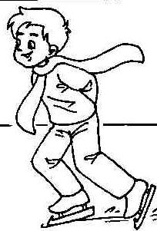
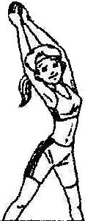

Water World Come to Water World!
Open: 9 am to 9 pm Two pools for children
Adults: $10 Two large pools for adults
Children (aged 15 or under): $7 Two restaurants
Tel: 21518296

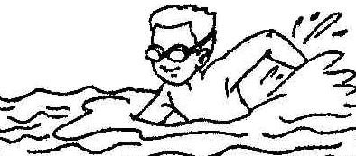

51. What do people want to do at Nancy’s Gym?
A. To enjoy swimming. B. To learn skating. C. To become thinner.
52. Lucy likes skating. Which ad is she probably interested in?
A. Ice World. B. Water World. C. Nancy’s Gym.
53. You can call at ▲ when you want to swim.
A. 45562233 B. 88682526 C. 21518296
54. You can go to swim in Water World at ▲ .
A. 8:00 am B. 9:30 am C. 10:00 pm
55. Which costs the most for an adult?
A. Keeping fit at Nancy’s Gym. B. Skating in Ice World.
C. Swimming in Water World.
B
Last week, Richard’s wife Leila had an accident. Richard’s youngest child, John, was at home when it happened. He was playing with his new toy car. Richard had given it to him a week before, for his third birthday.
Suddenly John heard his mother calling “Help! Help!” He ran to the kitchen. His mother had burned herself with some hot cooking oil (油). She was crying and the pan (锅) was on fire.
Richard had gone to his office. Both the other children had gone to school. John was too small to help his mother. ▲ . She soon put out the fire and took Leila to the hospital.
When Richard came home, Leila told him what had happened. He was very proud of his son. “When you are a man, you will be just like your father,” he said.
56. How old was John in this story?
A. One. B. Two. C. Three. D. Five.
57. How many people were there in their family?
A. Three. B. Five. C. Six. D. Seven.
58. Choose the right sentence to fill the blank (空白处) in the passage.
A. The whole kitchen was on fire
B. But John telephoned his father
C. John stood there not knowing what to do but crying
D. But he ran to the neighbor’s house and asked her for help
59. Which is the right order (顺序) according to the passage?
a. Leila had an accident.
b. John got his present, a new toy car.
c. Richard was very proud of his youngest son
d. John heard his mother calling “Help! Help!”
A. a-b-c-d B. b-a-d-c C. c-a-b-d D. c-b-a-d
60. What’s the best title (题目) of this passage?
A. A son to be proud of B. A little boy and his mother
C. An accident D. A proud father
C
Two magazines recently listed the best cities to live in. Here are two of the cities listed as “the world’s best.”
SAN JOSE, COSTA RICA The city has comfortable weather all year round (15°C to 26°C ). Housing is not very expensive in San Jose. Also, many of the city’s older neighborhoods are very beautiful and have small hotels and cafés(咖啡馆). Beautiful mountains are around the city. You can visit them easily from San Jose. So lots of people go sightseeing there every year. But air pollution is a problem in the city center.
HONG KONG, CHINA This lively city—once a small fishing village—is today an international business center. It is an interesting mix of East and West, old and new. Modern tall buildings are next to small temples (庙宇). Popular nightclubs are close to traditional teahouses. Busy people fill the streets at all hours of the day. But outside the city, there are parks for walking or relaxing. Hong Kong is famous for its wonderful native dishes. There’s also food from Europe, North America, and other parts of Asia. However, this small city has a large population. Nearly seven million people live in Hong Kong! That’s why housing is often very expensive. Traffic and air pollution are also a problem.
61. Which of the following is not mentioned about San Jose?
A. The weather. B. The mountains. C. The air. D. The traffic.
62. What makes Hong Kong the world’s best according to this passage?
A. The lively city and the wonderful dishes. B. The beautiful mountains and the lively city.
C. The expensive housing and the food. D. The city and the people.
63. The writer thinks housing in Hong Kong is expensive because ▲ .
A. it was a small fishing village B. it is a mix of East and West
C. it is famous for its wonderful food D. there are too many people in the city
64. What do the two cities have in common?
A. They both have beautiful mountains. B. They both have a large population.
C. Air pollution is a problem in both. D. They are both crowded.
65. From the passage, we can know that ▲ .
A. San Jose and Hong Kong are the only two cities of the world’s best
B. San Jose has more natural sights than Hong Kong does
C. the weather in both cities is fine
D. Hong Kong is the more popular city of the two
D
In every country, there are thousands of people who want to help out. Many join organizations run (管理) by their governments, for example, the Peace Corps in the United States and Voluntary Service Overseas in Britain. Since the powerful (猛烈的) earthquake took place in Sichuan, more than 200 thousand volunteers across China have been helping there! They do all kinds of work or come up with ways to help improve life. Some offer their professional skills for free. Others have no qualifications (资历), but they love to work hard to help.
One of the most famous volunteers in the world was Mother Teresa. She could be the best volunteer because she gave her life to helping the poorest people of Calcutta. She helped the homeless, cared for the sick, gave out food, and became the mother of those without families.
Now more and more teenagers actively look for volunteering opportunities, too. They volunteer because they think it will be fun or they will learn something. They also like the idea of being helpful to others, even if it is just handing out books for the teacher. As they get older, these reasons are still the same, but there are other important reasons for volunteering such as learning on-the-job, getting work experience, and improving their social life.
All volunteers bring joy to the people they help in so many ways. They might read books to the blind, fix up broken homes, find ways to get water for villages. Could you be a volunteer? What kind of volunteer work could you do? There is someone in the world who needs you.
66. The Peace Corps is ▲ in the United States.
A. a city B. an organization C. a volunteer D. a school
67. The word those in the passage means ▲ .
A. the homeless B. the sick C. the poor D. the kids
68. What is NOT the reason for teenagers to be volunteers according to the passage?
A. They want to make more friends. B. They want to be helpful.
C. It helps them get work experience. D. It can improve their social life.
69. Which of the following is true according to the passage?
A. Volunteers need qualifications. B. Volunteers offer their help without any pay.
C. Young kids can’t be volunteers. D. Some volunteers bring joy to others.
70. What is the main idea of this passage?
A. The world needs volunteers. B. Mother Teresa was a great volunteer.
C. Volunteers do all kinds of work. D. There are different ways of volunteering.
卷 二
说明：本卷有三大题，17小题，共50分。请用蓝、黑墨水的钢笔或圆珠笔做在“卷二答题卷”的相应位置上，做在试题卷上无效。
五、词汇运用（共10小题，每小题1分，计10分）
阅读下面短文，掌握其大意，根据所给汉语提示，写出空缺处各单词的正确形式，使短文完整、达意，每空限填一词。
Dear Patrick,
I got a new job today helping a nice family do the housework. In the Peterson family, there are 71 （四）kids, two cats and two 72 (鸟), so there’s a lot to do.
I have to cook a meal once a week. I’ve already thought 73 （关于）the first meal I will cook. I’ll make a 74 （水果）salad and if I have time I’ll also make a 75 (蛋糕). After the meal, of course, I’ll 76 （洗）the dishes.
During the day, I need to make beds and do some 77 (打扫). Then I have to do the weekly shopping and pick up the kids from school and make sure they do their 78 (家庭作业).
Sounds like a busy day? There’s more, much more. Whew, I think it will take 79 （更长久）than one day a week to 80 (完成) all these chores.
Robert
六、任务型阅读（共5小题，每小题2分，计10分）
Sally 喜欢收集新闻图片，因为她知道每一幅图片的背后都蕴藏着一个故事。你知道以下四幅图片背后的故事吗？请把A、B、C、D四则简要新闻故事与81~84的新闻图片配对。
81. 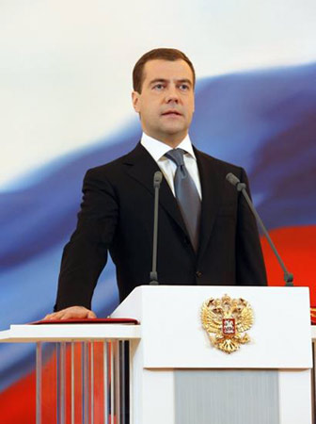 82. 
83. 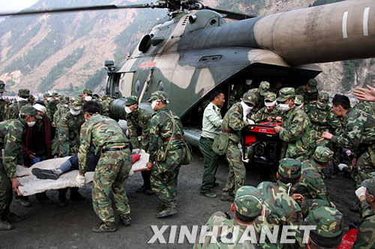 84. 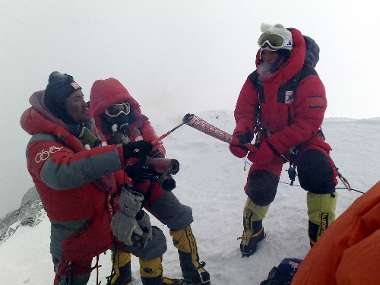
- A | - B
- On top of the world  On May 8, the Olympic flame（火焰）was lit on the top of Mount Qomolangma! It was a historic moment for China. | - We’ll beat this  - Soldiers and policemen have been sent into Sichuan soon after the 8.0 earthquake. They are helping there.
- C | - D
- A youthful president  - At the age of 42, he became the youngest president of modern Russia. | - Making friends at last  - “Getting to know each other better is the basis (基础) of friendship and should be started with youth exchanges,” said President Hu Jintao during his five-day “warm-spring” trip to Japan.

85. 新闻每天发生，视角各有不同。请以你的视角为下面这幅校园新闻图片写一个标题。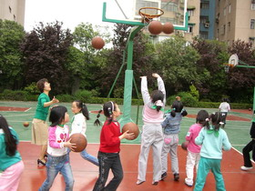
▲

七、书面表达（共2小题，86小题5分，87小题25分，计30分）
86．在一次英语沙龙活动中，外籍教师Ellen与大家一起畅谈人生理想。他让大家把自己的设想写下来保留着，看10年后有多少人能实现自己的理想。请根据表格中的提示或结合你的实际情况完成下面这一片段。
My future life
Job | a (an) teacher, reporter, artist…
Place to live in | Shanghai, Paris…
Others | travel…, keep…as a pet …
When I grow up, I want to be a (an) ▲ . And I think ▲ sounds like an interesting city, so I’d love to ▲ there. And one day in the future, I am going to ▲ . I am sure my future isn’t a dream!

87．Ellen看到大家都对自己的未来充满期待，感到特别高兴。为了鼓励大家学好英语，他准备出一期英语学习经验交流专刊。请根据以下问题和答案的提示并结合你的实际情况，以My English Learning为题写一篇80词左右的英文稿件，要求至少涉及其中的三个问题，并且不能出现你的真实姓名、校名和县名等。
提示：
When did you start learning English? (in … /…years ago)
How do you learn English? (listen carefully, study with a group, read English every day…)
What is difficult to learn? (listening, grammar…)
What other helpful ways do you know to learn English well? (watch English movies, sing English songs…)
My English Learning
参考答案和听力材料
I．参考答案
- 听力
1. B 2. B 3. C 4. A 5. C
6. C 7. B 8. A 9. C 10. B
11. A 12. B 13. A 14. A 15. C
- 单项填空
16. A 17. B 18. D 19. A 20. C
21. C 22. D 23. A 24. D 25. B
26. B 27. B 28. C 29. C 30. B
31. B 32. A 33. C 34. D 35. D
- 完形填空
36. D 37. D 38. B 39. C 40. B
41. A 42. B 43. D 44. B 45. D
46. C 47. A 48. C 49. D 50. A
- 阅读理解
51. C 52. A 53. C 54. B 55. B
56. C 57. B 58. D 59. B 60. A
61. D 62. A 63. D 64. C 65. B
66. B 67. D 68. A 69. B 70. A
- 单词拼写
71. four 72. birds 73. about 74. fruit
75. cake 76. wash 77. cleaning 78. homework
79. longer 80. finish
- 任务型阅读
81. C 82. D 83. B 84. A
85. A basketball game/ We have more exercise/ After-class activity/ Happy kids…
- 书面表达
  - 略
87. One possible version
English is one of my best subjects and I started learning English when I was ten years old. But at the very beginning, listening seemed a little difficult for me. So I have been doing a lot of listening practice, such as listening to tapes, watching English TV programs. And I found it really helped a lot. In fact, there are some more helpful ways to learn English well. For example, I enjoy singing English songs and I want to join an English club or find a pen pal from English-speaking countries. I believe that nothing is impossible if you put your heart into it.

II.评分标准
●第1～5小题，每小题1分。不选、多选或错选均不给分。
●第6～15小题，每小题2分。不选、多选或错选均不给分。
●第16～35小题，每小题1分。不选、多选或错选均不给分。
●第36～50小题，每小题1分。不选、多选或错选均不给分。
●第51～70小题，每小题2分。不选、多选或错选均不给分。
●第71～80小题，每小题1分。有词形变化的（72、77和79小题），如果写出基本词形的，可给0.5分。其余如有拼写错误均不给分。
●第81～85小题，每小题2分。
第85小题是一道开放性试题，只要学生能领会题目要求，写出相关的词、词组或句子均可给分。
●书面表达：
第86小题：第一格 1分。写出任何职业名称均可给分；
第二格 1分。写出任何城市名称均可给分；
第三格 1分。写出诸如live, work和study 等动词的均可给分；
第四格2分。只要学生能领会题目要求，写出相关内容（可选择表格中的内容，也可以自由发挥）均可给分。
第87小题25分，按6个档次给分。
第六档（22-25分）：要点具备,表达清楚，行文连贯，语言基本无误。
第五档（18-21分）：要点基本具备,表达基本清楚，行文基本连贯，语言有少量错误。
第四档（13-17分）：要点写到但不全,语言虽有较多错误，尚能达意。
第三档（8-12分）：要点不明确,语言错误多，影响意思表达。
第二档（4-7分）：只抄写了提示词；错误百出，不知所云。
第一档（0-3分）：白卷或文不对题。
注意事项：
⑴要求至少涉及所提供问题中的三个问题,提示答案供学生参考选用。
⑵评分时，按内容和表述两方面评分。注重语篇结构，注意思维的逻辑性和语言的流畅性，而不要局限在一两个语法点上。
⑶对于表达完整，语言流畅，能充分体现考生语言综合运用能力，但语言有少量错误的文章，可提高一个档次评分。如第四档可以提高到第五档。

浙江省2008年初中毕业生学业考试(丽水市卷)
英语听力材料
录音材料：
这是浙江省2008年初中毕业生学业考试(丽水市卷)英语科听力部分。该部分分三节。
注意，做题时，请先将答案划在试卷上，该部分录音内容结束后，你将有一分钟的时间将你的答案转涂到客观题答题卡上。
先看听力部分第一节：听小对话，选择图片。
听下面5段小对话。每段对话后有一个问题。从每题所给的A 、B 、C三幅图画中选出正确的选项，并标在试卷的相应位置。每段对话仅读一遍。
1. M: Jill, what’s your favorite sport?
W: Football. I like playing football best.
- M: Did you go hiking last Sunday?
W: Yes, what about you?
M: I went fishing. That’s my hobby, you know.
- M: Linda, how are you going to the cinema tonight?
W: Oh, I’m going there by bike.
- M: When is your birthday?
W: Tomorrow. Can you come to my party, Bob?
M: I’d love to. But I’m afraid I will be a little late. I must have a guitar lesson first.
- M: Excuse me. May I borrow a story book Harry Potter?
W: Sure. Here you are.
第一节到此结束。
第二节：听小对话，回答问题。
听下面5段小对话。每段对话后有一个问题。从每题所给的A 、B 、C三个选项中选出正确的选项，并标在试卷的相应位置。每段对话仅读一遍。
6. M: Hi, Judy! Where would you like to go on vacation?
W: I’d like to visit Beijing. I think it will be exciting there.
7. M: Look! Rainy again.
W: Yes, the radio says we’ll have another rain tonight.
8. M: Which subject do you like best, Lily?
W: Science. I want to be a scientist when I grow up.
9. M: Hi, Ann! What are you doing here?
W: I’m looking for a gift for my parent.
M: For your father?
W: Yes. You know, the day after tomorrow is Father’s Day.
10. M: My hometown is beautiful. You can go there to relax yourself.
W: Really? How often do you go to your hometown?
M: Not very often. I go there only on summer holidays and winter holidays.
第二节到此结束。
第三节：听下面一封邮件，请从题中所给的A 、B 、C 三个选项中选择正确的选项，完成下面的信息表。邮件读两遍。

From： Mary@yahoo.com
To： Clothes@taobao.com
Subject：A request
Dear sir,
I’m very sorry to trouble you. My name is Mary. I usually do the shopping at your store. Three days ago, I bought some clothes from your store. But I was not careful enough then. When I went home, I found some problems. The pants are too short for my husband. The shirt is too big for my son. And my daughter doesn’t like the red skirt. She likes a yellow one. I’ll be glad if you can change me some new ones.
Mary

第三节到此结束。
现在你有一分钟的时间将试卷上的答案转涂到客观题答题卡上。
听力部分到此结束。

