2006年全国中学生英语能力竞赛（NEPCS）初赛
初三年级组试题
（总分：150分 答题时间：120分钟）
听力部分（共四大题，计30分）
Ⅰ. 听辩单词（Words）（共5小题，计5分）
从下列各组单词中选出所听到句子中所含有的那个选项。每个句子只读一遍。
1. A. persons B. presents C. percent D. parents
2. A. buying B. bringing C. boring D. burning
3. A. language B. teenage C. sandwich D. passage
4. A. post B. missed C. must D. made
5. A. violin B. engineer C. volunteer D. pioneer
Ⅱ. 句子理解（Sentences）（共5小题，计5分）
从下列各组句子中选出与你所听到的句子所表达的意思相同或向近的个选项。每个句子只读一遍。
6. A. Alice couldn’t wait to take the exam this morning.
B. Alice felt nervous because she was afraid to take the exam.
C. Alice couldn’t take the exam because she hadn’t prepared for it.
D. Alice gets angry every time before taking her exams.
7. A. There was an animal cartoon on TV yesterday morning.
B. WE went to see the animals in the zoo yesterday.
C. The animal documentary we saw last night was fun.
D. It was the most interesting animals show we had ever seen.
8. A. He played a famous doctor in a film.
B. The popular show hasn’t made him famous.
C. He is known for making popular films.
D. He is famous and he acts in a popular show.
9. A. Lucy was very sick when she was in England.
B. Lucy worked hard when she was away from home.
C. Lucy missed her family a lot while she was abroad.
D. Lucy enjoyed her life when she was studying in England.
10. A. Ann is careful not to eat any unhealthy food.
B. Ann eats everything that she likes.
C. Anna wants to keep fit by eating less food.
D. Anna never eats when she drives.
Ⅲ. 对话理解（Dialogues）（共5小题，计10分）
A) 你将分别听到五段对话，针对每段对话提出一个问题，从下面各组图片中选出能回答所问题的最佳选项。对话及问题读两遍。
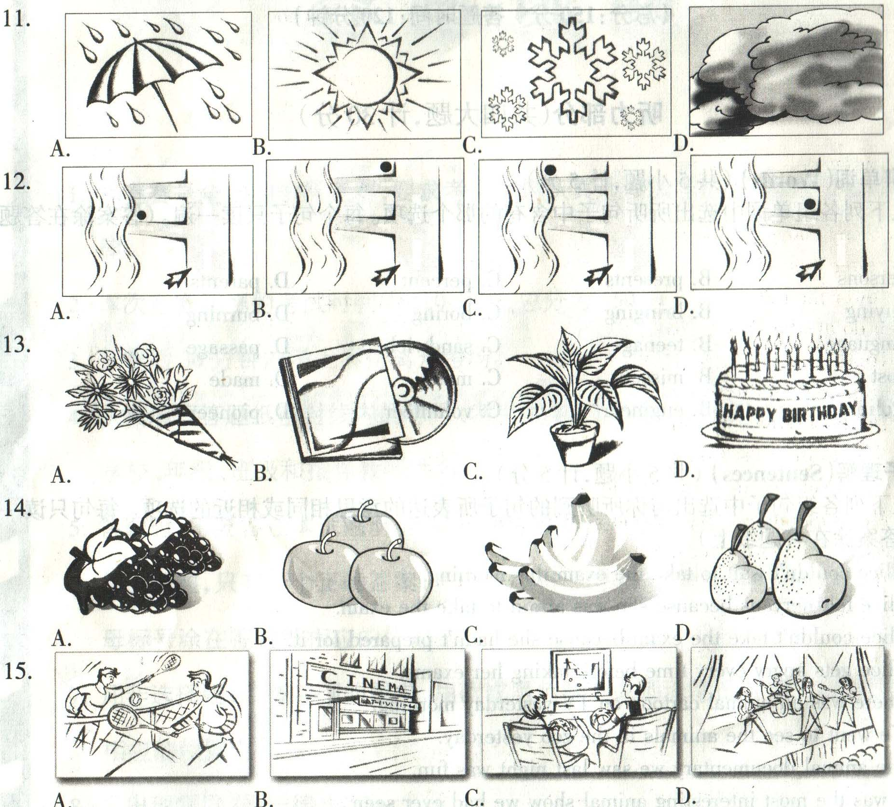
B) 你将听到一段对话，请根据对话内容选择下面各题的最佳答案。对话读两遍。
16. Why does she want to get a job?
A. She wants to give her father money. B. Her friends all have jobs.
C. She needs more money for herself. D. She wants to buy a bicycle.
17. Jane’s father doesn’t give her a lot of money because .
A. he doesn’t want her to go out with her friends.
B. he doesn’t have enough money.
C. he doesn’t want her to spend money.
D. his daughter is a poor student.
18. What is Jane’s father worried about?
A. She won’t have enough time for her homework.
B. She is so lazy that she can do nothing well.
C. She’ll come home late at night.
D. She’ll waste her money.
19. How often will Jane work?
A. Twice a week. B. Every other day. C. Once a week. D. Every day after school.
20. Jane doesn’t want to .
A. work at her father’s shop. B. clean the toilets.
C. get paid by the hour. D. clean the floors and windows.
Ⅳ. 短文理解（Passages）（共10小题，计10分）
A) 根据所听到的短文内容，选择下列各题的最佳答案。短文读两遍。
21. How many shops are there in the shopping center?
A. Fewer than 200. B. Over 200. C. Fewer than 20. D. No more than 29.
22. When do all the shops close?
A. 16: 30. B. 21: 30. C. 19: 30. D. 20: 30.
23. Where is the children’s room?
A. Downstairs near the lifts. B. Near North Square.
C. Next to the snack bars. D. In the Forest Cinema.
24. What can you see in Palmer’s shop?
A. Men’s clothes. B. A summer sale. C. A fashion show. D. Some restaurants.
25. What can you get in North Square?
A. Books and CDs. B. Movie tickets. C. Shoes and clothes. D. Food and drinks.
B) 你将听到一篇短文，请根据短文内容完成下面表格中的内容。短文读两遍。
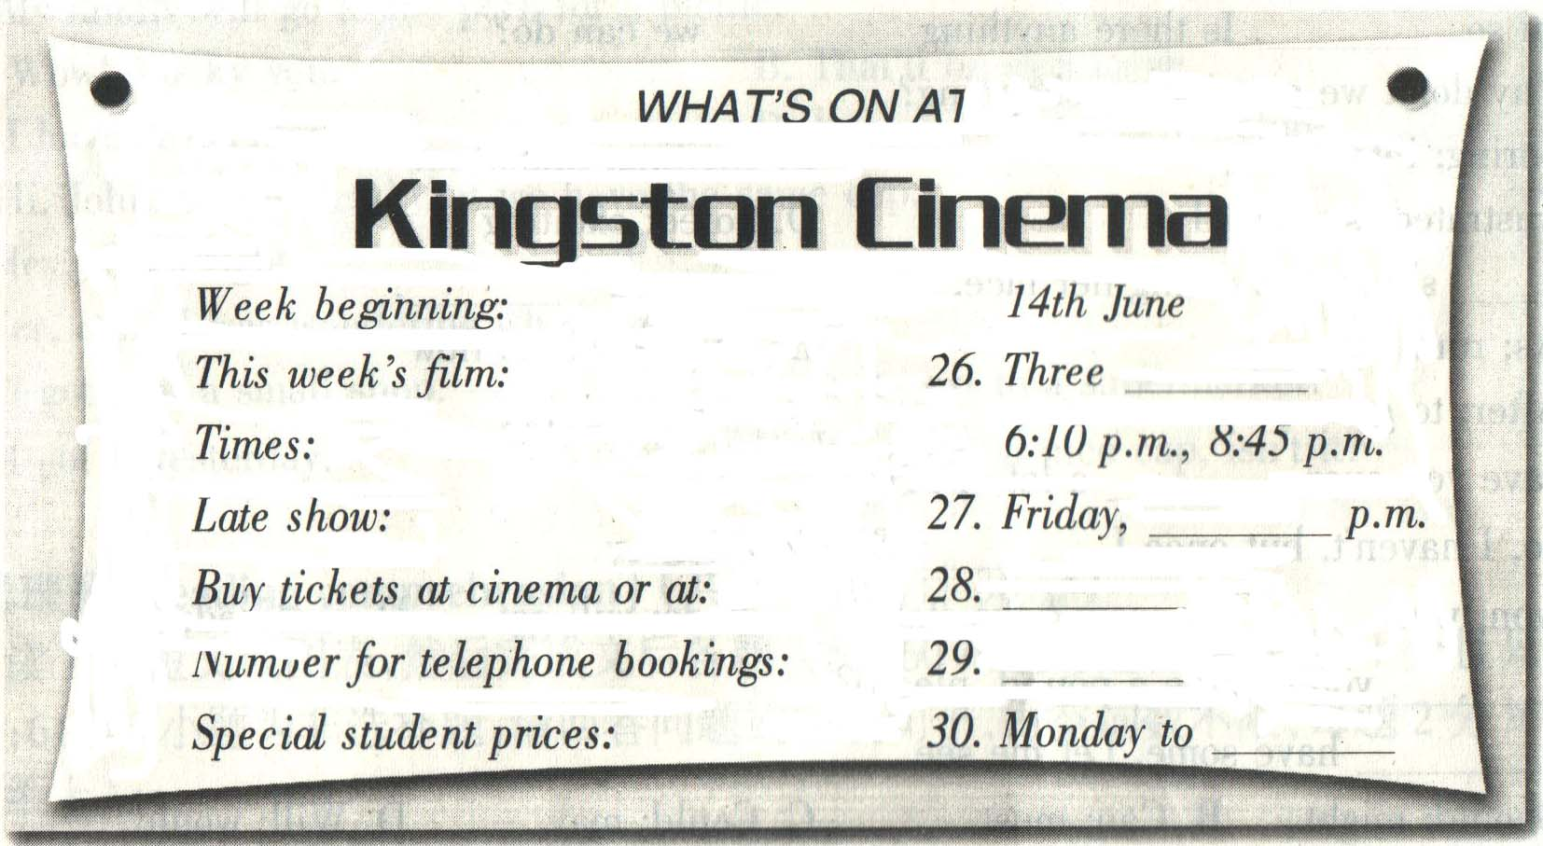
笔试部分（共七大题，计120分）
Ⅰ. 选择填空（Vocabulary and structure ）（共20小题，计20分）
从A、B、C、D四个选项中选出可以填入空白处的最佳选项。
31. —What about hiring a bike?
—It will cost you ￡2 hour or ￡5 day.
A. a, the B. an, an C. the, a D. an, a
32. —How much milk do you need?
—Just .
A. a few B. few C. a little D. very much
33. —John, I like your sweater.
—Thanks. I got it Peter my birthday.
A. over, on B. from, for C. fro, from D. about, in
34. I really like Maria. She’s a sweet girl is always polite to everyone.
A. so, that B. quite, which C. such, who D. very, whose
35. If this TV doesn’t work, bring it back we’ll give your money back.
A. and B. because C. so D. but
36. —Are you tired?
—Yes. Let’s have a cup of tea, ?
A. will you B. shall we C. won’t you D. aren’t we
37. I won’t leave unless you me everything. I have to know!
A don’t leave B. won’t teach C. would find D. tell
38. —Do you know the famous Cats is going to be performed in Beijing on 5th December?
—Yes. We’ve already got the tickets.
— .
A. We are too B. So do we C. So have we D. Neither have we
39. —I’m so . Is there anything we can do?
—Why don’t we go window-shopping?
A. boring, interesting B. exciting, important
C. frustrated, surprised D. bored, exciting
40. she was washing her face, the water stopped .
A. As, running B. As soon as, to flow C. After, to go D. Since, raining
41. —Have you ever a lot of money?
—No, I haven’t, but once I ￡10 in a lottery.
A. won, won B. seen, have stolen C. made, will get D. received, paid
42. — you change a pound, please?
—I have some. Let me see.
A. Should, might B. Can, must C. Could, may D. Will, would
43. Help yourself to some fish. The fish in this restaurant are locally.
A. cooking, living B. served, caught C. sold, finding D. made, seen
44. —Did you watch the football match last night?
—Yes. Liverpool didn’t play they did last week.
A. well than B. more than C. as well as D. as worst as
45. —Do you like cooking?
—Yes, but the one job I hate in the kitchen is .
A. getting up B. putting up C. hanging up D. washing up
46. —Hi, Nick. Oh, sorry, but I forgot to bring the tape you want.
— You can bring it next time.
—Thank you. I promise.
A. Do you mean it? B. That’s OK. C. That sounds good. D. Is that all?
47. —What should Id do for a cold?
—You should drink lots of water.
—
—You should go home and rest.
A. What else? B. I’m sure you’ll be OK.
C. How much should I drink? D. Don’t tell me what to do.
48. —Excuse me, but you aren’t allowed to smoke here.
—Oh, I’m sorry, but .
—This is a hospital. You’ll have to go outside if you want to smoke.
A. I don’t know where to park my car B. I like this movie a lot
C. I can’t find a smoking room around here D. I forgot to bring my backpack
49. —What are you going to do this weekend?
— Do you have any plans?
—My family will go to the park for a picnic.
A. Wow! Lucky you. B. That’ll be expensive.
C. I haven’t decided yet. D. I’ve never been here before.
50. —Hi, John. I have noticed that we have the same cap.
—Hey, that’s right.
—Yes, it is. I was wondering where you got yours.
A. I got it at a small shop. B. Is it next to a supermarket?
C. I got it yesterday. D. It’s really a nice cap, isn’t it?
Ⅱ. 阅读理解(Reading comprehension) （共20小题，计20分）
阅读下列短文或图表， 然后完成文后各题。（51—60小题为选择题，每题1分切只有一个最佳答案；61-70小题为非选择题，请回答问题或完成句子，每空词数不限，每题2分）
A
Ivan Fletcher loves crazy inventions. He writes a weekly magazine column called “Un-believable Inventions.”
“One of my favorite inventions is the Butter Stick. It looks like a glue, but it’s butter. You rub it on the bread of using a knife.” He says. “Another cool invention is Duster Slippers for pets. You put these special shoes on your dog or cat. As the animal runs around your house, it collects dust from the floor. Very useful!” A lot of these inventions come from Japan—the home of the crazy invention.
Ivan says that the British also invent a lot crazy things. “The other day I found an invention called a Cat Seat Saver,” he says. “The Cat Saver looks exactly like a sleeping cat—but it isn’t real. You put it on your seat if you have to go to the restroom. No one will sit in your seat because they think there’s a sleeping cat on it. Pretty cool!”
However, does anyone buy these things? Yes. Lucy Wade from the shopping website crazygadgets.com says that their customers are young, professional people.
“They buy these small things mostly for fun.” She says. “They are usually looking for a present for a friend’s birthday or a silly gift for a colleague”.
If you have an idea for an amazing invention, send it to Lucy at lucyw@crazygagets.com.
Fish Radio
This useful radio is completely waterproof, so you can listen to it in the shower. Simply stick on the bathroom wall and sing along to your favorite songs as you shower!
Watch Your Back Mirror
Don’t get caught surfing Internet of sending e-mails to your friends. Attach this mirror to your computer screen and you’ll be able to see when the boss is coming!
51. One of the inventions that Ivan Fletcher likes best is .
A. the Fish Radio B. the Butter Stick
C. the Watch Your Back Mirror D. the Cat Seat Saver
52. You put the Duster Slippers .
A. on your pet’s feet B. on your feet C. on your pet’s head D. on the floor
53. The Cat Seat Saver .
A. is a real cat B. is a pillow for cats
C. looks like a real cat D. collects dust from the floor
54. Why is the Fish Radio useful?
A. You can listen to it in the shower B. It is small enough to put in the bathroom
C. I is shaped like a fish D. It sings your favorite songs.
55. You put the Watch Your Back Mirror .
A. on your bathroom wall B. next to your boss
C. on your desk D. on your computer screen
B
When Kyle walked into Erie’s Pet World, he looked very anxious. He walked quickly to the front counter. The store’s owner, Erie, jumped out of his seat to greet Kyle. He was the store’s first customer of the day.
“Good morning, sir?” Erie said. “What can I help you with?”
“Well, I…” Kyle started to say.
“Wait, don’t tell me,” Erie (a) him. “You’re looking for a… a new puppy…for your daughter’s birthday. Right?”
“Not rally, I just…”
Erie didn’t let him finish. “Ah, I’ve got it. You just opened a new business and you want some fish for your office. I have some very nice tanks over here.”
“Actually, I…” Kyle was starting to look very (b) . His face had a strange expression on it.
“No fish? Ah, a cat! You look like a cat person. At Erie’s Pet World, we have the best breeds. Take a look at this Persian—long, white hair, and look at that cute expression. She’s looking at you. She’s thinking, “Take me home. Take me home.’ Would you like some cat food and toys as well?”
“No, thank you,” Kyle said. By this time, he was walking up and down. He had a pained look on his face. “Really, I’m not interested in cats or fish or puppies.”
“What do you want, then?” Erie asked.
Kyle looked like he was going to cry. “I just want to know if I can use your bathroom! He finally said.
56. What does the writer want to tell us?
A. A good pet seller. B. A funny story. C. A wonderful pet. D. A strange pet shop.
57. What was true about Erie’s Pet World?
A. The store was not busy. B. Kyle went there often.
C. The store was about to close. D. Kyle knew the shop owner well.
58. What kind of person is Erie?
A. Lazy. B. Shy. C. Talkative. D. Unfriendly.
59. Why did Kyle look anxious and pained?
A. He was eager to get a cat. B. He didn’t like animals.
C. He was late for work. D. He was not comfortable.
60. Choose the best words to complete the blanks (a) and (b) in the passage above.
A. watched; sensitive B. told; anxious C. talked; strange D. interrupted; nervous
C
(61) One of the strangest jobs at the Oscars is that of a seat-filler. When one of the stars needs to go to the bathroom, a sea-filler sits in the star’s seat. (62) That way, the TV cameras won’t show empty sets. Kathy Miller talks about her night as a seat-filler.
I was told to arrive at the theater at noon, wearing my dress for the evening. There were about 200 of us seat-fillers, all excited. We were told what we should and shouldn’t do (for example, “Don’t talk to the stars”), and then we waited until five o’clock. That’s when the stars started arriving. Through the crowd, I saw Gwyneth Paltrow (beautiful in a blue gown), and Mel Gibson (He’s a lot shorter than he looks in his movies!)
The show started at six o’clock. We had to stand outside the doors. Then, when someone came out ro go to the bathroom or have a cigarette, we were told to go and sit in his seat. The show was three hours long, and I only sat down five times. In the end, I was really tired. But I was happy because, during the evening, I sat behind Jim Carrey (He’s very tall!) and close the Denzel Washington, Nicole Kidman and Julia Roberts. It was an exciting night, but I think next year I’ll watch the Oscars on TV at home like everyone else!
61-62. Translate the underlined sentences into Chinese.
63. When was a seat-filler allow to sit in a star’s seat?
64. What did Kathy Miller feel about being a seat-filler?
D
Every year students from schools around the country enter the Top Student Competition. The top students are those who score more than 90% in a national test. It is good for both students and schools to score well on the test. Students who score well can get money for university. School that score well are more respected, so good teachers want to work there.
Schools keep track of the number of top students each year. For example, below are the records for Spring Hill High School. It is not a very large school with fewer than two hundred students. Each year, there are fifty to sixty high school seniors who take the national test. Do you think Spring Hill is a respected school?
Look at the graph.
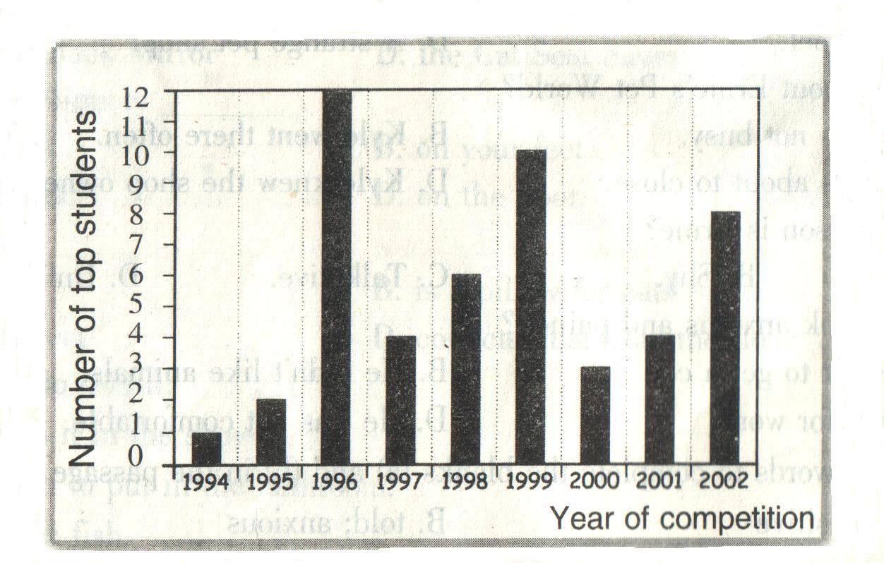
65. Students who score in a national test are top students.
66. According to this chart, Spring Hill High School had the most “top students” in the year .
67. This school is , but it is probably well .
E
6 hours Free Parking
If you spend $100 or more in our stores you will receive six hours of free parking. When you have spent $100 or more, just take this coupon () and your receipts to the customer service desk on level 4. They will stamp your parking ticket to allow 6 hours o free parking.
Offer available until November 14.

Win a $1000 CD Collection
Win your choice of $1000worth of CD’s from JB Music Store. Just buy any tow CDs and your name will go into the contest. Select your own prize from our wide variety of rock, pop, jazz, and classical music.
Contest ends on November 14. Prize drawn on November 21.
Check store for more information

Buy one, get one free
Buy one shirt or tie at Daniel’s Menswear, and get another shirt or tie of the same value free. Choose from any of our dress shirts or casual shirts. Choose one of our designer ties and we will give you another one at no cost.
Hurry! Offer ends on November 14. Offer limited to one per customer.

10% Off
Present this coupon at The Book Store to get a 10% discount on any looks you purchase. We have lots of books to choose from, including children’s books, novels, travel guides, hobbies, and non-fiction. You’re sure to find something that will enjoy. Shop now for Christmas and avoid the rush!
Offer available until November 14.

Half-Price movie tickets
Buy any full-price movie ticket on Tuesdays or Wednesdays, and you can buy a second ticket for a friend for only half price. The latest movies are all here, showing in one of our five theaters at Bayfildd Mall Shopping Complex.
Offer available through December 1. Limit one per customer.

Free Soft Drink
Buy any meal for at least $6 at Mike’s Café, and receive a free soft drink. We serve the best hamburgers and snacks in the Mall. Come in and try our delicious meals and our excellent service. You won’t be disappointed!
Free soft drink offer ends on November 14.
Read the information given above and then fill in each blank.
Some stores in the mall are offering specials for customers, including 6 hours free parking, (68) movie tickets, free soft drinks, etc. The music store is having a (69) to give away free CDs. In the clothes store you can buy one shirt or tie and get another one of the same value (70) . These offers are only available for a limited time.
Ⅲ. 完形填空（Cloze）（共20小题，计20分）
A) 阅读下面短文，根据其内容从所给的15个单词或词组中选出最恰当的10个填入空白处。
advertisers, brings, at the beginning, fashionable, fame, competitions, game, popular, professional, salaries, Toy, in fact, playing, gives
Do you think soccer is “a man’s (71) ”? Many women don’t think so. (72) , women’s soccer is becoming very (73) all over the world. The first Women’s World Cup was held in China in 1991. There were (74)
From sixty countries. In 1996, women started (75) soccer in the Olympic. Today, women play in international (76) all over the world. Some women play part-time, while others are (77) . Fortunately, some (78) are beginning to support women’s soccer clubs, too. This (89) money to the sport. Perhaps one day women players will have the same high (80) that male players enjoy.
B) 阅读短文，并用口号内所给的适当形式填空。
It happened last August at the airport. A few weeks ago, a group of us decided (81) (go) abroad together for a holiday. When we (82) (wait) in the queue at passport control I suddenly (83) (realize) that I (84) (leave) my passport at home. I rang my parents, but they (85) (work) in the garden. Luckily, my mother finally heard the hone. My passport (86) (find) in my trousers pocket. My mother said, “If you take a taxi this minutes you (87) (be) able to get on the plane in time.” I (88) (run) all the way to the plane and when at last I (89) (get) on it the other passengers (90) (start) clapping.
Ⅳ. 句式转换（Sentence pattern transformation）（共10小题，计10分）
A) 按要求转换下列句式，每个空词数不限。
91．I would like to go to the cinema with you.
to go to the cinema with me?
92. “What do you think of Italian food, Anne?” asked Tim.
Tim asked Anne Italian food.
93. I spoke to you about this problem before.
I to you about this problem.
94. We haven’t got time for a cup of tea.
We haven’t got time for a cup of tea, ?
95. How much did they pay you?
How much ?
B) 根据上就完成下句，使两句表达的意思基本相同，每空一词。
96. I’ll do everything I can to finish the work.
I’ll do to get the work finished.
97. Janet takes care of my cat when I am away.
Janet my cat when I am away.
98. Where do you think I should go?
Cold you give me on where I should go?
99. My exam results were disappointing
I with my exam results.
100. Listen carefully to everything the doctors says.
Make sure you to what the doctor says.

Ⅴ. 翻译（Translation）（共5小题，计10分）
根据提示，将下列各句翻译成英语。
101．我希望我已经做的能让你们开心。(make)
102．我喜欢安静的传统音乐，因此这种音乐会很适合我。(traditional, suit)
103．他遇到过许多困难，但是他从来没有放弃过。(come across)
104．虽然他已经在中国居住了两年，但是他却一点儿汉语也不会说。(although hardly)
105．英格兰队如果不改变打法，就会输掉这场比赛。（unless）
Ⅵ. 智力测验（IQ）（共5小题，计5分）
回答下列问题。
106. Which day comes two day after the day which begins with the sixth letter of the alphabet?
107. If the code for the JUMP is KVNQ means?
108. In each question below there are two words. One letter can be moved from the word on the left and placed into or added to the word on the right to make two new words.
Example: CAST→ BET (CAT) (EST)
SPOIL SORT →（ ）（ ）
109. There are 5 books, T, U, V, W and X stacked on top of one another on a shelf. Book U is two books below W and immediately on top of X. V is three books above U. Which book is on the top of the pile and which is at the bottom?
110. Look at the lines drawn inside the squares and name two squares with parallel（平行的）lines.
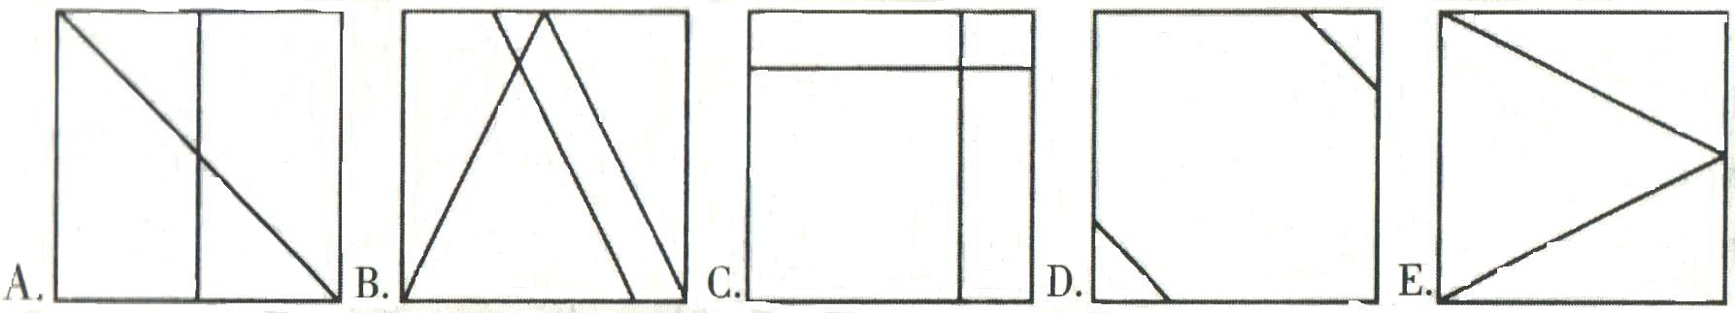
Ⅶ. 写作(Writing)（共2小题，计25分。其中A题10分，B题15分）
要求：1.根据所提供的内容，适当拓展想像空间，灵活的将所提供的信息体现在文章中；2.条理清楚，语句通顺，书写清晰、规范；3.不得少于规定的词数，所给出的文字部分不计入总词数。
A) You are an editor of a teen magazine. This is a part of a letter that somebody has sent you. Read it, then use the notes below to complete the letter of advice to him. (50—70词)
Not worry so much → things get better soon
Join a sports club → meet lots of people there
Apply for a better job → have more money / be able to go out more
Dear Editor,
I’ve just moved to a new city with my family and I’m not very happy here. I haven’t made any friends yet and I feel very lonely. Also, I’ve found a part-time job, but I don’t earn much money. That’s why I afford to go out very often. What can I do? Please help me.
Jonathan
Dear Jonathan,

I hope this advice is of some help to you.
Good luck.
Helen
B) Sony changed the way we listen to music in 1979 when it produced the first Walkman. In 1984 the CD Walkman arrived. Then came the MP3 player. Young people love the Walkman. However, not everyone thinks that Walkmans are wonderful! Do you agree with this statement! Give your opinion. ( 80—100 words)

2006年全国中学生英语能力竞赛（NEPCS）初赛
初三年级组试题参考答案听力部分
听力部分（共四大题，计30分）
1-5 BCABC 6-10 BCDCA 11-15 ACCBD 16-20 CBACB 21-25 BBACD
26. Brothers 27. 11:45 / a quarter to twelve 28. (the) theater 29. 639-884 30. Thursday
笔试部分（共七大题，计120分）
Ⅰ. 选择填空
31-35 DCBCA 36-40 BDCDA 41-45 ACBCD 46-50 BACCD
Ⅱ. 阅读理解
51-55 BACAD 55-60 BACDD
61. 奥斯卡典礼上最奇怪的工作之一就是“补空座”这一项差事了。
62. 这样，电视镜头中就不会出现空位。
63. When a star needs to go the bathroom or have a cigarette.
64. She was tired but excited.
65. more than 90% 66. 1966. 67. small / not very large; respected
68. half-price 69. contest 70. free
Ⅲ. 完形填空
71. game 72. In fact 73. popular 74. teams 75. playing 76. competitions
77. professional(s) 78. advertisers 79. brings 80. salaries
81.to go 82. were waiting 83. realized 84. had left 85. were working 86. was found
87. will be 88. ran 89. got 90. started
Ⅳ. 句型转换
91. Would you like 92. what she thought of 93. have already spoken 94. have we
95. were you paid 96. my best 97. looks after
98. some / any advice / suggestions 99. was disappointed 100. pay attention
Ⅴ. 翻译
101. I hope what I have done can make you happy.
102. I prefer quiet traditional music, so concerts suit me just fine.
103. He came across so many difficulties, but he never gave up.
104. Although he has lived in China for two years, he can hardly speak Chinese.
105. Unless the team of England improve its way, it’s going to lose the match.
Ⅵ. 智力测试
106. Sunday 107. STOP 108. SOIL SPORT 109. V is on the top and X is at the bottom. 110. B&D
Ⅶ.写作（writing）
A) One possible version:
Dear Jonathan,
I just got your letter and I think you shouldn’t worry so much. Things will get better soon if you have a positive attitude.
Why don’t you join a sports club? You’ll meet lot of people there.
If I were you, I would apply for a better job. This way you’ll have more money and you’ll also be able to go out more.
I hope this advice is of some help to you.
Good luck.
Helen
B) One possible version:
Technology has made it possible for us to listen to our favorite music wherever we go. One of the advantages of listening to a Walkman is that we can listen to music without disturbing other people. It also keeps us from getting bored on long journeys.
However, listening to a Walkman can cause some problems. Sometimes it can be dangerous because we can’t hear traffic. What’s more, Walkmans stops communication between people.
All in all, although Walkmans are popular among young people, I think we should be careful with them.
一、评分原则
1．本题总分为：A）10分；B）15分。按四个档次给分。
2．评分时，先根据文章的内容和语言初步确定其所属档次， 然后以该档次的要求来衡量，确定或调整本档次，最后给分。
3．作文词数少于50 或多于100 的，从总分中减去2分。
4．如书写较差，以至影响到交流，将分数降低一个档次。
二、各档次的给分范围和要求：
第四档（很好）：A）9-10分；B）12-15分
完成了试题规定的要求，覆盖所有内容要点，符合英语表达习惯，应用了较多的语法结构和词汇，没有语法和词汇错误，具备较强的语言运用能力，完全达到了预期的写作目的。
第三档（好）：A）6-8 分；B）9-11分
完成了试题规定的要求，应用的语法结构和词汇能满足题目的要求，符合英语表达习惯，基本没有语法和词汇错误，达到了预期的写作目的。
第二档（一般）：A）4-5 分；B）5-8分
未恰当完成试题规定的要求，漏掉内容要点，未描述清楚主要内容，写了一些无关内容，有语法和词汇错误，影响对内容的理解，信息未能清楚的传达给读者。
第一档（差）：A）1-3 分；B）1-4分
未完成试题规定的要求，明显遗漏主要内容，写了一些无关内容，语法结构单调，词汇项目有限，有较多的语法和词汇错误，影响对写作内容的理解，信息未能传达给读者。
0分
未能传达给读者任何信息：没有内容或内容太少，无法评判，写的内容均与所要求无关或所写内容无法看清。

声明：本资料由 考试吧（Exam8.com） 收集整理，转载请注明出自 http://www.exam8.com
服务：面向较高学历人群，提供计算机类，外语类，学历类，资格类，会计类，工程类，医学类等七大类考试的全套考试信息服务及考前培训.

