2006年全国中学生英语能力竞赛（NEPCS）决赛初一年级组试题

（总分：150分 答题时间：120分钟）
听力部分（共四大题，计30分）
I. 听辨单词（Words） （共5小题，计5分）
请听句子，从A, B, C, D四个选项中选出你所听到的句子中含有的单词。每个句子只读一遍。（答案涂在答题纸上）
1. A. pears B. bears C. wears D. years
2. A. dining room B. reading room C. classroom D. bedroom
3. A. bright B. quiet C. white D. light
4. A. makes B. takes C. bakes D. wakes
5. A. back B. black C. snack D. pack
II. 句子理解（Sentences） （共5小题，计5分）
请听句子，从A, B, C, D四个选项中选出与你所听到的句子意思相同或相近的选项。每个句子只读一遍。（答案涂在答题纸上）
6. A. There are many trees near our school. B. Bob often walks his dog after supper.
C. There are no cats in that tall tree. D. A dog and a cat are under the tree.
7. A. Purple is Peggy's favourite colour. B. Peggy is wearing a new purple skirt.
C. The purple shirts in the shop are on sale. D. Peggy is a new comer in our class.
8. A. The students go to school from Monday to Friday.
B. Most of the students go to school on foot.
C. We learn many things at school.
D. At school we have a history lesson every day.
9. A. My friend sometimes asks me what I want to be.
B. I want to get to the classroom earlier than anyone else.
C. First, let's go to the classroom.
D. I want to do my homework first.
10. A. Mike's parents also like Beijing Opera.
B. Mike's family don't like Beijing Opera.
C. Mike's parents like watching the 9 o'clock news, too.
D. Mike often goes to the cinema with his parents.
III. 对话理解（Dialogues） （共10小题，计10分）
A） 请听下列五组小对话，每组对话后有一个问题，根据你所听到的对话内容，选择能回答所提问题的最佳答案。每组对话及问题均读两遍。（答案涂在答题纸上）
11. A. White. B. Green. C. Blue. D. Orange.
12. A. A present and five cakes. B. Five presents and a cake.
C. A cake with five candles. D. Five cakes with one candle.
13. A. Play in a football match. B. Watch a basketball match.
C. Go swimming with Paul. D. Go out on his bicycle.
14. A. A quarter to five. B. Five thirty.
C. Six ten. D. Six past ten.
15. A. Two yuan. B. Four yuan. C. Five yuan. D. Twelve yuan.
B） 请听下面一段对话，根据你所听到的对话内容，选择能回答下列问题的最佳答案。对话读两遍。（答案涂在答题纸上）
16. Which is the photo of Peter's family?
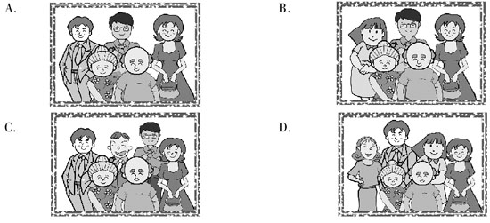
17. Where is Bill now?
A. In the UK. B. In the USA. C. In China. D. In France.
18. What does Peter's mother do?
A. She's a doctor. B. She's a teacher.
C. She's a writer. D. She's a shop assistant.
19. Which is the post office Peter works in?
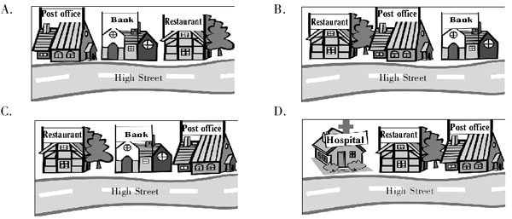
20. Which of the following is TRUE according to the dialogue?
A. David is 19 years old. B. Peter's father works on a farm.
C. Peter's mother wants to live on a farm. D. Rita is a doctor.
IV. 短文理解（Passages） （共10小题，计10分）
A） 请听下面的短文，根据你所听到的短文内容，选择能回答下列问题的最佳答案。短文读两遍。（答案涂在答题纸上）
21. On what days does Andy play games?
A. Mondays and Tuesdays. B. Tuesdays and Fridays.
C. Thursdays and Fridays. D. Tuesdays and Sundays.
22. Where does Andy do his homework?
A. At home. B. In the classroom.
C. On the way home. D. On the bus to school.
23. Why is Andy glad on Thursdays?
A. Because he has no lessons after 3 o'clock.
B. Because school is over at 2 o'clock.
C. Because there is no Maths lesson on that day.
D. Because there is no school in the afternoon.
24. What does Andy do on Saturday afternoon?
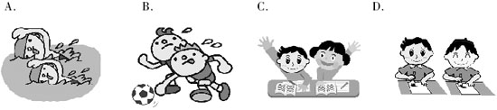
25. Which day is Andy's birthday？
A. New Year's Day. B. Easter Day. C. Christmas Day. D. Thanksgiving Day.
B） 非选择题：请听一封信，根据你所听到的内容补全下面的邀请函。信件读两遍。（答案写在答题纸上）
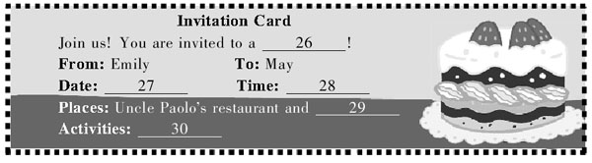
笔试部分（共七大题，计120分）
I. 选择填空（Vocabulary and structure） （共20小题，计20分）
A） 选出下列各题的最佳答案。（答案涂在答题纸上）
31. In England, people usually put “Mr” before the _________ of a man.
A. given name B. family name C. first name D. middle name
32. After school we usually play _________ soccer for half _________ hour on _________ sports ground.
A. /; an; the B. the; a; the C. /; a; / D. the; an; a
33. Frank can't find _________ dictionary. Can you lend _________ to _________?
A. her; mine; her B. his; yours; him C. my; yours; he D. /; yours; his
34. — Is this your shoe?
— Yes, it is, but where is _________?
A. the others B. other one C. another D. the other one
35. There are _________ boats on the river. The _________ one is Ada's.
A. five; fifth B. fifth; five C. five; fiveth D. fiveth; five
36. Sam eats too much _________. He doesn't eat any _________.
A. chickens; tomato B. tomato; chicken C. chicken; tomatoes D. tomatoes; chicken
37. Can you see _________ car over there near the tree?
A. a beautiful red B. beautiful a red C. a red beautiful D. red a beautiful
38. Here is a card _________ our teacher _________ our best wishes _________ it.
A. of; with; to B. from; to; with C. to; for; on D. for; with; on
39. — Mum, _________ I play computer games?
— Yes, you can, but you have to finish your homework first.
A. must B. may C. will D. need
40. That storybook is very _________. The children are _________ in it.
A. interesting; interest B. interest; interested
C. interesting; interested D. interested; interesting
41. — Isn't she a bus driver?
— _________. She is a postwoman.
A. No, she isn't B. Yes, she is C. No, she is D. Yes, she isn't
42. The skirt in that shop really looks smart, _________ it is too small for me.
A. or B. and C. but D. so
43. Would you like _________ a football game or _________ a book?
A. to see; look at B. look at; read C. watch; look at D. to watch; read
44. — _________ does your classmate John look like?
— He's very short, and always wears jeans.
A. How B. What C. Who D. Which
45. — Do you know where Tom lives?
— Certainly. He lives at _________, near my house.
A. Tonghua, 289 Xinhua Road, China B. Beijing, Chang'an Road, China
C. 56 Hope Road, London, England D. the USA, New York, 43 Green Road
B） 情景对话。（答案涂在答题纸上）
46. — You look very nice in that T-shirt, Bob.
— _________.
A. You're so kind B. Sorry, I don't like it at all
C. It's OK D. Thanks
47. — Hello, is that 665-9525?
— _________. It's 679-5525.
A. Sorry, wrong number B. Yes, who's that
C. Speak, please D. Sorry, he isn't in
48. — _________?
— It's purple. What about yours?
— It's pink.
A. Do you like pink or purple B. What colour is your new dress
C. Is your favourite colour purple D. What colour do you like best
49. — Good morning. Can I help you?
— Yes. _________.
A. You must lose weight B. I'm always ready to help others
C. I know the way to the hospital D. I want a hamburger, please
50. — Dad, I can't find my sweater.
— _________?
— Oh, yes. Thank you, Dad.
A. Where's your sweater B. Whose sweater do you like best
C. Is the one on the chair yours D. Do you know where it is
II. 阅读理解（Reading comprehension） （共20小题，计30分；51—60小题每题1分，61—70小题每题2分）
A
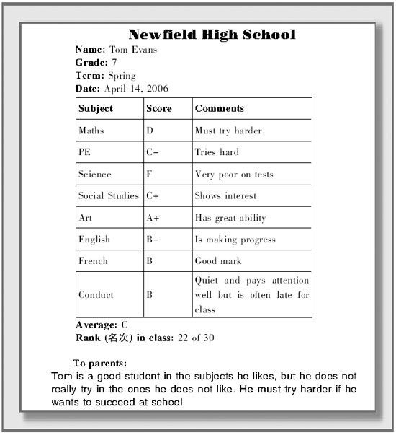
根据成绩报告单内容，选择最佳答案。（答案涂在答题纸上）
51. From this report, Tom seems （看起来） to be _________.
A. happy in his classes B. not doing his best
C. the top student D. the worst student
52. In which subject does Tom have the lowest grade?
A. Art. B. English. C. PE. D. Science.
53. The fact that Tom gets “A+” in Art shows that _________.
A. he likes Art B. he doesn't paint well
C. he likes the teacher D. he dislikes Art
54. What's the meaning of the word “comment” according to the school report?
A. 闲谈 B. 表扬 C. 评语 D. 批评
55. Tom is the _________ in his class.
A. 22nd B. 21st C. 30th D. 32nd
B

根据传单内容，选择最佳答案。（答案涂在答题纸上）
56. Which would be good names for Shop A, Shop B and Shop C?
A. Ely's Game Zone; Billy's Sporting Goods; Amazon Clothing Shop
B. Frozen Dessert Shop; Ely's Game Zone; Amazon Teen Clothing
C. Amazon Clothing Shop; Billy's Sporting Goods; Ely's Game Zone
D. Billy's Sporting Goods; Ely's Game Zone; Amazon Teen Clothing
57. If you and your friend both want to have a new flavour of ice cream, you two will have to pay _________ at least (最少).
A. 9 cents B. 18 cents
C. 90 cents D. 180 cents
58. The original price (原价) of a T-shirt is $12. How much is it at Shop C this weekend?
A. $3.60. B. $4. C. $8.40. D. $8.
59. You can't go shopping in the Brand New City Mall at _________.
A. 5:00 p.m. on Monday B. 9:00 p.m. on Sunday
C. 10:00 a.m. on Friday D. 5:00 p.m. on Saturday
60. Which is TRUE according to the leaflet (传单)？
A. Students can buy the ProSoccer game at any time in Shop A.
B. Shop B collects stickers, too.
C. All winter clothes are 30% off in Shop C.
D. The three shops are all at 1st Street and Maple Avenue.
C
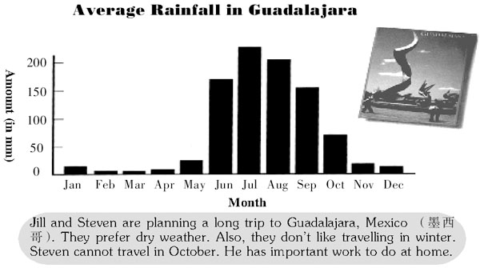
根据图表及文字内容，完成下列各题。（答案写在答题纸上）
61. July gets _________ rainfall in Guadalajara.
62. There are _________ months when the rainfall is below （低于……） 50 mm.
63. _________ are good months for Jill and Steven to travel.
D
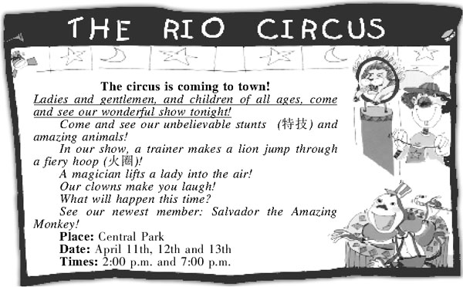
根据海报内容，完成下列各题。（答案写在答题纸上）
64. Translate the underlined sentence （划线的句子） into Chinese, please.
65. Who is the newest in the Rio Circus?
66. How many times does the circus perform （表演） altogether during the three days？
E
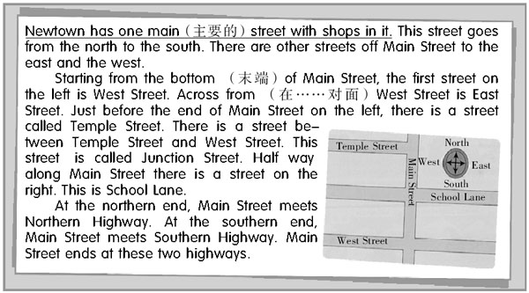
根据短文内容，完成下列各题。（答案写在答题纸上）
67. Write the names of the other two streets on the map in the correct places.
68. Translate the underlined sentence into Chinese, please.
69. There are _________ streets meeting Main Street between the two highways.
70. You can probably find a clothes shop in _________.
III. 完形填空（Cloze） （共20小题，计20分）
A） 从方框中选择适当的单词，并用其适当的形式完成短文，每词只能使用一次。其中有5个单词为多余选项。（答案写在答题纸上）
but, should, film, also, like, him, little, sometimes, make, let, with, work, a, three, few
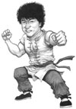
Jackie Chan is (71)_________ international superstar. His (72) _________ are full of action. They are (73) _________ very funny. They're never boring. In the action scenes, people throw strange things (74)_________ tables and chairs. Jackie does all those scenes (75) _________. It can be a (76) _________ dangerous. In fact, Jackie (77) _________ gets hurt.
Jackie (78)_________ films in Asia and America. He often stars (79) _________ other famous actors. They enjoy (80) _________ with him. Jackie Chan's films are really fun.
B） 根据首字母提示，用动词的适当形式填空。每空一词。 （答案写在答题纸上）
Ann is 14. She (81) l_________ in Glasgow with her family. Glasgow (82) i_________ in Scotland. Ann (83) g_________ to school with her friends every day. She (84) h_________ classes five days a week. Ann and her friends all (85) l_________ sports. Jack and Betty (86) c_________ swim very well. Ann is best at (87) p_________ football and basketball. Peter likes (88) r_________ horses. Her friends (89) l_________ music, too. Peter loves rock music, but Betty loves pop music. In the evening they all (90) l_________ to songs.
IV. 句式转换（Sentence pattern transformation） （共10小题，计10分）
A） 按要求转换下列句式。每空一词。（答案写在答题纸上）
91. He lives with his grandmother in a faraway city. (对划线部分提问)）
_________ does he _________ with in a faraway city？
92. I think there is some bread in the fridge. (改为否定句)
I _________ _________ there is _________ bread in the fridge.
93. This is a Chinese documentary. (改为复数句)
These are Chinese _________.
94. I can see five bags of rice in the car. (对划线部分提问)
_________ _________ rice can you see in the car?
95. My father is a history teacher. My mother is a history teacher, too. （合并成一句）
_________ _________ are _________ history teachers.
B） 根据上句完成下句，使两句意思基本相同。每空一词。（答案写在答题纸上）
96. In Canada there are a lot of beautiful mountains and lakes.
Canada _________ a lot of beautiful mountains and lakes.
97. My favourite school day is Wednesday. What's yours?
I like Wednesday best. _________ _________ you?
98. The office business hours are 8:00 a.m. — 6:00 p.m.
The office is open _________ 8:00 a.m. _________ 6:00 p.m.
99. Wendy uses English to write her emails.
Wendy _________ her emails _________ English.
100. Ms Gao teaches us how to play volleyball．
We _________ how to play volleyball _________ Ms Gao.
V. 翻译（Translation） （共5小题，计10分）
根据提示将下列句子译成英语。（答案写在答题纸上）
101. 请告诉他们不要在薄冰上滑冰。（on thin ice）
102. 吉姆想加入哪个俱乐部，是英语俱乐部还是音乐俱乐部？ （or）
103. 约翰想给自己买副眼镜。（want）
104. 我们学校和其他学校有点不同。（be different from）
105. 看！那间有两个大窗户的房间是那对双胞胎的。 （with）
VI. 智力测试（IQ） （共5小题，计5分）
按要求完成下列各题。（答案写在答题纸上）
106. Find a letter to replace （代替） the question mark in this mathematical (数学的) box. Remember that letters can easily be changed into numbers.
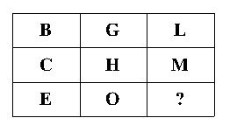
107. The following letters all have a numerical value （数值）. If the word TEA is worth （相当于） 4, and TEAS is worth 8, what would SEATS be worth?
108. At a birthday party half the guests drink cola, a quarter have lemonade, a sixth have orange juice, and the remaining （剩余的） three have water. How many guests are there at the party?
109. Read the dialogue. Can you guess the meaning of “pulling my leg”? (You may answer it in English or Chinese.)
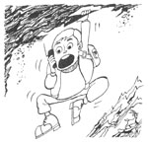
Sam: Hello?
Daniel: Sam!Help me!
Sam: What's the matter, Daniel?
Daniel: I'm hanging from a rock with one hand. I can't hold on much longer. Come to help me quickly!
Sam: Very funny, Daniel. Why are you always pulling my leg?
Daniel: It's true!
110. If the red house is on the right and the blue house is on the left, where is the White House?
VII. 写作（Writing） （共2小题，计25分；A题10分，B题15分）
A
请根据下面的文字，并结合图片所提供的信息编写一段Liz 和Travel Agent之间的对话。（答案写在答题纸上）
要求：1. 发挥想象，将所给文字及图片所提供的信息结合起来，并全部体现在对话中；
2. 条理清楚，意思连贯，语句通顺，标点正确，书写规范、清晰；
3. 不得少于50词。
Liz and her friends are having a holiday. They are going to stay in Holly Cottage, and want to get some information about it, so Liz goes to the travel agency (旅行社) ...
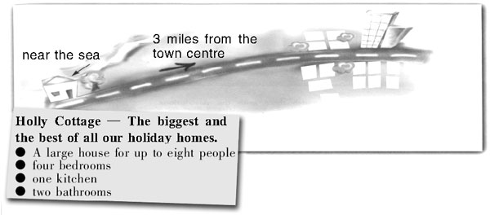
B
请阅读下面一段文字。
Jenny likes singing stars very much, especially the Super Voice Girls. She is crazy about them. She follows their hairstyles and clothes. She doesn't do well in her studies. Her parents and teachers are worried about her.
假如你是Jenny的朋友Tim，请根据上述内容，给Jenny写一封信，帮助她解决问题，走出困境。信件开头已给出，不计入总词数。（答案写在答题纸上）
要求: 1. 叙述有条理，符合逻辑;
2. 用词得当，语法正确;
3. 书写清晰、规范;
4. 词数: 60—80。
Dear Jenny,
How's everything going? We are all worried about you because you think too much about singing stars. ...
2006年全国中学生英语能力竞赛(NEPCS)决赛初一年级组试题参考答案

听力部分（共四大题，计30分）
I. 听辨单词（Words）
1—5 BDCBA
II. 句子理解（Sentences）
6—10 CBABA
III. 对话理解（Dialogues）
A) 11—15 BDACD
B) 16—20 CABBC
IV. 短文理解（Passages）
A) 21—25 BDAAC
B) 26. birthday party 27. September 2nd 28. about 6:30 p.m. 29. the City Park 30. first eat and talk and then go to see a free film
笔试部分（共七大题，计120分）
I. 选择填空（Vocabulary and structure）
A) 31—35 BABDA 36—40 CADBC 41—45 ACDBC
B) 46—50 DABDC
II. 阅读理解（Reading comprehension）
A) 51—55 BDACA
B) 56—60 BCCBD
C) 61. the most 62. seven 63. March, April and May
D) 64. 女士们、先生们以及所有的孩子们，欢迎今晚来观看我们精彩的表演！
65. Salvador the Amazing Monkey.
66. Six.
E) 67. 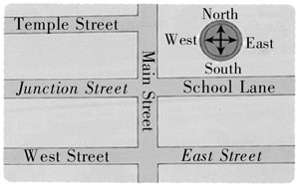
68. Newtown 有一条主街，街道上有商店。69. five 70. Main Street
III. 完形填空（Cloze）
A) 71. an 72. films 73. also 74. like 75. himself 76. little 77. sometimes 78. makes 79. with 80. working
B) 81. lives 82. is 83. goes 84. has 85. like / love 86. can 87. playing 88. riding 89. like / love 90. listen
IV. 句式转换（Sentence pattern transformation）
A) 91. Whom; live 92. don't think; any 93. documentaries 94. How much 95. My parents; both
B) 96. has 97. What / How about 98. from; to 99. writes; in 100. learn; from
V. 翻译（Translation）
101. Please tell them not to skate on thin ice.
102. Which club does Jim want to join, the English club or the music club?
103. John wants to buy a pair of glasses for himself. / John wants to buy himself a pair of glasses.
104. Our school is a little different from other schools.
105. Look!The room with two big windows is the twins'. / Look!The twin's room is the one with two big windows.
VI. 智力测试（IQ）
106. Y. (Y is the 25th letter in the alphabet. The number for the letter in the top row added to the one in the central row gives the one in the bottom row.)
107. 12. (If TEA is worth 4, and TEAS is worth 8, S is worth 4. Therefore, the addition of another S makes SEATS worth 12.)
108. 36.
109. Playing a joke on me （戏弄我）.
110. In Washington DC.
VII. 写作（Writing）
A) One possible version:
Travel Agent: Can I help you?
Liz: Yes, can you tell me something about Holly Cottage, please?
Travel Agent: Well, it's the biggest and the best of all our holiday homes. It's a large house for up to eight people.
Liz: Where is it?
Travel Agent: It's three miles from the town centre.
Liz: Is it near the sea?
Travel Agent: Yes.
Liz: How many rooms are there?
Travel Agent: There are four bedrooms, one kitchen and two bathrooms.
Liz: Thank you very much.
B) One possible version:
Dear Jenny,
How's everything going? We are all worried about you because you think too much about singing stars. I think we can have our favourite singers, but we shouldn't spend too much time or money on them. There are many good things we can learn from them. For example, they work hard and always try their best to do things well. They never give up and have a fighting spirit as well. We are students, so our studies should come first. Don't you agree?
Yours truly,
Tim
一、 评分原则：
1． 本题总分为: A） 10分； B）15分。按四个档次给分。
2． 评分时，先根据文章的内容和语言初步确定其所属档次，然后以该档次的要求来衡量，确定或调整本档次，最后给分。
3． A部分作文词数少于50或多于100的， 从总分中减去２分; B部分作文词数少于60的, 从总分中减去2分。
4． 如书写较差，以至影响交流，将分数降低一个档次。
二、 各档次的给分范围和要求：
第四档（很好）：A） 9—10分； B） 12—15分
完全完成了试题规定的要求，覆盖所有内容要点，符合英语表达习惯，应用了较多的语法结构和词汇，没有语法和词汇错误，具备较强的语言运用能力，完全达到了预期的写作目的。
第三档（好）：A） 6—8分； B） 9—11分
完成了试题规定的要求，应用的语法结构和词汇能满足题目的要求，符合英语表达习惯，基本没有语法和词汇错误，达到了预期的写作目的。
第二档（一般）：A） 4—5分； B） 5—8分
未恰当完成试题规定的要求，漏掉内容要点，未描述清楚主要内容，写了一些无关内容，有语法和词汇错误，影响了对写作内容的理解，信息未能清楚地传达给读者。
第一档（差）：A） 1—3分； B） 1—4分
未完成试题规定的要求，明显遗漏主要内容，写了一些无关内容，语法结构单调，词汇有限，有较多语法和词汇错误，影响对写作内容的理解，信息未能传达给读者。
0分
未能传达给读者任何信息，没有内容或内容太少，无法评判，写的内容均与所要求内容无关或所写内容无法看清。

2006年全国中学生英语能力竞赛（NEPCS）决赛初一年级组试题听力部分录音原文
Part I. Words
Listen to the sentences. Then choose the word you hear in the sentence. Each sentence will be read only once.
1. Lily loves teddy bears very much.
2. Come to my bedroom and look at my new books.
3. Some kites are in a big white box under the desk.
4. Millie takes a bus to school every morning.
5. The child sits in the back of the car behind the driver.
Part II. Sentences
Listen to the sentences. Then choose the sentence which has the same or similar meaning as the sentence you hear. Each sentence will be read only once.
6. There aren't any cats in that tall tree.
7. Peggy is in a new purple skirt today.
8. The students have classes five days a week.
9. I want to be the first one to come to the classroom.
10. Mike's parents like Beijing Opera, too.
Part III. Dialogues
A) You will hear five dialogues and five questions. Choose the best answer to each question according to the dialogue. Each dialogue will be read twice.
11. W: Is Ben's car green?
M: I don't think so. He hates green.
W: What colour is it then?
M: I think it's white.
Q: What colour doesn't Ben like?
12. W: You're five today, Jack. Happy birthday to you!
M: Thank you, Mum.
W: Would you like to have a cake with five candles on it for your birthday party?
M: I think I'd better have five cakes with one candle, Mum.
Q： What does Jack want for his birthday party?
13. M: Hello, Mrs Brown. Is Owen there?
W: No, he's out on his bicycle at the moment.
M: Oh, can he go swimming this evening?
W: Sorry, Paul. He's got a football match this evening.
Q: What is Owen going to do this evening?
14. W: Excuse me. Is there a bus to London at five thirty?
M: No, but there is one at a quarter to five, madam.
W: Mm ... that's too early. When's the one after that?
M: Ten past six.
W: Yes, I can take that one.
Q: At what time will the woman take the bus?
15. M: Can I help you?
W: Yes, I'd like three kilos of apples, please.
M: Do you want the ones at two yuan, four yuan or five yuan?
W: The ones at four yuan, please.
Q: How much will the woman pay for the apples?
B) Listen to the dialogue, and then choose the best answer to each question according to the dialogue. The dialogue will be read twice.
W: Tell me about your family, Peter.
M: Well, you know Rita, my sister, is a writer, don't you?
W: Yes, is she your only sister?
M: She is. But I've got two brothers. David's older than me, and Bill's younger.
W: How old is Bill?
M: He's 19. He's studying English in England at the moment.
W: That sounds interesting. And David? What does he do?
M: Oh, he is a teacher, the same as my mother.
W: And what about your father?
M: He's a doctor in a children's hospital. My mother says he works too hard. She wants him to stop.
W: Oh, really?
M: Yes, she wants to go and live on a farm in the country, near David.
W: Um ... are you a doctor too?
M: No, I'm not. I work in a post office — the one in the High Street, between a bank and a restaurant.
Part IV. Passages
A) You will hear a passage. Choose the best answer to each question. The passage will be read twice.
Andy is a student at an international school. At school, he likes playing games best. He plays them on Tuesdays and Fridays at two o'clock. He doesn't like Maths because the teacher gives them homework every day. He does his homework on the bus on the way to school. On Thursdays he's glad because school is over at three o'clock. There is no school on Saturdays, so in the afternoon he goes swimming with his friends. He likes the long school
holidays in summer and holidays at Christmas. His birthday is on December 25th, so he gets a lot of presents at Christmas.
B) Listen to the letter, and then complete the invitation card. The letter will be read twice.
Dear May,
How are you? Are you coming to my birthday party in September? My family, my friends and my classmates are all coming. The party is on Saturday, September 2nd at about 6:30 p.m. It's at Uncle Paolo's restaurant in the city. First, we will eat and talk from 6:30 to 7:45. After that we will go to see a film in the City Park in the centre of the city. Every Saturday night, there is a free film at 8:00. I hope you can come.
Please write back soon.
Yours sincerely,
Emily

声明：本资料由 考试吧（Exam8.com） 收集整理，转载请注明出自 http://www.exam8.com
服务：面向较高学历人群，提供计算机类，外语类，学历类，资格类，会计类，工程类，医学类等七大类考试的全套考试信息服务及考前培训.

