2006年全国中学生英语能力竞赛(NEPCS)决赛初三年级组试题
（总分：150分 答题时间：120分钟）
听力部分（共四大题，计30分）
I. 听辨单词（Words） （共5小题，计5分）
从下列各组单词中选出所听句子中含有的那个选项。每个句子只读一遍。（答案涂在答题纸上）
1. A. accident B. student C. president D. present
2. A. check B. cheat C. chest D. cheer
3. A. praised B. increased C. surprised D. afraid
4. A. coming B. welcoming C. incoming D. becoming
5. A. baskets B. markets C. bicycles D. biscuits
II. 句子理解（Sentences） （共5小题，计5分）
从下列各组句子中选出与你所听到的句子所表达的意思相同或相近的选项。每个句子只读一遍。（答案涂在答题纸上）
6. A. John hates to spend most of his time at school.
B. John doesn't enjoy his life as a student.
C. As a student, John spends most of his time in school.
D. John wants to take a part-time job although he is a student.
7. A. Sue can't relax because of the pressure of work.
B. Sue thinks her job is stressful but rewarding.
C. Sue's job is easy and she doesn't need a break.
D. Sue feels stressed out and wants to give up her job.
8. A. I don't like my jeans because they're too old.
B. My jeans are now too tight for me to wear.
C. I need to gain some weight because I can't wear my jeans anymore.
D. I used to like wearing jeans but now I don't.
9. A. We wanted to make friends with our next door neighbour.
B. We had a peaceful party together with our neighbour.
C. Our neighbour invited us to join their party.
D. Our evening was disturbed by the party noise from our neighbour.
10. A. Leo was sorry because he was late for the dinner.
B. Leo felt awful because he didn't have enough money to pay for the dinner.
C. Leo was unhappy because he had to pay the dinner bill.
D. Leo felt sad because he was not invited to the dinner.
III. 对话理解（Dialogues） （共10小题，计10分）
A) 你将分别听到五段小对话，针对每段对话将提出一个问题，从下面各组图片中选出能回答所提问题的最佳选项。对话及问题读两遍。（答案涂在答题纸上）
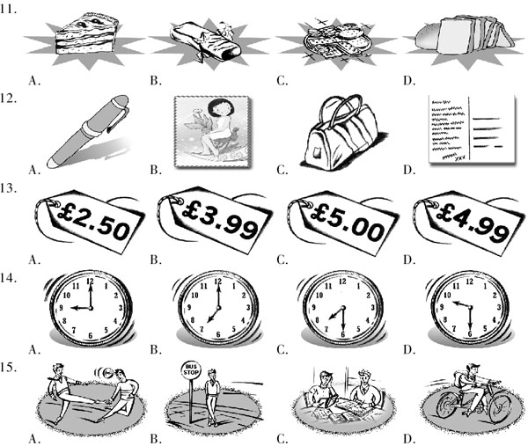
B) 你将听到一段对话，请根据对话内容选择下面各题的最佳答案。对话将读两遍。（答案涂在答题纸上）
16. When does this conversation probably happen?
A. At the beginning of the summer vacation.
B. During the school term.
C. After the summer vocation. D. At the beginning of the new term.
17. What does the boy like to do?
A. Listen to classical music. B. Play the cello.
C. Go to concerts. D. Use his computer.
18. Before the girl can go to Yo Yo Ma's concert, she must _________.
A. do a lot of homework B. clean the house
C. attend every cello lesson D. get a job
19. Why doesn't the boy know who Yo Yo Ma is?
A. He only likes violin players. B. He doesn't like classical music.
C. He only likes jazz music. D. He doesn't like any kind of music.
20. What may the boy and the girl both do?
A. Travel to Europe. B. Take music lessons.
C. Buy new computers. D. Make their own webpages.
IV. 短文理解（Passages）（共10小题，计10分）
A) 根据所听电话留言的内容，选出下列各题的最佳答案。短文读两遍。（答案涂在答题纸上）
21. What is this message about?
A. Some team players. B. A volleyball club.
C. A sports TV programme. D. The rent for the hall.
22. When do the members meet?
A. Every Saturday morning. B. Every Monday afternoon.
C. Every Wednesday evening. D. Every Sunday evening.
23. Why does the meeting finish at ten?
A. Players may get too tired to go home.
B. Playing for more than two hours is too long.
C. It's too cold in the Jubilee Hall.
D. People don't want to miss the 10:15 sports programme.
24. What should players take to the hall?
A. A map. B. A heater. C. A sweater. D. A watch.
25. How much do players pay each week?
A. ￡2.75. B. ￡3.25. C. ￡5.75. D. ￡7.25.
B) 你将听到一篇短文，请根据短文内容完成下面图表中的内容。短文读两遍。（答案写在答题纸上）
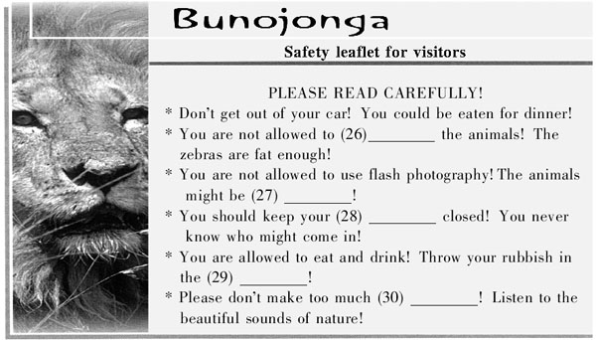
笔试部分（共七大题，计120分）
I. 选择填空（Vocabulary and structure） （共20小题，计20分）
从A，B，C，D四个选项中，选出可以填入各题空白处的最佳选项。（答案涂在答题纸上）
31. Yesterday I downloaded a new programme _________ the Internet. Now I can watch TV and movies _________ my computer.
A. on; from B. on; in C. in; with D. from; on
32. — Too many people are killed on the roads every year.
— Yes, but the government isn't doing _________ about it.
A. nothing B. much C. everything D. more
33. You got all the answers _________ last time. You'll have to do the test again _________ carefully.
A. correct; most B. wrong; much more
C. easy; even D. careless; but
34. — Have you ever _________ to Rome?
— Years ago, and _________ is one of the best holidays I've ever had.
A. been; that B. gone; this C. went; it D. been; those
35. I'm hungry. _________ go out for dinner?
A. Why do we B. How about C. Shall we D. Don't you
36. — Kurt, why are you so happy?
— The World Cup Final is on tonight. There's _________ I like _________ football.
A. anything; but B. nothing; more than
C. none; as D. more; than
37. — What do you think of Jerry?
— He is clever. _________, he can be forgetful.
A. And B. So C. Because D. However
38. I really appreciated your _________ when I was in hospital. It was so nice to have a visitor.
A. happiness B. cheer C. kindness D. work
39. Most people are _________ when they hear about people _________ come face to face with danger in order to save others.
A. surprising; that B. exciting; as C. amazed; who D. interested; which
40. I _________ think teenage girls who got their ears _________ were very strange, but now they seem quite normal.
A. used to; pierced B. get used to; covering
C. used to; burnt D. am used to; pulled
41. I need _________ this letter. Would you mind _________ me your pen, please?
A. to finish; lending B. writing; to give
C. to see; borrowing D. finding; drop
42. _________ you are, _________ you live, you must be interested in the future of this planet.
A. Whoever; however B. Whatever; whichever
C. Whoever; wherever D. Whenever; wherever
43. — I broke my brother's notebook computer. What should I do?
— If I were you, I _________ him right away, and then apologise for it.
A. would have told B. would tell C. won't tell D. could tell
44. I can't meet you tomorrow. Can we _________ it off till the day after?
A. call B. get C. put D. turn
45. — Please stop asking so many questions.
— Pardon?
— Sorry, John. I wish you _________ ask so many questions. I'm busy now.
A. could B. wouldn't C. would D. shouldn't
46. — My son won the first prize in the speech contest last week.
— Please give my congratulations to him.
— _________
A. I'm surprised. B. Yes, I think so. C. Everyone says so. D. Thanks. I will.
47. — I'd like to get two seats for the show tomorrow.
— Where would you like to sit?
— _________
A. May I sit here? B. Do you have the money?
C. How much are the middle seats? D. Can I pay by card?
48. — Jane, can you help me join a web club?
— Sure. _________
— Music, especially the Backstreet Boys.
A. Can I join one of the clubs too?
B. That'll be good for you.
C. What are you interested in?
D. There are a lot of Backstreet Boys' clubs on the Net.
49. — I did very badly in my maths exam.
— I can help you study for the next one.
— Thank you. _________
— Of course, you just have to study harder.
A. How can you help me?
B. Do you think I can do better next time?
C. You've been really helpful.
D. I haven't heard from you for a long time.
50. — Lily, what are you going to do after you graduate?
— I'm thinking of becoming a computer programmer.
— _________
— Well, my parents want me to be a doctor, but I don't want to do that.
A. Do you know what I want to become?
B. Why do you want to be a doctor?
C. You said you would go to a medical school.
D. Thanks for your advice.
II. 阅读理解（Reading comprehension） （共20小题，计30分）
阅读下列短文或图表，然后完成文后各题。（５1—６0小题为选择题，每题1分且只有一个最佳答案；61—70小题为非选择题，请回答问题或完成句子，每空词数不限，每题2分）（答案涂写在答题纸上）
A
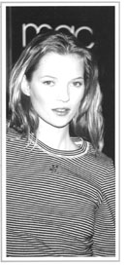
Before the 1980s, models were just beautiful people in magazine photographs. People knew very little about them. They didn't know how old they were, where they lived or what their favourite sports were. Most people didn't even know their names.
Then came the 1980s, the era（时代） of the supermodel. This was when some models became so famous that they became as well known as Hollywood film stars. Most people today have heard of Naomi Campbell, Kate Moss, Elle Macpherson, Claudia Schiffer and the other supermodels. Stories about them appear in magazines. Journalists interview them. Television documentaries have been made about their lives. There are also hundreds of supermodel websites created by fans. On these websites, fans include information about the models' weight, shoe size and hair colour.
One of the reasons these models became so famous was the huge amounts of money they were paid. Canadian supermodel Linda Evangelista once said, “I won't get out of bed for less than $10,000 (￡6500) a day.” Claudia Schiffer had a four-year contract （合同） with the cosmetics （化妆品） company Revlon. The company paid her ￡4,000,000 for just thirty days' work per year—that's more than ￡130,000 per day!
Supermodels don't make their money just from posing for the camera or walking down the catwalk. They have discovered many other areas where they can market themselves: films, television shows, exercise videos, calendars, and even the lingerie（女内衣） business. Elle Macpherson has her own underwear company which makes millions of pounds a year.
Supermodels have many other things in common, too. They travel all over the world to work. They own houses and flats in many different places.
51. Before the 1980s, _________.
A. supermodels didn't exist
B. models were as well known as Hollywood stars
C. some models were called supermodels
D. people knew the names of many models
52. How do people get to know about the lives of supermodels?
A. By watching their shows. B. By calling their mobiles.
C. By surfing their websites. D. By sending presents to them.
53. For one day's work, Linda Evangelista expects to be paid _________.
A. ￡6,500 or more B. less than ￡6,500
C. ￡4 million D. more than ￡130,000
54. Which of the following is not true?
A. Supermodels are paid too much money.
B. Nowadays supermodels are just as famous as Hollywood stars.
C. Supermodes don't just make money from modelling.
D. All the supermodels have their own underwear companies.
55. What makes supermodels so famous?
A. Stories, interviews, TV documentaries, etc.
B. Their physical appearance.
C. The modelling jobs they do.
D. The businesses they run.
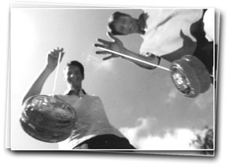
B
The yo-yo is one of the oldest and most popular of all toys. The Greeks were playing with yo-yos around 500 BC. It was a popular children's toy in the Philippines during the 16th century, and it was the toy to own in Britain in the early 19th century. Even the Prince of Wales had one!
The first American yo-yo company was started in 1928. The American yo-yos had a special feature. They could stop at the end of the string and spin（旋转） in one place before moving up again. This was called “sleeping”. It allowed the user to do tricks while the yo-yo was spinning. Soon yo-yo fans of all ages were doing tricks with names like “walk the dog”, “rock the baby” and “around the world”.
During the 1970s, yo-yo companies began making their yo-yos more interesting and exciting. Yo-yos lit up in the dark, they whistled, and they had funny shapes. In 1985, the yo-yo even went into space. It was taken on the space shuttle Discovery to see how it would perform in zero gravity（重力）. It would still spin, but without gravity to pull it down, it would not “sleep”.
Over the years, competitions and exhibitions have led more and more people to take ‘yo-yoing' seriously. In 1990, the first international yo-yo convention （大会） was held. In 1993, the American Yo-Yo Association was started. For serious yo-yo fans, there's even a National Yo-Yo Museum in Chico, California.
The best thing about yo-yos, though, is that you don't have to be a genius to figure them out. You just need to keep practising, and pretty soon you'll be spinning with the best of them.
56. Why is the yo-yo one of the oldest and most popular of all toys?
A. It was played around 500 BC.
B. Philippine children played with it during the 16th century.
C. The British have had it for over 200 years.
D. All of the above.
57. A special feature of the American yo-yos allows you to _________.
A. figure out how to use your yo-yo B. whistle with your yo-yo
C. go around the world with your yo-yo D. do tricks with your yo-yo
58. On the space shuttle Discovery, the yo-yo _________.
A. did not spin B. would spin but didn't “sleep”
C. could do lots of tricks D. could not be controlled at all
59. What has made more people interested in yo-yos?
A. The history of yo-yos.
B. The special features of yo-yos.
C. More yo-yo competitions and exhibitions.
D. The toys for the Royal family.
60. Which of the following is true?
A. American yo-yos could stop and spin at the end of the string.
B. The American Yo-Yo Association began in 1928.
C. The National Yo-Yo Museum is in the UK.
D. Without practice people can figure out how to use a yo-yo.
C
Movie listings for San Jose
November 7—November 13
Plaza Theatre
Children's Toys (2:00, 4:10, 6:20, 8:35, 10:55)
Revenge in Paris (1:30, 3:50, 6:05, 8:40, 11:00)
The Three Sisters (1:10, 3:05, 5:00, 7:00, 9:55)
Everybody's in Love (12:45, 3:00, 5:20, 7:40, 10:05)
Century 2000
Revenge in Paris (12:25, 2:50, 5:05, 7:30, 9:50, 12:05)
The Three Sisters (12:15, 2:10, 4:05, 6:10, 8:10, 10:10, 12:10)
Everybody's in Love (12:30, 2:50, 5:05, 7:25, 9:45, 12:00)
Daytime Nightmare (4:20, 6:35, 8:50, 10:55)
Movie City
Children's Toys (12:30, 2:45, 5:00, 7:15, 9:25)
The Three Sisters (1:00, 3:00, 5:00, 7:00, 9:00)
Everybody's in Love (12:45, 3:00, 5:15, 7:35, 9:50)
UA Blossom Hill
Revenge in Paris (12:00, 2:15, 4:50, 7:00, 9:10)
The Three Sisters (12:30, 2:35, 4:45, 6:50, 7:55, 10:00)
Everybody's in Love (12:00, 2:20, 4:45, 7:05, 9:25)
Note: —Afternoon shows start before 5:00 pm. Tickets are $5.00 each. Tickets for all other shows are $8.50 each.
—Movie snacks (like popcorn and candy) at the Plaza Theatre and Movie City are expensive. Snacks are cheap at the Century 2000 and UA Blossom Hill.
Karen and Steve want to see a movie. There are five movies now showing. Children's Toys and The Three Sisters are comedies. Revenge in Paris is an action movie. Everybody's in Love is a romance. Daytime Nightmare is a horror film.
Karen likes comedies and action movies. She sometimes sees romances. She doesn't like horror films. Steve loves action movies and horror movies. He sees comedies once in a while. He doesn't like romances.
Steve finishes work at 5:30. Karen will meet him at his office. First, they will have dinner. Then, they'll go to a movie. All of the theatres are near Steve's office, except the UA Blossom Hill. It's a 30-minute drive away.
61. The 7:30 pm movie _________ at _________ would be best for Steve and Karen.
62. The Plaza Theatre opens _________ than the other ones.
63. The UA Blossom Hill is _________ from Steve's office, but the snacks there are _________.
D
People often say that living with teenagers is worse than living with any other age group. Is this true? We talked to one parent with teenage children to find out.
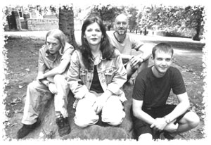
Marilyn Scott
Yes, sometimes it's really difficult living with teenagers. It isn't only their age, it's also the type of people they are. My two sons are completely different. Tom's easier to live with than Harry. Harry's a typical moody （情绪坏的） fifteen-year-old. He's a lot noisier and more aggressive（性格暴燥的） than Tom, and he isn't as considerate. So he's much harder to live with. But Harry's got his good side too. He's very bright and his exam results are always better than Tom's.
Tom's two years older than Harry, so he's more mature （成熟的） and less stubborn （倔强的） than his brother. He's also a bit more patient and can be very helpful when he wants to be. But he's got bigger problems at school. He's as intelligent （聪明的） as Harry, but he's much lazier and his exam results are always worse than his brother's. Harry wants to be a pilot when he leaves school, but Tom doesn't know what he wants to do.
In some ways I'm a bit more worried about Harry because he isn't as happy as Tom. But I also worry about Tom because he hasn't got any plans for his future. Yes, life is hard living with teenagers, but I'll miss them when they leave home.
64. According to Marilyn, what makes it difficult to live with teenage children?
65. Translate the underlined sentence into Chinese.
66. Tom's as _________ as Harry, but Harry gets _________ exam results than Tom.
67. What is Marilyn's worry about Harry?
E
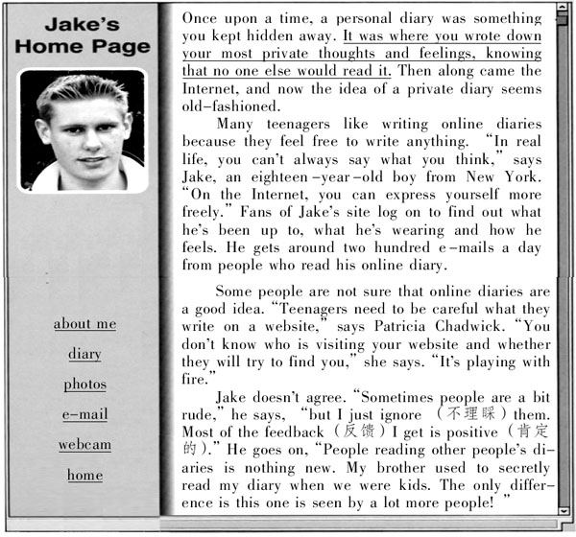
68. Translate the underlined sentence into Chinese.
69. Why are online diaries popular among teenagers?
70. What does Jake say when some people disagree with the idea of online diaries?
III. 完形填空（Cloze）（共20小题，计20分）
A) 根据文章内容及首字母提示用最恰当的词完成下文。（答案写在答题纸上）
Jackie Chan, possibly the biggest movie star in the world, is (71) f_________ for his action movies. In fact, Chan's movies are (72) m_________ than simple action movies—they are action-comedies. He started using comedy (73) e_________ in his career when he was preparing to be the next Bruce Lee. He (74) r_________ that his friendly face would stop him from being as tough as Lee, so he started to use comedy. However, Chan quickly found that using (75) h_________ was not so simple. His movie Rush Hour was a much bigger (76) s_________ in America and Europe than in Asia. Chan says this was (77) b_________ in different countries, people have different
(78) s_________ of humour. The humour in Rush Hour just didn't work with Asian audiences. “From that time, I knew that I would have to (79) m_________ two movies a year; one for the Asian market and one for the American market.” Everyone likes humour, but the humour everyone likes is (80) d_________!
B) 阅读短文，并用括号内所给动词的适当形式填空。（答案写在答题纸上）
On Friday afternoon we were getting ready to go to the pictures when the baby-sitter rang (81)_________ (say) that she would come at 6:30 instead of 6 pm. So when we got to the cinema the film (82)_________ (start) already. We (83)_________ (lead) to our seats by the usher in the dark. We (84)_________ (watch) the film for about half an hour when something (85)_________ (hit) me on the head. A little boy who (86)_________ (sit) two rows behind me said, “I am sorry, madam. I (87)_________ (do) it by accident. I (88)_________ (throw) an ice cream to the boy who (89)_________ (sit) in front of you. I thought he (90)_________ (catch) it.”
IV. 句式转换 （Sentence pattern transformation） （共10小题，计10分）
A) 按要求转换下列句式，每空词数不限。（答案写在答题纸上）
91. We did nothing before the doctor arrived. （用not... until改写）
We __________________ until the doctor arrived.
92. “Have you lost weight?” asked David. （改为宾语从句）
David asked me if I __________________.
93. We give girls the same opportunities as boys in this school. （改为被动语态的疑问句）
__________________ the same opportunities as boys in this school?
94. Can I leave my backpack in the car? （改为否定句）
You __________________ your backpack in the car.
95. She felt very embarrassed when she tripped over. （改为感叹句）
__________________ moment it was when she tripped over!
B) 根据上句完成下句，使两句表达的意思基本相同，每空一词。（答案写在答题纸上）
96. Denzil and his father are very similar in appearance.
Denzil _________ _________ his father.
97. She can't wait to start her new job.
She's _________ _________ to starting her new job.
98. Make sure you're quiet if you get home late.
Don't _________ any _________ if you get home late.
99. Can you ask somebody for his home telephone number?
Can you _________ _________ his home telephone number?
100. We can't travel abroad without taking a passport.
To travel abroad we _________ _________ take a passport.
V. 翻译（Translation） （共5小题，计10分）
根据英文提示把下列句子译成英语。（答案写在答题纸上）
101. 我认为不应该允许十六岁的孩子驾车。（allow）
102. 她儿时上过六所不同的学校。（as; send）
103. 一般美国人会与他们的家人一起过圣诞节。（spend）
104. 如果你用这种方法做，肯定能成功。（be sure）
105. 杰克太累了以致不能和我们一起去参加晚会了。（come along with）
VI. 智力测试（IQ） （共5小题，计5分）
完成下列英语智力题。（答案写在答题纸上）
106. In the sentence there is a word of four letters hidden between words that are next to each other. Find this four letter word.
Example: Scientific paper books. sand
The winter ice covers the pond. _________
107. In each of the following questions you must change one letter in the top word to make a new word. By changing a different letter in this new word it is possible to make the bottom one, which is given.
Example:


108. The number codes for three of the following four words are given below. These codes are not written in the same order as the words, and one of the codes is missing.
FOAL COLT CALF LAST
5384 8371 5681
Work out the correct code for each word and answer the following questions.
① What word has the number code 8634? ( )
② What is the code for the word COLT? ( )
109. What is the five-letter word in English whose pronunciation isn't changed by removing four of its letters?
110. The words below can be put into the puzzle.
Which word should be in the shaded part?
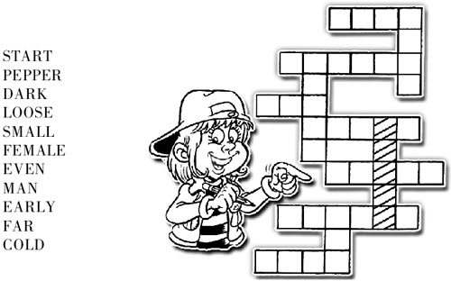
VII. 写作（Writing） （共2小题，计25分，其中A题10分，B题15分）
要求：1. 根据所提供的内容，适当拓展想象空间，将所提供的信息灵活地体现在文章中； 2. 条理清楚，语句通顺，标点正确，书写清晰、规范； 3. 不得少于规定的词数。所给出的文字部分不计入总词数。（答案写在答题纸上）
A) Read the advertisement, and then use the notes to write a letter to Kraftwerk Tours asking for information about the trip. (50-70 words)
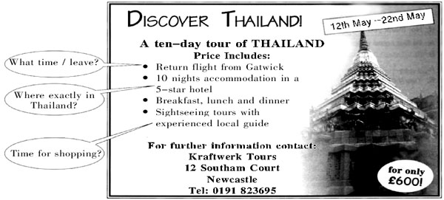
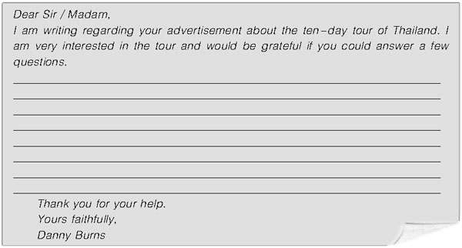
B) You've been asked to write an article for your school magazine about the advantages and disadvantages of being either a teacher or a doctor. In your writing you need to write about either being a teacher or a doctor, not both. Write your article using the ideas below. (80-100 words)
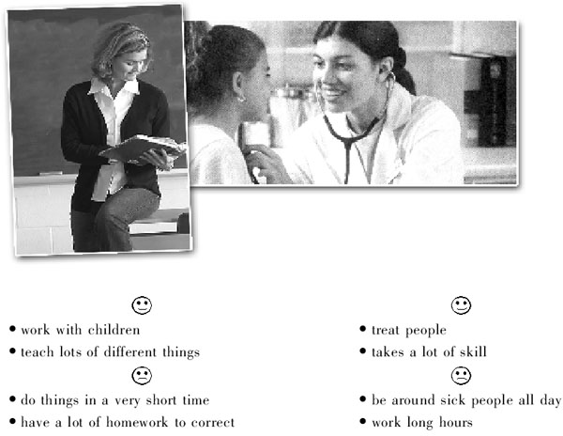

2006年全国中学生英语能力竞赛(NEPCS)决赛初三年级组试题答案

听力部分（共四大题，计30分）
I． 听辨单词（Words）
1—5 ADCBD
II． 句子理解（Sentences）
6—10 CABDB
III． 对话理解（Dialogues）
A) 11—15 DDBAC B) 16—20 ADCBA
IV． 短文理解（Passages）
A) 21—25 BCDCA
B) 26. feed / give food to 27. frightened 28. car windows 29. rubbish bags 30. noise
笔试部分（共七大题，计120分）
I. 选择填空（Vocabulary and structure）
31—35 DBBAC 36—40 BDCCA 41—45 ACBCB 46—50 DCCBC
II． 阅读理解（Reading comprehension）
51—55 ACADA 56—60 DDBCA
61. Revenge in Paris; Century 2000
62. later
63. far; cheap
64. Not only their age but what type of people they are.
65. 他也比较有耐心，而且在他想要帮助别人时也的确能帮上忙。
66. intelligent / clever / bright; better
67. He isn't as happy as Tom.
68. 日记是你写下你最私密的想法和感觉的地方，你知道没人会读到它。
69. Because they feel free to write anything they like online.
70. He doesn't think it is a big deal for other people to read his online diary.
III. 完形填空（Cloze）
A) 71. famous 72. more 73. early 74. realized / realised 75. humo(u)r 76. success 77. because 78. senses 79. make 80. different
B) 81. to say 82. had started 83. were led 84. had been watching / had watched 85. hit 86. was sitting / sat 87. did 88. threw 89. is sitting 90. would catch
IV. 句式转换（Sentence pattern transformation）
A) 91. didn't do anything 92. had lost weight 93. Are girls given 94. can't leave 95. What an embarrassing
B) 96. looks like 97. looking forward 98. make; noise 99. find out 100. have / need to
V. 翻译（Translation）
101. I don't think sixteen-year-olds should be allowed to drive.
102. As a child she has been sent to six different schools.
103. In general, Americans spend Christmas with their families.
104. You are sure to succeed if you do it this way.
105. Jack was too tired to come along with us to the party.
VI. 智力测试（IQ）
106. rice 107. ① MILK ② SOME 108. ① LOAF ② 5681 109. Queue. 110. SMALL
VII. 写作（Writing）
A) One possible version:
Dear Sir / Madam,
I am writing regarding your advertisement about the ten-day tour of Thailand. I am very interested in the tour and would be grateful if you could answer a few questions.
Your advertisement states that the price includes a return flight from Gatwick. What time does the flight leave?
The advertisement also mentions that the price includes 10 nights accommodation in a five-star hotel. Where exactly in Thailand is the hotel?
Finally, the advertisement mentions that there will be sightseeing tours of Thailand. Will there also be time to go shopping?
Thank you for your help.
Yours faithfully,
Danny Burns
B) Possible versions:
a) Have you ever considered becoming a teacher? There are many advantages and disadvantages to doing this kind of job.
One of the main advantages to being a teacher is that it is rewarding because you work with children. Besides, it is exciting as you will teach lots of different things.
Nevertheless, a teacher's job can be difficult sometimes. First of all, it can be stressful because you have to do things in a very short time. Moreover, it is tiring because you have a lot of homework to correct.
All things considered, I think becoming a teacher is a good idea.
b) Have you ever considered becoming a doctor? There are many advantages and disadvantages to doing this kind of job.
One of the main advantages of being a doctor is that it is rewarding as you treat people. Besides, it is well paid because the job takes a lot of skill.
Nevertheless, a doctor's job can be very difficult sometimes. First of all, it can be depressing because you have to be around sick people all day. Moreover, it is a stressful job as you have to work long hours.
All things considered, I think becoming a doctor is a good idea as long as you know the disadvantages.
一、 评分原则：
1． 本题总分为: A） 10分； B） 15分。按四个档次给分。
2． 评分时，先根据文章的内容和语言初步确定其所属档次，然后以该档次的要求来衡量，确定或调整本档次，最后给分。
3． 作文词数少于50或多于100的， 从总分中减去2分。
4． 如书写较差，以致影响交流，将分数降低一个档次。
二、 各档次的给分范围和要求：
第四档（很好）：A） 9—10分； B） 12—15分
完全完成了试题规定的要求，覆盖所有内容要点，符合英语表达习惯, 应用了较多的语法结构和词汇，没有语法和词汇错误，具备较强的语言运用能力，完全达到了预期的写作目的。
第三档（好）：A） 6—8分； B） 9—11分
完成了试题规定的要求，应用的语法结构和词汇能满足题目的要求，符合英语表达习惯, 基本没有语法和词汇错误，达到了预期的写作目的。
第二档（一般）：A） 4—5分； B） 5—8分
未恰当完成试题规定的要求，漏掉内容要点，未描述清楚主要内容，写了一些无关内容，有语法和词汇错误，影响了对写作内容的理解，信息未能清楚地传达给读者。
第一档（差）：A） 1—3分； B） 1—4分
未完成试题规定的要求，明显遗漏主要内容，写了一些无关内容，语法结构单调，词汇项目有限，有较多语法和词汇错误，影响对写作内容的理解，信息未能传达给读者。
0分
未能传达给读者任何信息：没有内容或内容太少，无法评判，写的内容均与所要求内容无关或所写内容无法看清。
2006年全国中学生英语能力竞赛(NEPCS)决赛初三年级组试题听力部分录音原文
Part I. Words
Choose the word which you hear in the sentence. Each sentence will be read only once.
1. I heard Tom had an accident yesterday and hurt his leg.
2. I tried to cheer him up because he was feeling down.
3. She was very surprised and didn't know what to say.
4. The local people are always welcoming to foreign visitors.
5. Could you get some more of those biscuits in the supermarket?
Part II. Sentences
Choose the sentence which has the same or a similar meaning as the sentence you hear. Each sentence will be read only once.
6. John is a student, so a major part of his day is spent in class.
7. Sue's job gives her lots of stress, so she finds it difficult to relax.
8. My old jeans don't fit anymore because I'm bigger than I used to be.
9. Our peaceful evening was invaded by the noise of a party next door.
10. Leo was embarrassed because he hadn't brought enough money to pay for the dinner.
Part III. Dialogues
A) You will hear five mini-dialogues. There is one question for each dialogue. Look at the following five groups of pictures. Choose the best one to answer each question. The dialogues and questions will be read twice.
11. W: I'll have a cup of coffee, please.
M: Would you like a slice of cake with it? Our cook has just made a very nice chocolate one.
W: I'd prefer some bread, if you've got some.
M: Certainly. I won't be a moment.
Question: What will the woman eat with her coffee?
12. W: I've bought this postcard to send to Tony. Do you have a stamp?
M: Sorry, I haven't got any left. Let me have the card and I'll post it later.
W: OK. Just let me write her address. Can I use your pen?
M: Here you are.
Question: What will the woman give the man?
13. M: Can I help you?
W: Yes, I want these white sports socks. I know they're usually ￡5 but are they half price in the sale?
M: ￡2.50, you mean? No, they are cheaper this week, but the sale price is ￡3.99.
Question: How much do the woman's sports socks cost?
14. M: You are coming to my party tomorrow, aren't you Joy?
W: I hope so, but I have to play in a concert at seven and it won't end until about half past nine.
M: That's all right. Everybody's coming at nine o'clock so you'll only be half an hour late.
W: Oh good. I'll see you then.
Question: What time will the party start?
15. M: Mum, it's Jack. I won't be home until seven, I'm afraid. I'm on the bus now.
W: Were you playing football with your friends after school again? You've got lots of homework to do.
M: I know. That's what I was doing, at Peter's house.
W: OK. Well, there's no traffic, so the bus should be quick.
Question: Why is Jack late?
B) You will hear a dialogue. Choose the best answer to each question. The dialogue will be read twice.
Boy: Summer vacation is finally here!
Girl: This was the hardest school year ever. So, what are you doing this summer?
Boy: Not too much. I plan to spend a lot of time with my new computer. I just got some new games. I'm also making a webpage. How about you?
Girl: My parents want me to take more cello lessons.
Boy: Do you want to?
Girl: I guess so. Besides, my dad says that if I go to every lesson, he'll take me to a Yo Yo Ma concert.
Boy: Who?
Girl: You don't know who Yo Yo Ma is? He's the best cello player in the world!
Boy: Hey, sorry, I don't listen to classical music. So, what else are you going to do?
Girl: My family always goes somewhere in July. This year, we may go to Spain.
Boy: Really? We're thinking about going to Europe, too. Maybe I'll see you there.
Part IV. Passages
A) You will hear a telephone message. Choose the best answer to each question. The message will be read twice.
This is a message for Marco Daniele. My name's David Dolby. I'm sorry I missed your call. I understand that you want some information about the volleyball club. The club meets once a week, on Wednesday evening. There are sometimes matches on Sunday morning, but those are just for our team players. Our meetings begin at a quarter to eight, and are about two and a quarter hours long, so we finish at ten. People like to get home in time for the 10:15 sports programme on television. We meet in the Jubilee Hall in Park Lane, behind the High Street. The hall doesn't have very good heating so you'll need to bring a sweater to put on afterwards. It's also quite expensive to rent, so our players pay ￡2.75 each week. I hope this answers all your questions and we'll be very pleased to see you at our next meeting!
B) You will hear a passage. Complete each blank according to passage you hear. The passage will be read twice.
Park Keeper: Now, ladies and gentlemen, just a few safety regulations before you drive off. The most important one is, stay in your car at all times. Otherwise you might end up as fast food; and you mustn't feed the animals; sometimes the zebras come close if they see you eating, but they don't need any more food, believe me! Never use flash photography, not even with koala bears hidden in the trees; they might be frightened. Also, you should keep your car windows closed; animals can be very curious! Last week, a monkey jumped into a car and the people were bitten. You are allowed to eat and drink in your cars, of course, but please remember that every car has been given rubbish bags. So throw any rubbish in there and not out of the window. And finally, please, don't make too much noise. If you listen, you will hear beautiful sounds, the animals, the water, the wind in the trees. And now ... [fade]

声明：本资料由 考试吧（Exam8.com） 收集整理，转载请注明出自 http://www.exam8.com
服务：面向较高学历人群，提供计算机类，外语类，学历类，资格类，会计类，工程类，医学类等七大类考试的全套考试信息服务及考前培训.

