2006年全国中学生英语能力竞赛(NEPCS)决赛初二年级组试题

（总分：150分 答题时间：120分钟）
听力部分（共四大题，计30分）
I. 听辨单词 (Words) （共5小题，计5分）
听句子，选出句子中出现的单词。每个句子只读一遍。（答案涂在答题纸上）
1. A. taught B. bought C. thought D. brought
2. A. sleeping B. skiing C. swimming D. skating
3. A. older B. warmer C. cooler D. colder
4. A. headache B. toothache C. backache D. stomachache
5. A. excuse B. exercise C. exam D. example
II. 句子理解 (Sentences) （共5小题，计5分）
听句子，选择与所听句子意思相同或最相近的选项。每个句子只读一遍。（答案涂在答题纸上）
6. A. Jerry paid twenty dollars for a meal just now.
B. That book cost Jerry twenty dollars just now.
C. It took Jerry twenty minutes to walk home.
D. Jerry spent much time playing computer games.
7. A. The radio says today is as hot as yesterday.
B. The man likes drinking hot water every day.
C. It was hot yesterday, but it is much hotter today.
D. It is hot today, but yesterday was even hotter.
8. A. Some of the workers in that city don't go to work by bus.
B. In that city, some of the workers don't go home by train.
C. None of the workers in that city go to work by bus.
D. All the workers in that city go to work by bus.
9. A. On Saturday morning, Nick often goes to bed late.
B. On Sunday morning, Nick often gets up late.
C. Nick likes to watch TV on Saturday morning.
D. Nick has to do his homework on Sunday evening.
10. A. Larry ate a hamburger and some chicken for breakfast.
B. Sandwiches and hamburgers are Larry's favourite food.
C. At first, Larry wanted a hamburger, but not French fries.
D. Larry asked for a hamburger and French fries.
III. 对话理解 (Dialogues) （共10小题，计10分）
A) 听五组小对话和对话后的问题，选择描述正确的图片回答问题。每组对话和问题读两遍。（答案涂在答题纸上）
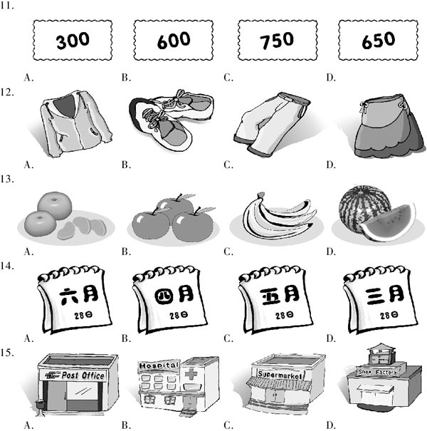
B) 听一组长对话，根据其内容选择最佳选项回答下列问题。对话读两遍。（答案涂在答题纸上）
16. Where did the woman lose her bag?
A. On the bus. B. In the town centre.
C. At home. D. In her office.
17. How much money was in the bag?
A. About ￡40. B. About ￡50. C. About ￡20. D. About ￡60.
18. What else was in the bag?
A. A mobile phone. B. A watch. C. An MP3 player. D. A car key.
19. What time did the woman lose her bag?
A. At about 9:30. B. At about 12:00. C. At about 10:00. D. At about 11:30.
20. What is the woman's phone number?
A. 3625091. B. 3602951. C. 6320591. D. 6302195.
IV. 短文理解(Passages)（共10小题，计10分）
A) 听短文，根据其内容选择最佳选项完成下列各题。短文读两遍。（答案涂在答题纸上）
21. How old is Joe Hyden?
A. Sixteen. B. Twelve. C. Fourteen. D. Two.
22. What does Michael like playing?
A. The guitar. B. The drums. C. The piano. D. The violin.
23. Whom does Joe Hyden get on well with?
A. Jacob. B. Naomi. C. David. D. Sam.
24. When are Joe, Michael and David at home?
A. During the holidays. B. Every day.
C. In the daytime. D. At night.
25. What does Joe dislike about a big family?
A. Going to school. B. Being in some place by himself.
C. Playing football with his brothers. D. Little kids are always around him.
B) 非选择题：听短文，根据其内容完成下面的表格。短文读两遍。（答案写在答题纸上）
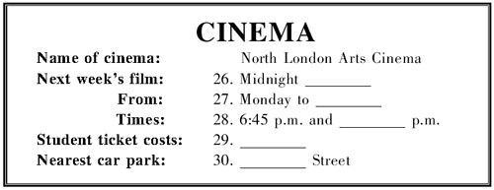
笔试部分（共七大题，计120分）
I. 选择填空 (Vocabulary and structure) (共20小题，计20分)
A) 选择能够替换划线部分的最佳选项。（答案涂在答题纸上）
31. The boys in that school are better at playing football than basketball.
A. had better B. work harder at
C. do better in D. are more interested
32. Tim's father is really kind of busy these days.
A. a little B. little C. much D. more
33. The dish tastes good, but the smell is awful.
A. delicious B. very bad C. popular D. better
34. What's your view of the question?
A. opinion B. look C. means D. way
35. —What time is it?
—It's around five o'clock.
A. over B. after C. under D. about
B) 选出下列各题的最佳选项。（答案涂在答题纸上）
36. Who drives ________, your sister or your brother?
A. the most carefully B. more carefully
C. the most careful D. more careful
37. —How are you going to the railway station to meet your father ________ Sunday morning?
—I'm going there ________ my car.
A. on; in B. in; by C. in; in D. on; by
38. Sandy didn't have ________ money for a bus ticket, ________ she had to walk home in the rain.
A. many; and B. much; because C. any; so D. some; but
39. —What ________ can you see in the picture?
—Some flowers and trees.
A. something B. other C. the other D. else
40. They never told us anything about their plan, so we didn't know why ________.
A. they go there B. do they help you
C. they bought the bike D. did they live there
41. —What ________ sunny day it is!Let's go and visit ________ Browns, shall we?
—OK.
A. a; / B. / ; the C. a; the D. the; a
42. If she ________ New York this afternoon, I ________ New York, too.
A. goes to; go to B. leaves for; will leave for
C. will visit; visit D. will come to; will come to
43. —________ does Hector's uncle go to Moscow on business?
—Never.
A. How often B. How long C. How far D. How soon
44. —Which of the two MP4 players are you going to buy?
—I'll buy ________ of them, so I can give one to my friend.
A. all B. both C. none D. everyone
45. It's too hot. Would you mind ________ the window?
A. to close B. closed C. opening D. open
C) 情景会话。（答案涂在答题纸上）
46. —I'm going shopping. ________?
—No, I have enough food for one week, but could you please buy me some drinks?
—No problem.
A. What about going to the theatre with me
B. Why not buy some drinks
C. Do you need any food from the supermarket
D. Can you help me look after my baby
47. —Oh, no!________!
—But you used it just now to take a photo of the park.
—Oh I remember, I put it down on the steps when I put my coat on.
A. What a nice watch B. How well your camera works
C. I can't find my camera D. Let's take photos here
48. —Hello. May I speak to Tony?
—Hello. ________. He will answer you in a second.
—Thank you.
A. Hold on, please B. Sorry, you have the wrong number
C. I'm sure you can do well D. We don't have Tony here
49. —I'm going to see Betty in hospital, but I don't know what to bring her.
—What about some beautiful flowers?
—________. It's better than sweets.
A. You can take her something to eat B. Sounds like a good idea
C. I'd better not take them D. Just take some sweets
50. —You will play the guitar at a concert in London!Will you sing, too?
—Yes, I will sing an English song.
—________?
—It's the most exciting city I know.
A. How do you like my guitar B. What do you think of London
C. What do you like about the concert D. Would you like to play the guitar
II. 阅读理解(Reading comprehension)（共20小题，计30分；51—60小题每题1分，61—70小题每题2分）
A
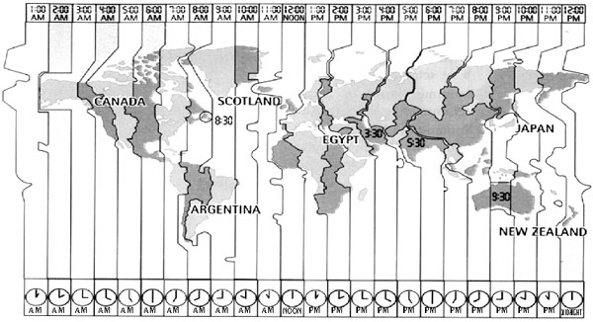
Canada 4:00 a.m. to 8:00 a.m.
Canada is a big country with six time zones. In the west, it is four a.m., and everyone is asleep, but in Halifax on the east coast it is eight o'clock and people are having breakfast. It is a cold Friday morning in November, and the temperature is ten degrees below zero Centigrade.
Argentina 9:00 a.m.
In Buenos Aires, the capital of Argentina, it is nine a.m. on a warm summer morning, and people are starting work or school. November is a summer month in Argentina because it is in the southern hemisphere（南半球）.
Scotland 12:00 noon
Scotland is part of the United Kingdom. The capital of Scotland is Edinburgh, and the capital of the UK is London. It is twelve noon, or midday, in Edinburgh. Children are having lessons, but they are looking forward to the weekend because there is no school on Saturday and Sunday.
Egypt 2:00 p.m.
Friday is already the weekend in Egypt. Friday is a special day for Muslims, so schools, offices and shops are closed in all Arab countries. So now, at two p.m., most people in Egypt are having lunch with their families.
Japan 9:00 p.m.
Japan is seven hours ahead of Egypt, so it is already Friday evening there. The weekend is beginning. Most people are out with friends or watching television or playing computer games.
New Zealand 12:00 midnight
It is late on Friday night, so most people are asleep. Now Saturday morning is arriving. It is morning in Canada too, but that is Friday morning!
阅读短文，根据其内容选择最佳答案完成下列各题。（答案涂在答题纸上）
51. In eastern Canada, the time is ________ that in western Canada.
A. four and a half hours behind B. four hours ahead of
C. three hours ahead of D. the same as
52. While Canadian children in Halifax are having breakfast, Argentinean children are ________.
A. sleeping B. going home C. at school D. having supper
53 It's midday in the capital of ________ when it's 9:00 a.m. in the capital of Argentina.
A. Japan B. Canada C. New Zealand D. Scotland
54. Two p.m. in Egypt is not a good time to telephone people in New Zealand, because in New Zealand ________.
A. it's midnight and most people are asleep
B. it's noon and many people are having lunch
C. it's the morning and many people are working
D. it's the afternoon and most people are playing computer games
55. What time is it in New Zealand if it's 11:15 p.m. in Japan?
A. 1:15 p.m. B. 2:15 p.m. C. 1:15 a.m. D. 2:15 a.m.
B
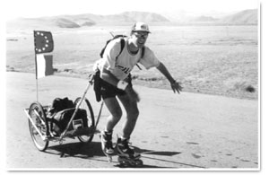
The first person to skate solo around the world, Fabrice Gropaiz of France, began his journey in San Francisco three years ago. Since then, he has skated more than 30,000 kilometres through thirty-three countries.
He skated across the USA and northern Mexico from west to east, then across Europe, Russia, Mongolia, China and Australia before flying across the Pacific Ocean to San Francisco again.
In all the big cities, television and newspaper reporters interviewed him.
He travelled with fifteen kilogrammes of equipment, which he pulled behind him on a homemade trailer. His equipment included a tent, a change of clothes and a video camera.
A friend, David Lai, made a web site (www.worldskate.com), and Fabrice sent regular news to the site. He wrote in English so that people all over the world could understand. Thousands of people sent emails to Fabrice during his journey. People saw him on television and read about him, and many readers and listeners offered to help him. Fabrice asked them to send money to a medical research organisation. In this way, he raised a lot of money for important medical research.
Between stops, he travelled 100 kilometres on good days. But there were also bad days and problems: bad weather, broken skates, dangerous drivers, snakes on the roads in Mexico, and a wolf attack in Mongolia. However, none of these problems stopped him, and he wants to do another trip.
阅读短文，根据其内容选择最佳答案完成下列各题。 （答案涂在答题纸上）
56. What does the word “solo” in the first sentence, paragraph one mean?
A. 认真地 B. 独自地 C. 高兴地 D. 紧张地
57. Where did Fabrice begin his skating around the world?
A. In Mexico. B. In Mongolia. C. In San Francisco. D. In Russia.
58. What didn't Fabrice bring on his trailer?
A. A tent. B. Clothes. C. A video camera. D. A mobile phone.
59. In what language did Fabrice give information to the web site?
A. French. B. Spanish. C. Russian. D. English.
60. Which of the following is TRUE according to the passage?
A. Fabrice skated across four continents （大陆） during his journey.
B. It took Fabrice four years to skate through thirty-three countries.
C. Fabrice travelled 100 kilometres in bad weather.
D. Fabrice got no money from his readers and listeners for medical research.
C
In 2003, 14-year-old Jenna spoke to a journalist about moving to Spain.
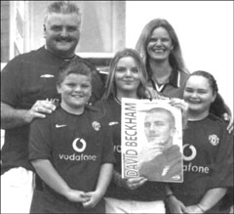
“I've only been a Beckham fan for a few years but my dad always loved seeing him play at Manchester United. It took him ten hours to get there by car from Cornwall! Mum also follows Becks now. When she and I heard he was leaving to play in Spain, I said,‘Let's move to Spain!’(61)Dad agreed to come but my elder brother decided to stay in England. He's still living in our house there.
At first we didn't know if Becks would play for Barcelona or Madrid, so my parents bought a place in Alicante. It's only about three hours away from both cities. Our new home has three bedrooms and two bathrooms on one floor, and there's a flat with another two bedrooms and bathrooms under that. There's a pool, too.
My friends in England will come and visit for my birthday in February. They think I'm a bit mad but they're pleased for me too. (62) It's great to live in another country and learn a new language, but I'm finding Spanish quite difficult. I learned French in England and I keep mixing the two. It'll be easier when I start at my new school.
Becks is playing up really well in Spain, which keeps my dad happy!What I love most about him is that he's a big family man. Being famous hasn't changed him. I'm having a great time in Spain and I'd really like to meet Becks one day.”
A）将文中划线的61、62小题的两处句子分别翻译成汉语。（答案写在答题纸上）
B）根据短文内容回答下列问题。（答案写在答题纸上）
63. Who had the idea of moving to Spain?
64. Why did Jenna's family buy a new house in Alicante at first?
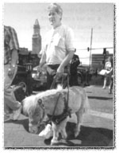
D
Dan Shaw is blind. When he walks down the street, people stare at him. They look at him because he has Cuddles. Cuddles is his guide horse. She is a miniature horse. In fact, Cuddles is only 26 inches high!
Sometimes, blind people have guide dogs to help them. However, some blind people don't like dogs. They may be afraid of dogs. They may be allergic（对……过敏） to dogs. Now, they can have guide horses instead.
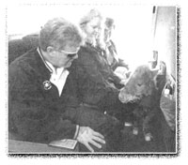
Dan Shaw was the first person to have a guide horse. Cuddles helps him a lot. Guide horses are very small, but they are very strong. One day, Dan and Cuddles were on a busy street. Suddenly, a bicycle came towards them. Cuddles used her strong body. She pushed Dan out of the way. The horses have good memories, too. Cuddles can remember how to go to different places with Dan, such as the grocery store or the post office.
Miniature horses live a long time. Some miniature horses live for about 40 years. Most dogs only live for about 15 years. Guide horses do not have to live inside, like dogs do. They can live outside, but they need a home with a big backyard. This is because they eat a lot of grass.
Many blind people want guide horses like Cuddles. Right now, there are only a few, but soon, there will be more.
阅读短文，根据其内容回答下列问题。（答案写在答题纸上）
65. What helps Dan Shaw cross the street?
66. What advantages （长处） does Cuddles have?
67. Why do the guide horses need a home with a big backyard?
E
“I'll have cucumber sandwiches, crumpets, scones with jam and cream, a slice of Dundee cake and a pot of Earl Grey tea, please. But no sugar—I'm on a diet.” Many people say such things in English tea shops.
In England, tea is not just a drink, it's a meal as well. In some homes it's the last meal of the day, although for many people it's a light meal between lunch and dinner. But most working people don't have time for a proper tea.
Most tea shops serve tea between three and five in the afternoon, although the most popular time is around four o'clock. So an English tea is great for people on holiday who have the time to enjoy it. Why not try a typical English tea in Oxford? After a long day visiting the romantic city, here are some tea shops to visit.
The Randolph Hotel in Beaumont Street is in the very centre of the city. It's a fine Victorian building and offers the best traditions of English teatime, with piano music in the background.
The Nosebag in St Michael's Street is popular with university students. Excellent homemade cakes and a good choice of teas are available （可得到的） but go early as there are always long queues.
The Wykeham Coffee Shop in Holywell Street is a small tea shop opposite New College, and is popular with tourists and students.
George's Café in the Covered Market is popular with market workers and shoppers.
Queen's Lane Coffee House on the High Street is one of the oldest restaurants in Oxford, and despite its name, serves excellent teas, and also has a choice of newspapers.
阅读短文，根据其内容完成下列各句，每空不得超过5个词。（答案写在答题纸上）
68. This passage is about teatime and ________ in Oxford, England.
69. In addition to （除了） drinking tea, people can listen to ________ in the Randolph Hotel and eat ________ in the Nosebag.
70. Two tea shops are very popular with students. One is the Nosebag, and the other is ________.
III. 完形填空(Cloze)(共20小题，计20分)
A) 阅读短文，根据其内容从方框中挑选合适的动词，并用其适当形式填空完成短文。每个词只能使用一次。（答案写在答题纸上）
know, act, write, have, be, live, finish, work, do, marry
He was born in 1564 in Stratfordon-Avon. He was the son of a Stratford businessman. He went to the local grammar school. In 1582 he (71)________ Anne Hathaway. They (72)________ three children. We (73)________ that he left Stratford in about 1585, but no one knows where he went or what he (74)________ for the next five years. In September 1592 we know that he lived and (75)________ in London as a playwright （剧作家） and as an actor at the Globe Theatre. He was not on the actor-list after 1603 so he probably stopped (76)________ at this time because he was already famous for his (77)________.
He wrote his first play, Henry VI, in 1590-1591. He also wrote a large number of poems. He (78)________ his last play, The Tempest, in 1612. After that, he left London and went back
(79)________ in Stratford. He died in 1616. His plays (80)________ very successful today.
Many people think he was the greatest English writer of all time. His name was William Shakespeare.
B) 阅读下面的电子邮件，根据其上下文和首字母提示，在文中空白处填入适当的单词补全电子邮件。每空一词。（答案写在答题纸上）
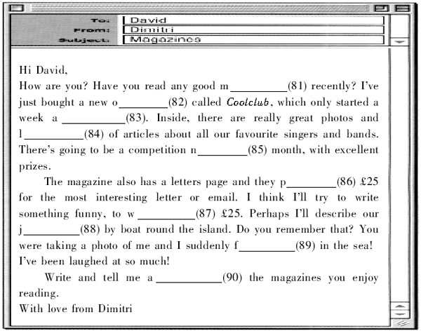
IV. 句式转换 (Sentence pattern transformation)（共10小题，计10分）
A) 按要求转换下列各句。每空一词。（答案写在答题纸上）
91. They would like to drink three glasses of milk. （对划线部分提问）
________ ________ milk would they like to drink?
92. The little girl saw something to eat on the table. （改为否定句）
The little girl ________ ________ to eat on the table.
93. Mr Green likes Chinese food very much. （对划线部分提问）
________ ________ Mr Green like Chinese food?
94. His sister was a worker last year. （用a businesswoman改为选择疑问句）
________ his sister a worker ________ a businesswoman last year?
95. There isn't much food in the fridge. （改为反意疑问句）
There isn't much food in the fridge, ________ ________?
B) 根据上句改写下句，使两句意思相同或相近。每空一词。（答案写在答题纸上）
96. What a nice girl she is!
________ ________ the girl is!
97. There are no differences between the two DVDs.
This DVD is ________ ________ as that one.
98. Why don't you ask your brother for help?
________ ________ asking your brother for help?
99. She doesn't know how she can get to the shopping centre.
She doesn't know ________ ________ get to the shopping centre.
100. My aunt takes the bus to work every day.
My aunt goes to work ________ ________ every day.
V. 翻译(Translation)（共5小题，计10分）
根据所给提示词，将下列汉语句子翻译成英语。（答案写在答题纸上）
101. 我想睡觉，你能将电视的音量调小些吗？（turn down）
102. 上个月末，他们观看了一场有关海豚的电影。（film about...）
103. 我不想去钓鱼，因为那听起来真的很无聊。（sound）
104. 昨天晚上他不得不在家照看小妹妹，因为父母都不在家。（have to; look after）
105. 玛丽比吉姆聪明，但吉姆比玛丽有趣多了。（smart; funny）
VI. 智力测试(IQ)（共5小题，计5分）
按要求完成下列各题。（答案写在答题纸上）
106. Jack is twice as old as Jill, but in five years time he will only be one and a half times as old as Jill. How old are Jack and Jill now?
107.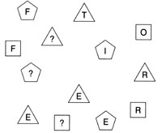
If there are three numbers hidden （隐藏的） in this picture, what letters should replace （代替） the question marks（问号）?
108.Can you pick up the pins（大头针） one by one without disturbing （弄乱） the others?
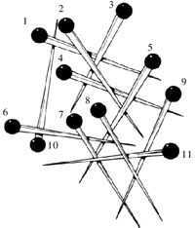
________→________→________→________→________
→________→________→________→________→
________→________
109. Find the job hidden in each sentence.
e.g. You have to correcror carefully. teacher
1. You hit my car!The dent is there for all to see! __________
2. The area is full of beautiful lakes and rivers. __________
110. Jack plays computer games every day and he never works hard at his lessons, so it is out of the question for him to pass the end-of-term examination. What does “out of the question” mean here? You may answer it in Chinese or in English.
VII. 写作(Writing)（共2小题，计25分。A篇为10分，B篇为15分）
A) 根据图片及文字提示编写一段短文。（作文写在答题纸上）
要求：1. 将文字以及图片中的信息体现在短文中；
2. 行文流畅，语法正确，单词拼写规范正确；
3. 词数不少于60。
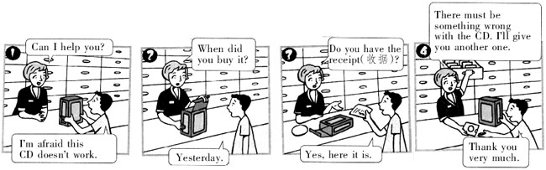
B) 阅读下面一段叙述，针对其中提出的问题写出你的看法。（作文写在答题纸上）
Some students think that exam scores（考试分数） should be something private （私人的） and they don't want others to know them. They think their teachers should not show them to others.
要求：1. 条理清楚，观点鲜明；
2. 用词得当，语法正确，书写规范；
3. 词数：80—100。

2006年全国中学生英语能力竞赛(NEPCS)决赛初二年级组试题参考答案

听力部分（共四大题，计30分）
I． 听辨单词 (Words)
1—5 DCADB
II. 句子理解 (Sentences)
6—10 BDABD
III. 对话理解 (Dialogues)
A) 11—15 CBDAB B) 16—20 BCDCA
IV． 短文理解（Passages）
A) 21—25 BACAD
B) 26. Meeting 27. Thursday 28. 9:15 / a quarter past nine / fifteen past nine / nine fifteen 29. ￡2 / two pounds 30. Hauxton
笔试部分（共七大题，计120分）
I. 选择填空(Vocabulary and structure)
A) 31—35 CABAD
B) 36—40 BACDC 41—45 CBABC
C) 46—50 CCABB
II． 阅读理解(Reading comprehension)
A) 51—55 BCDAD B) 56—60 BCDDA
C) 61. 爸爸同意来西班牙，但是哥哥决定留在英格兰。他现在仍然住在我们在那儿的房子里。
62. 生活在另一个国家和学习一种新的语言都是很棒的事，但我现在发现西班牙语很难学。
63. Jenna.
64. Because they didn't know if Becks would play for Barcelona or Madrid (and it's not far away from Barcelona or Madrid).
D) 65. A guide horse. / Cuddles.
66. A strong body and a good memory.
67. Because they eat a lot of grass.
E) 68. tea shops
69. piano music; homemade cakes
70. the Wykeham Coffee Shop
III. 完形填空(Cloze)
A) 71. married 72. had 73. know 74. did 75. worked 76. acting 77. writing 78. finished 79. to live 80. are
B) 81. magazines 82. one 83. ago 84. lots 85. next 86. pay 87. win 88. journey 89. fell 90. about
IV. 句式转换 (Sentence pattern transformation)
A) 91. How much 92. saw nothing 93. How does 94. Was; or 95. is there
B) 96. How nice 97. the same 98. What / How about 99. how to 100. by bus
V. 翻译(Translation)
A) 101． I want to sleep. Could you please turn down the TV?
102． They watched a film about dolphins at the end of last month.
103． I don't want to go fishing because that sounds really boring.
104． He had to look after his little sister at home last night because his parents were out.
105． Mary is smarter than Jim, but Jim is much funnier than Mary.
VI. 智力测试(IQ)
106. Jack is ten and Jill is five.
107. V, H and U. (The three numbers are three, four and five.)
108. 8, 11, 9, 7, 6, 5, 2, 4, 3, 1, 10
109. dentist, driver
110. impossible / 不可能的
VII. 写作(Writing)
A) One possible version:
Adam bought a CD yesterday, but the CD didn't work. The next day he took it to the shop and told the shop assistant about it. After he answered some questions she asked, Adam showed the receipt to her. At last she thought he was right, so she gave Adam another CD. Adam thanked her and went home with the new CD happily.
B) One possible version:
I think it is really a bad thing to let others know my exam scores.
If I get a low score, some people may laugh at me and it will make me sad. If I get a high score, I will be happy, but it may make others unhappy. They may think I am not smarter than them and maybe they will even think my score isn't true. Then I will have fewer friends than before and it will also make me sad.
Just keep my exam scores a secret, and I will be happier.
一、 评分原则：
1． 本题总分为: A） 10分； B）15分。按四个档次给分。
2． 评分时，先根据文章的内容和语言初步确定其所属档次，然后以该档次的要求来衡量，确定或调整本档次，最后给分。
3． 作文词数少于50或多于100的， 从总分中减去2分。
4． 如书写较差，以至影响交流，将分数降低一个档次。
二、 各档次的给分范围和要求：
第四档（很好）：A） 9—10分； B） 12—15分
完全完成了试题规定的要求，覆盖所有内容要点，应用了较多的语法结构和词汇，没有语法和词汇错误，具备较强的语言运用能力，完全达到了预期的写作目的。
第三档（好）：A） 6—8分； B） 9—11分
完成了试题规定的要求，应用的语法结构和词汇能满足题目的要求，基本没有语法和词汇错误，达到了预期的写作目的。
第二档（一般）：A） 4—5分； B） 5—8分
未恰当完成试题规定的要求，漏掉内容要点，未描述清楚主要内容，写了一些无关内容，有语法和词汇错误，影响了对写作内容的理解，信息未能清楚地传达给读者。
第一档（差）：A） 1—3分； B） 1—4分
未完成试题规定的要求，明显遗漏主要内容，写了一些无关内容，语法结构单调，词汇项目有限，有较多语法和词汇错误，影响对写作内容的理解，信息未能传达给读者。
0分
未能传达给读者任何信息，内容太少，无法评判，写的内容均与所要求内容无关或所写内容无法看清。

2006年全国中学生英语能力竞赛(NEPCS)决赛初二年级组试题听力部分录音原文
Part I. Words
You will hear five sentences. Choose the word you hear. Each sentence will be read only once.
1. Luckily, they brought their umbrellas and raincoats.
2. Little John and his two brothers enjoy swimming in the river.
3. Is he older than any other boy in his class?
4. I'm sorry I can't come to class because I have a stomachache.
5. If you want to be healthy, you have to have good food and exercise every day.
Part II. Sentences
You will hear five sentences. Choose the sentence which has the same or a similar meaning to the sentence you hear. Each sentence will be read only once.
6. Jerry spent twenty dollars on that book just now.
7. It was much hotter yesterday than today.
8. In that city, not all the workers take the bus to work.
9. Nick often sleeps late on Sunday morning.
10. Larry ordered a hamburger with French fries.
Part III. Dialogues
A) You will hear five short dialogues and questions. Choose the best picture for each question. Each dialogue and question will be read twice.
11. W: How many students are there at your school?
M: Oh, there are a lot of students. It's quite a big school.
W: More than three hundred?
M: Oh yes, more than twice that. About seven hundred and fifty, I think.
Q: How many students are there at the school?
12. M: Hi, Anna. You're looking well. New skirt?
W: Thanks, George. No, I've had this skirt for a long time. I bought these shoes this morning. Do you like them?
M: Yes, very nice. They look good with that skirt.
Q: What did Anna buy this morning?
13. W: How do you make your favourite fruit salad?
M: Well, first cut up some apples, bananas and oranges. Put them in a bowl.
W: And then?
M: Add some honey and yogurt. Finally mix them all up.
Q: What does the boy not need to make his favourite fruit salad?
14. W: Which month do you like?
M: March is a nice month, but I think May is the best one. What about you?
W: I like June best because I can go swimming then.
Q: What is the girl's favourite month?
15. W: Excuse me. Where is the nearest hospital?
M: Walk along this street. Take the second turning on the left. It's next to a shoe factory.
W: Thanks.
Q: Where does the woman want to go?
B) You will hear a long dialogue. Choose the best answer to each question. The dialogue will be read twice.
M: Good morning, madam. Can I help you?
W: Yes. I've lost my bag.
M: Oh, I am sorry. Now, where did you lose it?
W: In the town centre. I had it when I got off the bus.
M: Was there much money in the bag?
W: No, there wasn't. I usually have forty or fifty pounds in it, but today I think there was only about twenty.
M: What else was in the bag?
W: Just my car key.
M: Was the bag expensive?
W: No, it was an old one. It wasn't big enough really.
M: Now, what time did you lose it?
W: Well, I left home at about nine thirty and the bus took half an hour, so I lost it at about ten o'clock.
M: Right. Well, I'll phone you tomorrow to tell you if we find it. Are you at home in the afternoon?
W: Sorry, I won't be back until the evening. Could you phone me before ten in the morning?
M: Certainly. I'll call then. Now, what's your phone number?
W: It's 3625091.
Part IV. Passages
A) You will hear a passage. Choose the best answer to each question. The passage will be read twice.
Hello, my name is Joe Hyden and I am 12 years old. My eldest brother David is 16 and my elder brother Michael is 14. I have three younger brothers. My little sister, who is called Naomi, is only two. David likes playing the drums and Michael likes playing the guitar. They both play quite loudly but no one really minds. I get on well with David but not with my younger brothers Jacob and Sam. David, Michael and I are lucky because we all go to school. We go to a school that is far, far away and we are only at home during the holidays. It's good being in a big family. I often play football with my brothers. In smaller families, this is not possible. Also, a big family usually means a big house, so you can always find somewhere to be by yourself. I like that sometimes. The bad things are that there are always little kids around you. They can be so noisy! Everything around you is very busy and really messy, and there's lots of housework to do. It also costs much more to go anywhere. But I like being in a big family.
B) You will hear a passage. Complete the form according to the passage. The passage will be read twice.
Thank you for calling the North London Arts Cinema, Wood Green. There is no one to answer your call at the moment.
The North London Arts Cinema is open seven days a week and shows a lot of British and foreign films.
Next week we will show an Italian film called Midnight Meeting. You can see that film from Monday to Thursday. It will be on twice a day in the evenings. That's at 6:45 and 9:15. The film lasts two hours and fifteen minutes. Tickets are ￡4, but there is a special student ticket at ￡2 for all our midweek films. Please bring your student card if you want the cheaper ticket.
The nearest car park to the cinema is in Hauxton Street. That's H-A-U-X-T-O-N. It's just five minutes' walk from the cinema.
Thank you for calling the North London Arts Cinema. If you need further information, phone during office hours—9:00 a.m. to 4:30 p.m., Monday to Friday.

声明：本资料由 考试吧（Exam8.com） 收集整理，转载请注明出自 http://www.exam8.com
服务：面向较高学历人群，提供计算机类，外语类，学历类，资格类，会计类，工程类，医学类等七大类考试的全套考试信息服务及考前培训.

