声明：本资料由 考试吧（Exam8.com） 收集整理，转载请注明出自 http://www.exam8.com
服务：面向较高学历人群，提供计算机类，外语类，学历类，资格类，会计类，工程类，医学类等七大类考试的全套考试信息服务及考前培训.

2009年龙岩市初中毕业、升学考试
英 语 试 题
考室座位号

（满分：150分 考试时间：120分钟）
注意：
请把所有答案填涂或书写到答题卡上！请不要错位、越界答题！
在本试题上答题无效。

第一部分 听力测试（共30小题；每小题1分，满分30分）

Ⅰ.听对话, 选出与对话内容相符的图片。每段对话读两遍。
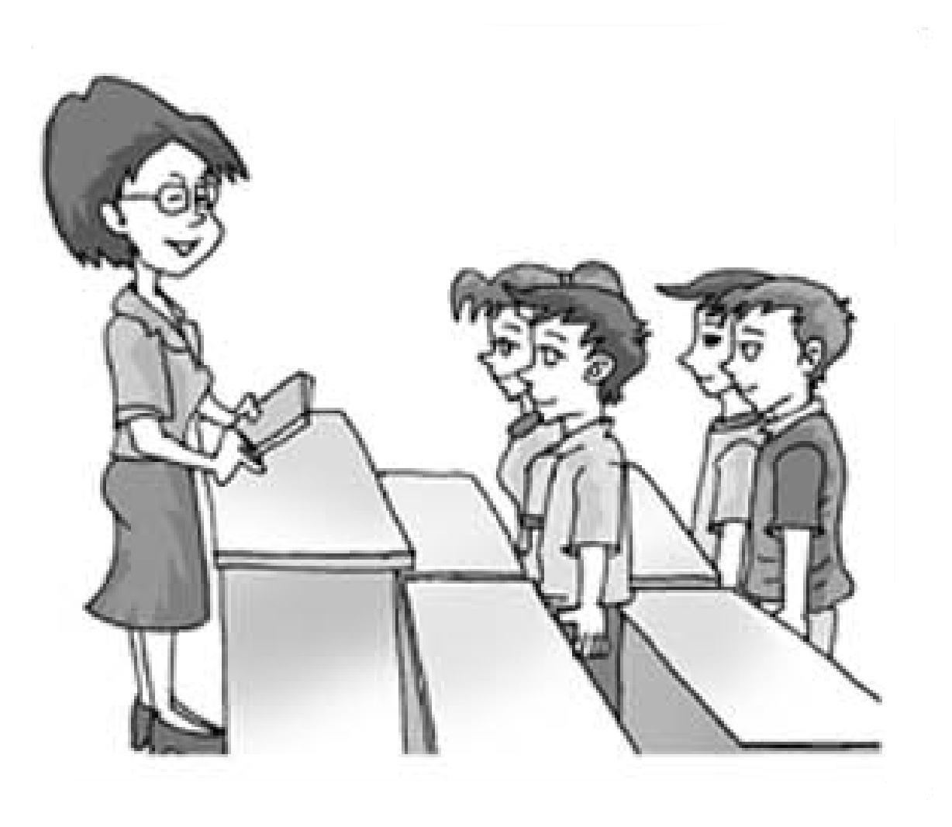
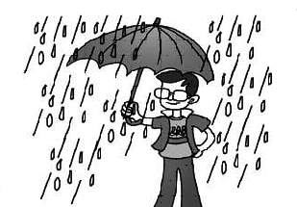
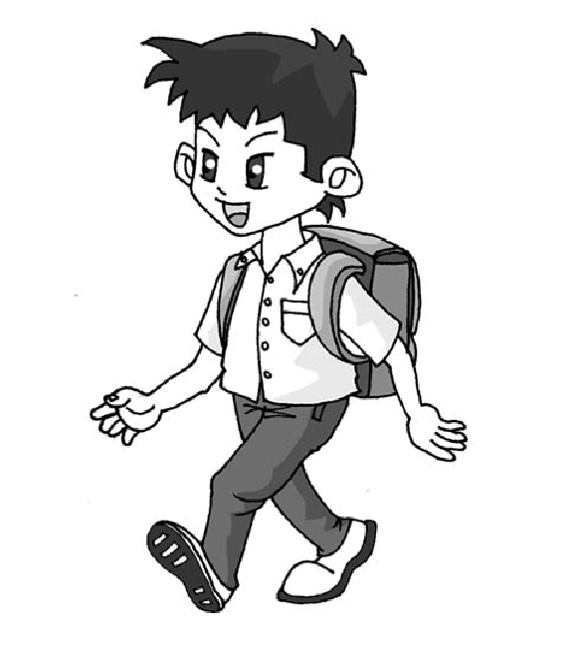
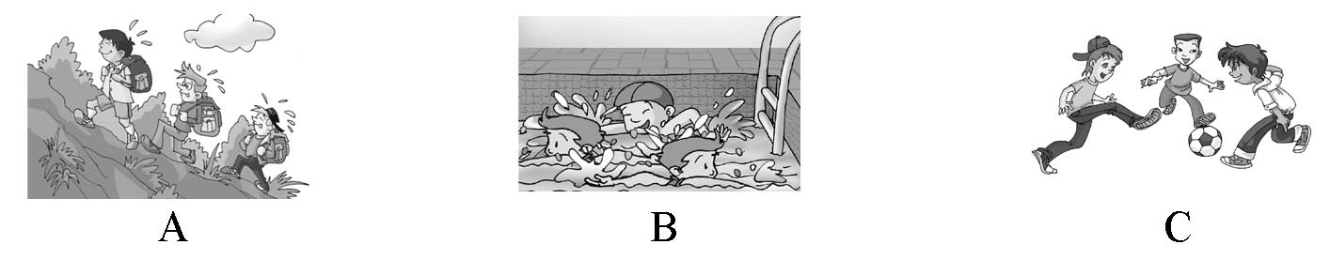
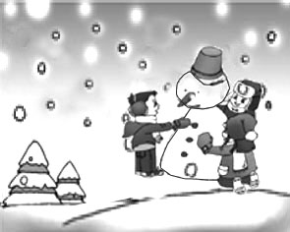

A B C D E
11. ___________ 2. ___________ 3. ___________ 4.___________ 5. ___________
Ⅱ.听句子, 选择正确答语。每个句子读两遍。
16. A. It’s big. B. It’s blue. C. It’s made in China.
17. A. All right. B. Thanks a lot. C. Never mind.
18. A. Twice a week. B. By car. C. Two days ago.
19. A. No, I won’t. B. Good idea. C. Well done.
10. A. From London. B. For a meeting. C. In England.
III.对话理解。听下面7段对话，每段对话后有一个或几个小题，从题中所给的A、B、C三个选项中选出最佳选项。每段对话读两遍。
听第一段对话，回答第11小题。
11. What kind of animal does Michael like best?
A. Pandas. B. Dogs. C. Cats.
听第二段对话，回答第12小题。
12. Where was Ann last night?
A. At home. B. In the hospital. C. At school.
听第三段对话，回答第13小题。
13. What’s the relationship(关系) between the two speakers?
A. Teacher and student. B. Husband and wife. C. Father and daughter.
听第四段对话，回答第14小题。
14. What does Bob want to have for breakfast?
A. Noodles. B. Sandwiches. C. Dumplings.
听第五段对话，回答第15小题。
15. What does the man want to buy?
A. Some new pens. B. Some new books. C. Some New Year’s cards.
听第六段对话，回答第16、17小题。
16. What’s the matter with the woman?
A. She has a cold. B. She has a toothache. C. She has a cough.
17. What did the doctor ask her to do?
A. Stay in hospital. B. Take a rest. C. Take some medicine.
听第七段对话，回答第18至20小题。
18. What will Jane do this weekend?
A. Join a club. B. Go to a concert. C. See a movie.
19. How much does a ticket cost?
A.￥20. B.￥40. C.￥60.
20. What will the speakers do to raise money for the concert?
A. Sell newspapers. B. Sell flowers. C. Ask their parents for help.
Ⅳ. 听短文，判断下列句子是否符合短文内容（符合用“A”表示，不符合用“B”表示）。
短文读两遍。
21. The young man sent roses to the girl as a birthday present.
22. The shopkeeper didn’t know the young man.
23. The girl was 22 years old then.
24. The next morning 32 roses were sent to the girl.
25. The girl was happy when she received the roses.
Ⅴ. 听短文，根据短文内容填写表格（每空一词）。短文读三遍。
A Mountain Trip
Where to go | 86 Mountain
How to go | by 87
When to leave | at 88 tomorrow morning
Where to get a blue ticket | in the 89
What season now | 90
第二部分 语言知识运用（满分25分）

Ⅵ. 选择填空（共15小题；每小题1分，满分15分）
从A、B、C三个选项中，选出可以填入空白处的最佳选项。
26. —What’s on the desk?
—There _____ some cards on it.
A. am B. is C. are
27. —What are you looking for, Sally?
—I’m looking for my pen. I can’t find ______ anywhere.
A. one B. it C. this
28. —Where are you going?
—I’m going to the ______to borrow some books.
A. library B. cinema C. museum
29. Attention, please! I have ______ important to tell you.
A. nothing B. anything C. something
30. —Where is Taiwan, do you know?
—Why? It’s ______the southeast of China.
A. in B. on C. to
31. I’m new here. I feel lonely because I have ______friends to talk with.
A. few B. many C. little
32. Maria didn’t catch the last bus, ______she had to walk home.
A. because B. so C. but
33. I want to buy a stamp. Could you tell me ______?
A. how can I get one B. where can I get one C. where I can get one
34. —Have you ever been to Mount Tai?
—Yes. I ______there last year.
A. went B. have gone C. am going
35. Do you know the brave boy ______saved several classmates in the earthquake?
A. who B. what C. which
36. Mother is ill in bed. I have to ______ her at home.
A. wait for B. think about C. look after
37. —What a hot day!
—The weather report says it will be much ______ tomorrow.
A. hot B. hotter C. hottest
38. It’s Saturday tomorrow. Our class ______ to have a picnic if it doesn’t rain.
A. goes B. will go C. went
39. The People’s Republic of China(PRC) will celebrate her ______birthday on October 1,2009.
A. sixty B. sixties C. sixtieth
40. The stones are so heavy. How ______they ______ to the top of the building without modern machines?
A. do; lift B. did; lift C. were; lifted
（背面还有试题）
Ⅶ. 完形填空（共10小题；每小题1分，满分10分）
阅读下面短文，从短文后各题所给的三个选项（A、B和C）中，选出可以填入空白处的最佳选项。
A little girl thought she was not as beautiful as other girls and nobody liked her. So she was always 41 and didn’t like to talk to others. However, one day, her mother 42 her a beautiful hair clip(发夹). When she wore it, she looked much more beautiful than 43 . She decided to wear it to school.
On her way to school she found that everyone who saw her smiled 44 her. Most of her classmates said 45 to her, but this never happened before. She thought that the beautiful hair clip 46 her happiness. She was so happy about all of the wonderful things. All her classmates wanted to know what happened to her， 47 she didn’t want to tell them about her beautiful hair clip.
When she went back to her 48 after school, her mother asked her, “Did you know you dropped your hair clip? I 49 it by the door this morning.”
She understood that she didn’t wear the hair clip to school at all.
It is not important what we wear or 50 we look. The most important is how we think about ourselves.
41. A. excited B. unhappy C. tired
42. A. told B. dropped C. gave
43. A. now B. before C. ago
44. A. at B. for C. on
45. A. goodbye B. thanks C. hello
46. A. borrowed B. brought C. bought
47. A. if B. but C. or
48. A. classroom B. shop C. home
49. A. knew B. liked C. found
50. A. how B. what C. when

第三部分 口语运用（满分10分）

Ⅷ. 口语运用（共10小题；每小题1分，满分10分）
第一节:补全对话。从方框内选出最佳选项完成下面的对话。
A: Hello, may I speak to Bob, please?
B: Sorry, he isn’t in now. 51
A. Can I leave a message?
B. What time will the party begin?
C. I’ll give him the message.
D. May I ask who is speaking?
E. Does he know where you live?
A: This is Tony, Bob’s classmate. 52
B: Sure, go ahead.
A: Tomorrow is my birthday. I’d like to invite him
to my home for my birthday party.
B: That’s very kind of you. 53
A: It will be at 5:00 in the afternoon.
B: I’ll tell him about that. 54
A: Yes, he has been to my home before. And please ask him to come with Amy.
B: OK. 55
第二节:情景选择。根据所给情景，从A、B、C三个选项中选出最佳选项。
56. —Can I take this seat?
—_______. It’s for our teacher, Mr Li.
A. Of course B. You’d better not C. Yes, please
57. —You speak English well.
—_______.
A. Don’t say so B. Just so-so C. Thank you
58. —There’s going to be an exciting basketball match in our school.
—_______ I can’t wait.
A. It’s boring. B. What a pity! C. That’s great.
59. —I have to make a speech at a meeting. I feel nervous about it.
—_______. I’m sure you can do it well.
A. Take it easy B. Don’t be so sad C. That’s all right
60. —What do you think of the math problem?
—_______. All of us can work it out.
A. It’s a piece of cake B. It’s difficult C. I hope so

第四部分 阅读理解（满分40分）

Ⅸ. 阅读理解（共25小题；61—80小题每小题1.5分，81—85小题每小题2分）
阅读材料，按要求完成下列各题。
A：阅读下面材料，根据材料内容判断句子正误（正确用“A”表示，错误用“B”表示）。
Sunny English Club  For students  16:00-18:00 every Saturday  150 yuan a month  Tel: 3785290  Foreign teachers, English songs and films and more! | Music Class  For children under 15  9:00-17:00 every Sunday  20 yuan a class  Art School of Fujian  Tel: 5409871  Learn to play the piano, the guitar and the drum. | Health Centre  9:00-17:30  16 Heping Street  Tel: 3801451  Give you good advice to keep healthy!  Free examinations for those over 70.
61. You’ll pay 150 yuan if you want to study in the English club for a month.
62. Music Class is open from 9:00 to 17:00 every Sunday.
63. Children under 15 can learn to play the piano in Art School of Fujian every Saturday.
64. If you want to know how to keep fit, you can go to Health Centre.
65. Those who are over 60 years old can get free examinations in Health Centre.
B：阅读下面材料，从每题所给的三个选项（A、B和C）中，选出最佳选项。
Dear Emma,
I’m fourteen and I’m from Manchester. I’m on an adventure(冒险) holiday at the moment. I like it very much but I have a problem and I need your advice.
I’m the only boy in the group and the girls laugh at me all the time and I hate it. What can I do? I don’t want to leave the centre, but I’m really unhappy.
Thanks for listening.
Unhappy Oliver
Dear Oliver,
There are two things you can do to stop the girls laughing at you. Firstly, try to pretend(假装) that you haven’t heard what they are saying. Secondly, try to talk to one of them and tell her how you feel. The girls don’t really want to hurt you and they will change if they know that you feel unhappy.
Have a good holiday!
Emma
66. Oliver is unhappy because_______.
A. Emma doesn’t answer his question
B. he has a problem during the adventure holiday
C. he doesn’t like the adventure
67. The girls in the group make Oliver unhappy by _______.
A. laughing at him all the time
B. asking him to leave the centre
C. calling him bad names
68. Emma gives Oliver _______ piece(s) of advice.
A. one B. two C. three
69. Emma advises Oliver to_______.
A. leave the centre
B. teach the girls a lesson
C. tell one of the girls his real feelings
70. Which of the following is TRUE to the passage?
A. Oliver is from London.
B. Oliver solves his problem by himself.
C. Oliver is the only boy in his group.
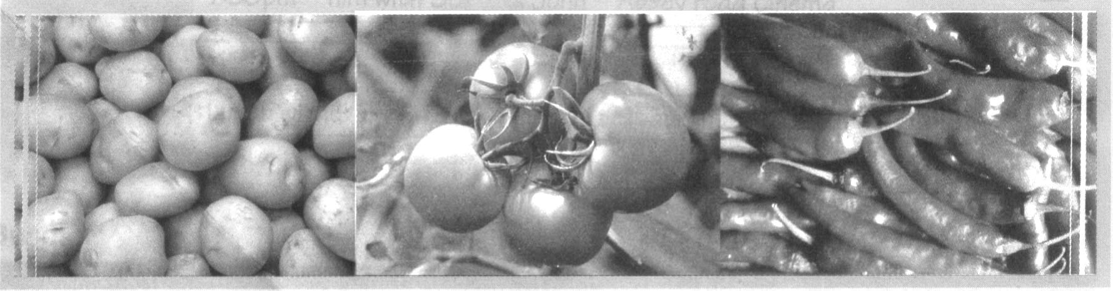
C：阅读下面短文，从每题所给的三个选项（A、B和C）中，选出最佳选项。
Thousands of years ago, people only ate food that was grown near their homes. Some kinds of food were only grown in one place, so people from other places didn’t know about them. When Europeans first traveled to Central and South America in the 1500s, they discovered strange kinds of food that they had never seen before. Today, these are grown in a lot of different countries and they’re sold in supermarkets all over the world. They don’t seem strange any more!
Potatoes were first grown in the Andes in South America. In 1586, they were taken to Europe by explorers(探险家). In 1719, they were taken to North America. Before 1719, nobody in North America had ever seen or eaten a potato. Today each American eats more than 60 kilos of potatoes a year.
Tomatoes were also first grown by native(本地的) Americans. When European explorers visited the south of America in 1500, they took tomato seeds(种子) back to Europe. Soon, tomatoes were grown in Europe, but people in England didn’t eat them. At that time, a lot of English people thought that tomatoes were poisonous!
Chilies(辣椒) have been eaten in Central and South America for more than 8,000 years! In the 1500s, chilies were taken to Europe by explorers. Today, they are grown in hot countries all over the world.
71. How many kinds of food are mentioned in the passage?
A. Two. B. Three. C. Four.
72. People in Central and South America have eaten chilies for more than_______ years.
A. 1,500 B. 1,586 C. 8,000
73. The underlined word “poisonous” in the passage means “_______” in Chinese.
A. 有毒的 B. 重要的 C. 辛辣的
74. According to the passage, we know that _______.
A. people only ate food grown near their homes after 1719
B. people in Europe were the first to plant potatoes
C. the European explorers took chilies to Europe in the 1500s
75. Which of the following is the best title(标题) for the passage?
A. Traveling to America B. “Strange” Food C. The Earliest Explorers
D：阅读下面短文，从方框内选择恰当的句子填入短文空白处，使短文内容完整、意思连贯。
All around the world, people drink tea. But tea does not mean the same thing to everyone.
76
In China, for example, people always drink tea when they are getting together. 77
They prefer their tea plain, with nothing else in it.
78 The Japanese have a special way of serving tea called tea ceremony. It is very old and full of meaning. Everything must be done in a special way in the ceremony. There is even a special room for it in Japanese homes.
79 In England, the late afternoon is “tea time”. Almost everyone has a cup of tea then. The English usually make tea in a teapot and drink it with milk and sugar. They also eat cakes, cookies and a little sandwich at teatime. This is the so-called “Afternoon Tea” in Britain.
In the United States, people drink tea mostly for breakfast or after dinner. 80 1
Making tea with the bags is faster and easier than making tea in teapots. In summer, many Americans drink cold tea—“iced tea.” Sometimes they drink iced tea from cans, like soda.
A. Tea is also important in Japan.
B. Another tea-drinking country is England.
C. Americans usually use tea bags to make their tea.
D. The Chinese drink it at any time of the day at homes or in teahouses.
E. In different countries, people have very different ideas about drinking tea.

E：阅读下面短文，根据短文内容回答问题或翻译句子。
Dear Leis,
I read in my magazine that you are looking for a pen pal, so I’m writing to say hello.
My name’s Alice Nichols and I’m 16. I live in Hania in Greece, but my family comes from England. Hania is a beautiful old town near the island of Crete. In summer the town is full of tourists.
I’m a student at a private school. I’ve been at the same school for five years now, so I know it very well. Most of the time I like going to school, but there are some things I can’t stand doing—like PE. I enjoy playing sports, but I don’t like doing exercises! My favorite subjects are geography and English.
I often go to the beach in my free time. I love just sitting around and talking to friends. I’m getting better at understanding boys, but I hate listening to hours of talk about football. It’s just so boring!
What’s life like in your town? I’d love to hear all about your family and friends. Have you got an e-mail address? It’s easier to keep in touch that way.
I am looking forward to hearing from you!
Best wishes!
Alice
81. How old is Alice Nichols?
82. How long has Alice Nichols studied at the private school?
83. What subject does Alice Nichols like best?
84. Does Alice Nichols like listening to hours of talk about football?
85. 请将划线句子翻译成汉语。
（背面还有试题）
第五部分 写（满分45分）
Ⅹ. 词汇运用（共10小题; 每小题1分，满分10分）
A:根据首字母及句子意思补全单词，使句子意思连贯、语法正确。
91. Look at the sky! The kites are flying so h that they look like small birds.
92. —Excuse me. How can I get to the post office?
—Go down this road until you see a tall building. You can’t m it.
93. Mum, I’m h after a long run. Please give me something to eat.
94. —I advise doing something to relax ourselves after the exams. Do you a with me?
—Yes, but how?
95. Most Chinese have three m a day. They are breakfast, lunch and supper.
B:根据句意和汉语提示，在空格中填入正确的短语（每空限填一词）。
96. “Now class, ______ ______(上交) your papers,” the teacher said when the class was nearly over.
97. You should ______ ______ (放弃) smoking. It’s bad for your health.
98. The story says Monkey King was ______ ______ (解救; 释放) by a Tang dynasty monk, Xuanzang.
99. —Michael, would you mind making your bed?
—Sorry, Mum. I’ll do it______ ______ (马上).
100. After doing my homework, I was tired and ______ ______ (入睡) soon.
Ⅺ. 综合填空（共10小题；每小题1分，满分10分）
根据短文大意，从方框内选择恰当的单词，将其正确形式填入横线上（每词限用一次）。
know, himself, decide, spend, face, do, successful, in, able, any
Liu Qian is a magician(魔术师) from Taiwan. For the CCTV Spring Festival Gala(春节联欢晚会) he put on two magic shows. They were very 101 . Now so many people are crazy about magic. We all want to 102 how to do a trick!
Liu didn’t go to 103 magic-training school. He learned by 104 . He worked hard at it. Now he is a great magician.
When Liu was seven, he saw a coin trick 105 a big store. At that moment Liu
106 to learn magic.
Liu trained hard to better his skills. Then one day he was 107 to put on a show for his class.
“I saw the surprise on everyone’s 108 . It was cool.”
Liu still 109 his training hard today. He may 110 three years working on a new show.
Ⅻ. 写作（满分25分）
第一节 看图写句（共5小题；每小题2分，满分10分）
根据每题所提供的情景和提示词写一个与图画内容相符的句子。（要求用上提示词）
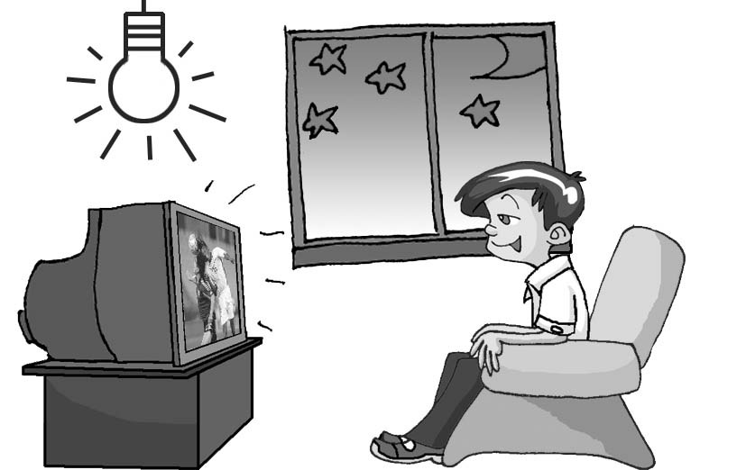
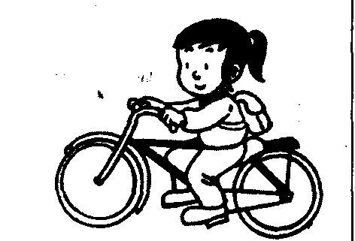
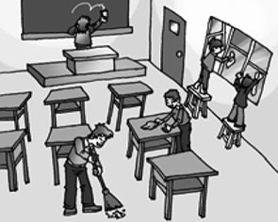
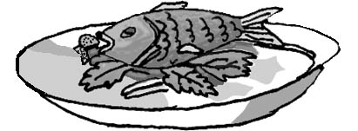
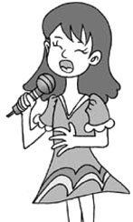

111 112 113 114 115
111. (Jane, like)
112. (good, eat)
113. (we, tomorrow) （请将答案填写在答题卡上）
114. (Jack, now)
115. (Lily, school, yesterday)

第二节 书面表达（满分15分）
学校实施课程改革以来，同学们拾回了许多快乐时光。请根据要求，以“A Happy Weekend”为题，用英语写一篇短文，向全班同学简要介绍你上星期六是怎样度过的。
要求：
1. 内容包括：（1）具体时间；（2）地点；（3）事件（做了什么事情）；（4）感受；
2. 词数：80左右，开头部分已给出，不计入总词数；
3. 短文中不得出现真实的人名、校名和地名。
参考词汇：see a movie, climb a mountain, play basketball, visit friends, excited

A Happy Weekend

I had a happy day last Saturday.

（请将答案填写在答题卡上）

2009年龙岩市初中毕业、升学考试
英语试题听力录音稿
这是2009年龙岩市初中毕业、升学考试英语试题听力部分。该部分分为五大题，共30小题。
请注意，做题时，先将答案标在试卷上，录音内容结束后，再将答案转涂到答题卡上。每小题将给出3秒种的阅题时间和3秒钟的答题时间。
现在是听力试音时间。
W: Hello, Beijing Railway Station. Can I help you?
M: Yes, I’d like to book some tickets to Mount Tai on March 13th.
W: OK. The train leaves at 11 a.m. and arrives at Taishan Railway Station at 6 p.m.
M: Sounds great! And what about the price?
W: We have tickets at￥150 for the hard sleeper and ￥300 for the soft sleeper. Which kind do you want?
M: I’d like to book 21 tickets for the hard sleeper.
W: All right. 21 hard sleeper tickets. Please pay for the tickets before 5:00 p.m. May I have your name and telephone number, please?
M: Sure. I’m Li Weikang and my telephone number is 82502448. Thank you.
W: You’re welcome.
试音到此结束。听力考试现在开始。
I.听对话，选出与对话内容相符的图片。每段对话读两遍。（停顿3秒）
01. W: What does your mother do, Tom?
M: She is a teacher. She teaches maths. （3秒钟后重复一遍，停顿6秒）
02. W: What do you often do in your free time?
M: I often play football with my classmates. （3秒钟后重复一遍，停顿6秒）
03. W: Kangkang, do you go to school by bike?
M: No, my home is not far, so I go to school on foot. （3秒钟后重复一遍，停顿6秒）
04. W: Wow! It’s snowing! Why not go to make a snowman?
M: Sounds great. （3秒钟后重复一遍，停顿6秒）
05. M: It was raining hard on my way home yesterday.
W: Did you take an umbrella?
M: Yes, but I still got wet. （3秒钟后重复一遍，停顿3秒）
II.听句子，选择正确答语。每个句子读两遍。（停顿3秒）
06. What color is your new bag? （3秒钟后重复一遍，停顿6秒）
07. I’m sorry. I lost your pen. （3秒钟后重复一遍，停顿6秒）
08. How often do you go to the English Corner? （3秒钟后重复一遍，停顿6秒）
09. What about going swimming this Saturday? （3秒钟后重复一遍，停顿6秒）
10. Where does Mike come from? （3秒钟后重复一遍，停顿3秒）
Error: Reference source not found．对话理解。听下面7段对话，每段对话后有一个或几个小题，从题中所给的A、B、C三个选项中选出最佳选项。每段对话读两遍。
听第一段对话，回答第11小题。（停顿3秒）
W: What kind of animal do you like best, Michael?
M: Pandas are my favorite. （3秒钟后重复一遍，停顿3秒）
听第二段对话，回答第12小题。（停顿3秒）
M: Did you watch the football match last night, Ann?
W: No, I looked after my brother in the hospital. （3秒钟后重复一遍，停顿3秒）
听第三段对话，回答第13小题。（停顿3秒）
W: Dad, I’ll be late for school. Could you drive me to school today?
M: Sure. But you should get up earlier next time.
W: Thank you. I will. （3秒钟后重复一遍，停顿3秒）
听第四段对话，回答第14小题。（停顿3秒）
W: What would you like to have for breakfast, Bob?
M: I’d like to have some noodles.（3秒钟后重复一遍，停顿3秒）
听第五段对话，回答第15小题。（停顿3秒）
W: Good morning. Can I help you?
M: I want to buy some New Year’s cards. （3秒钟后重复一遍，停顿3秒）
听第六段对话，回答第16、17小题。（停顿6秒）
M: What can I do for you, madam?
W: I have a fever and feel terrible.
M: Let me examine you. Mmm… Nothing serious. You just have a cold. Take some medicine,
and you will be OK soon.
W: Thank you, doctor. （3秒钟后重复一遍，停顿6秒）
听第七段对话，回答第18至20小题。 （停顿9秒）
M: Hi, Jane. What are you going to do this weekend?
W: My friends and I decide to go to a concert.
M: A concert? Who will sing at the concert?
W: Celine Dion.
M: Wonderful. I’d like to go, too. How much is a ticket?
W: Twenty yuan.
M: Oh, it’s too dear. I’m afraid I can’t afford it.
W: We don’t have so much money, either. I think we can sell flowers to raise money.
M: That’s a good idea. I’ll join you. I hope we will have enough money before the concert.
（3秒钟后重复一遍，停顿9秒）
Ⅳ．听短文，判断下列句子是否符合短文内容。短文读两遍。（停顿15秒）
A young man was in love with a beautiful girl. One day, the girl said to him, “It’s my birthday tomorrow.” “Oh,” said the young man, “I will send you roses. One rose for each year of your life.” The same evening he went to a flower shop and paid for the roses. He asked the shopkeeper to send them to the girl the next day. The shopkeeper knew the young man very well, because he often bought flowers in his shop before. So he decided to send ten more roses to show thanks to the young man. And he did so. The next morning thirty-two roses were sent to the girl. When the young man went to see her happily, he found the girl didn’t want to speak to him. Maybe he never knew why she was so angry with him. （3秒钟后重复一遍，停顿15秒）
Error: Reference source not found．听短文，根据短文内容填写表格。短文读三遍。（停顿15秒）
Hello, everyone! Here’s some information about our trip to Yellow Mountain tomorrow. We have a long way to go, so we have to start early. We will have breakfast at half past seven. Don’t be late, please, as the bus has to leave at eight. When you finish your breakfast, please go to the car park. There we’ll get on the bus. That’s the big car park behind the hotel. We’ll have lunch at a restaurant near Yellow Mountain and please go to the office to get a blue ticket. You need to show it when you have lunch. Oh, one more thing. I know it’s summer but it can get quite cold in the mountains even in July, so bring a jacket with you. You’ll need one in the evening. That’s all, and I’ll see you tomorrow morning. （3秒钟后重复2遍，停顿15秒）

听力考试到此结束。请将答案转涂到答题卡上。

2009年龙岩市初中毕业、升学考试
英语试题参考答案及评分标准

第一部分（涂卡部分）
6－50小题、56－60小题每小题1分；61－75小题每小题1.5分，与答案不符不给分。
6-10 BCABA 11-15 ABCAC 16-20 ACBAB 21-25 ABAAB 26-30 CBACA
31-35 ABCAA 36-40 CBBCC 41-45 BCBAC 46-50 BBCCA 56-60 BCCAA
61-65 AABAB 66-70 BABCC 71-75 BCACB
第二部分（填写部分）
Ⅰ. 听力部分（每小题1分，共10分，与答案不符不给分）
1-5 BADEC
86. Yellow（答“yellow”不扣分）, 87. bus, 88. 8/8:00/eight(o’clock), 89. office, 90. summer
VII. 口语运用（每小题1分，共5分，与答案不符不给分）
51-55 DABEC
Ⅸ. 阅读理解
76-80 EDABC（每小题1.5分, 共7.5分，与答案不符不给分）
（81-85小题每小题2分，共10分，只要句子语法正确，意思基本符合文意即可得分）
81. Sixteen(16)./She’s 16(sixteen) years old.
82. Five(5) years. /For 5(five) years./She has studied there for 5(five) years.
（只答“Five(5)”给1分）
83. She likes geography and English./Geography and English. （只答其中一项给1分）
84. No./No, she doesn’t.
85.（我）期盼/期待/盼望着你的回（来）信。
Ⅹ.词汇运用
（91-95小题每空1分,95小题答meal给0.5分,其余各题与答案不符不给分）
91. high, 92. miss, 93. hungry, 94. agree, 95. meals
（96-100小题每空0.5分，共10分,与答案不符不给分）
96. hand/turn in, 97. give up, 98. set free 99. right now(away)/at once, 100. fell asleep
Ⅺ. 综合填空（共10小题；每小题1分，满分10分,选词正确,但词形错误给0.5分）
101. successful, 102. know, 103. any, 104. himself, 105. in,
106. decided, 107. able, 108. face, 109. does, 110. spend
Ⅻ. 写作（满分25分）
第一节 看图写句（共5小题；每小题2分，满分10分）
能用上所给提示词，所写句子与图片内容相符，且无语法和拼写错误给2分；能用上所给提示词，语法和拼写无误，但句子内容与图片无关给1分；只抄下提示词不给分。如无特殊要求，时态、句式可灵活使用。
111. Jane likes singing / Jane likes to sing a song(songs).
112. It is good to eat fish. / Eating fish is good (for our health).
113. We will do some cleaning(in our classroom) tomorrow./
We will clean our classroom tomorrow.
114. Jack is watching TV now./Now Jack is watching TV (at home).
115. Lily went to school by bike yesterday(morning/afternoon)./Yesterday Lily rode to school.
第二节 书面表达（共15分）
一、评分原则
1．本题总分为15分，按五个档次给分。评分时，先根据文章内容要点、应用词汇、语法结构的准确性及上下文的连贯性初步确定其所属档次，然后根据拼写、书写和词数等情况调整档次，最后给分；
2．拼写与标点符号是语言准确性的一个方面。评分时，应视其对交际的影响程度予以考虑。英、美拼写及词汇用法均可接受；如书写较差以至影响交际，将分数降低一个档次。
3．词数少于60的，从总分中减去2分；
4．参考词汇可以全部用上，也可选用其中一两个或使用其它词汇。
二、内容要点
1．具体时间；
2．地点；
3．上周六所做的事情（此项为短文的重点，可以写几件事情，也可以详细叙述一件事）;
4．感受。
三、各档次的给分范围和要求
第五档13－15分 能写出全部要点，行文连贯，语言基本无误，完全达到写作要求。
第四档10－12分 能写出全部要点，行文基本连贯，语言有少量错误，基本达到写作要求。
第三档07－9分 能写出大部分要点，语言虽有较多错误，尚能达意。
第二档04－6分 能写出基本要点，语言错误多，未达到写作要求。
第一档00－3分 只写出一、二个句子，语言错误多。
0分 未表达任何与本题内容有关的信息，只字未写。
四、参考范文
A Happy Weekend
I had a happy day last Saturday. I got up early in the morning. After a quick breakfast, I went to visit some good friends. We went to climb a mountain where we sang and played games the whole morning. In the afternoon, we played basketball in our school playground. In the evening, we went to see a movie. It was a story about exploring. What a happy day I had! I was so excited that I couldn’t fall asleep until it was late at night. (79words)

