2002年重庆市中考试题
A卷
听力部分
I．听力测试(共20小题；每小题1分，共20分)
A)情景反应(共5小题；每小题1分，满分5分)
本题共有5段对话。根据你所听到的交际用语，选择正确答案，并将其字母代号填入题前括号内。每题念两遍。
( )1. A. It's nice of you. B. That's right C. That's OK.
( ) 2. A. Fine. Thank you. B. How are you? C. The same to you.
( )3. A. Yes, please. B. Not at all. C. Do, pi ease.
( )4. A. I'm sorry to hear that. B. Are you sure? C. Why wasn't he careful?
( )5. A.Help yourself. B. Me, too. C. Good idea.
B)对话理解(共10个小题；每小题1分，满分10分)
本题有10段对话。请先听对话，再根据对话内容和所提问题，选择正确答案，并将其字母代号填入题前括号内。对话念三遍。
( )6. When is the woman going to leave Beijing?
A. On Saturday. B. On Sunday. C. On Friday.
( )7. What's the woman's home telephone number?
A. 6562828 B. 5562828 C. 6652828
( ) 8. Where is the woman now?
A. In hospital. B. At home. C. In her office.
( )9. What does the man do? '
A. A worker. B. A teacher. C A shopkeeper.
( ) 10. What kind of weather will it be?
A. Warm. B. Cold. Hot
( ) 11. What does the woman mean?
A. She wants to go to the party tomorrow.
B. Mary has time to go to the party.
C. She has been to the party.
( ) 12. What does the man like to have for supper?
A. Potatoes. B. Eggs. C Noodles.
( ) 13. Who is a doctor?
A. Doreen B King C. King's father
( ) 14. What are the two speakers going to. do?
A. Go to school. B. Go to watch games. C. Go to the cinema.
( )15. What does Sally do?
A. He is a doll. B. He does nothing. C. He is a student
C)语篇理解(共5小题；每小题1分，满分5分)
本题有一篇短文，请先听短文，再根据短文内容和所提问题选择正确答案，并将其字母代号填入题前括号内。短文念三遍。
( ) 16. How was Jack at school?
A. He did well in his lessons.
B. He liked his school.
C. He was too lazy to study.
( )17. Where did Jack's parents work?
A. On a farm. B In a school C. In a hospital.
( )18. What did Jack's parents want him to be?
A. A doctor. B. A student C. A cleaner.
( ) 19. How many days did the cleaners work a week?
A. One day. B. Three days. C. Five days.
( )20. What do you think of Jack?
A. He was a clever boy.
B. He was good at his lessons.
C. He was not clever.
笔试部分
II．词语释义(共5小题；每小题1分，满分5分)
找出与下列各题画线部分意思相同或相近的选项，并将其字母代号填入题前括号内。
( ) 21. Is your mother in?
A. in home B. at home C in the family
( ) 22. He has had the TV set for more than 10 years.
A. over B. nearly C, almost
( ) 23. I' m sure we won't be late. Take your time, please.
A. Lose no time. B Don't hurry. C Be on time.
( ) 24 She is badly ill We must send for a doctor.
A. ask a doctor to come B send her for a doctor C send her to a doctor
( ) 25. He didn't study hard, so he failed the exam.
A. missed B. forgot C didn't pass
Ⅲ．单项填空(共25小题：每小题1分，满分25分)
从A、B、C三个选项中，选出可以填入空白处的正确答案，并将其字母代号填人题前括号内。
( ) 26. We can't see sun on a rainy day.
A. a B the C :不填
( ) 27. —Where's your father?
—At .
A. Mr Green's B Mr Green C. the Mr Green's
( ) 28. of us in our, class likes playing basketball
A. Every one B Everyone C All
( ) 29. Shanghai is larger than city in Sichuan.
A. any B any other C all
( ) 30. There were two people at yesterday' s meeting.
A. hundreds B hundreds of C hundred
( ) 31 We'll go for a walk if it tomorrow.
A. will not rain B isn't raining C. doesn't rain
( ) 32. Mr John lives 108 Bonn Street
A. in Bon Cat
( ) 33. —I don't like fish chicken. What about you?
—I don' t like fish I like chicken very much.
A. and; and B or; but C but; or
( ) 34. Do you know when ?
A. he comes B will he come C. he will come
( ) 35. I haven't had a good rest since 1 my home town.
A. left B have left C had left
( ) 36. At last the child stopped .and listened to the music.
A. to cry B crying C cry
( ) 37. is wrong to play tricks on other people.
A. This . B That C It
( ) 38. Tell him be late for school
A. not to B doesn't C. to not
( ) 39. English in Canada
A. is speaking B speaks C is spoken
( ) 40. Nobody told us to do.
A. what B how C why
( ) 41. This room is to hold 50 people.
A. enough big B big enough C too big
( ) 42. —Are you interested in maths?
—Yes, but I find difficult
A. its B it C to be
( ) 43. It kept for 3 days.
A. on raining B to rain C. rained
( ) 44. —I think everything goes on well
— .
A. So I do B I do so C So do I
( ) 45. —Have you enjoyed your stay in China?
—Yes, of course. .
A. Very much B Very good C Wonderful
( ) 46. —Nothing serious,! hope.
—1 .
A. don't hope B hope not C hope no
( ) 47. If you want to watch TV, you may turn .
A. down B it on C on it
( ) 48 —Oh, the way, what's your father?
—He is a doctor.
A. on B in C. by
( ) 49. —Hello! Can I speak to Alice, please?
— , please.
A. Call on B Hold on C Go on
( ) 50. —I'm sorry to hear your mother is ill in hospital.
— .
A. Thank you B Never mind C Not at all
Ⅳ．完形填空(共10小题；每小题1分，满分10分)
先通读下面短文，掌握其大意，然后在短文后面各题所给的选项中选出正确答案，并把它的字母代号填入题前括号内。
It was a very cold morning. Some children were 51 on the ice. It was snowing 52 but they enjoyed themselves there. Mike, the tallest boy, skated fast and he ;53 that there was a hole 54 the ice. He 55 into the: water. The other children called out loudly for help. 56 at that moment a young worker 57 by and heard them. He put his bike by the side of the river 58 ran to them. When he pulled Mike out of the 59 , he was all wet Then he sent Mike to a hospital 60 that the young man hurried to work.
( ) 51. A. walking B skating C. sitting
( ) 52. A. hardly B hard C. heavy
( ) 53. A. didn't see B can't see C. not see
( ) 54. A. on B in front of C in
( ) 55. A. jumped B felt C fell
( ) 56. A. Just B Only C. When
( ) 57. A. passed B was passing C. past
( ) 58. A. and B but C then
( ) 59. A. ice B snow C. water
( ) 60. A. Before B After C. And
V．阅读理解(共15小题；每小题2分，满分30分)
阅读下列短文，从A、B、C三个选项中选出能回答所提问题或能完成所给句子的正确答案，并把它的字母代号填入题前括号内。
A
Mrs Black was eighty, but she had a small car, and she always drove to the shops in it on Saturday and bought her food.
She did not drive fast because she was old, but she drove well and never hit anything. Sometimes her grandchildren said to her, "Please don't drive your car, Grandmother. We can take you to the shops. "
But she always said, "No, I like driving. I began to drive fifty years ago, and I'm not going to shops now. "
Last Saturday she stopped her car at the traffic lights because they were red, and then she couldn't start the car again. The lights were green, then yellow, then red, then green again, but her car did not start.
A policeman came and said to her kindly.
"Good morning. Don't you like any of our colours today?"
( ) 61. For what did Mrs Black always drive to the shops?
A. To buy food. B. To meet friends. C To buy clothes.
( ) 62. Why didn't Mrs Black drive fast?
A. Because her car was old.
B Because she was a new driver.
C. Because she was old.
( ) 63. Her grandchildren wanted her .
A. to walk to the shops
B to sell her car
C. not to drive any more
( ) 64. Mrs Black began to drive when she was .
A. 50 B. 30 C.80
( ) 65. Which of the following is not true?
A. The policeman was kind.
B Mrs Black liked the colours of the traffic lights.
C There was something wrong with Mrs Black’s car last Saturday.
B
In 1936 George Black worked on the railway. He had got a good job and was paid 180 pounds a year. Then the next year he got married(结婚)and bought a new, three-bedroom; house. It cost him 370 pounds. In those days there was a good and useful rule; the price(价格) of a house was double the amount(总额) a man got in a year. Seven years passed before George finished paying for his house.
George's youngest son Alfred was born in 1950. Alfred works for a newspaper and is paid 5000 pounds a year. He has just married and bought a new, three-bedroom house for himself and wife. The price of the house was 24000 pounds, nearly five times as much as Alfred gets in a year. He wants to know what has happened to the old rule about the price of a house, because he will not finish buying his house until the year 2004.
( ) 66. George Black was paid pounds a mouth.
A. 180 a 370 C. 15
( ) 67. George got married .
A. in 1936 a before 1936 C. after 1936
( ) 68. Alfred was George's .
A. last son a first son C young child
( ) 69. When he finishes paying for his house, Alfred will be years old
A. 54 a 50 C.45
( ) 70. It's for George to buy a house than for Alfred.
A. harder a easier C later
C
Wei Hua had a busy day yesterday. She got up before 7 o'clock in the morning, and quickly washed her hands and face. She got to school early. She had a little rest after lunch, but worked hard in class all day. She played basketball after school, and then walked home.
Wei Hua's pen was broken, so she needed a new one. On her way home she bought a new pen at a shop. When she reached home, she had a short rest and a glass of water. After that she helped her parents. She quickly cooked the supper, and cleaned the house.
She watched TV for half an hour after supper. Then she started her homework. She finished it at half past nine. She went to bed before a quarter to ten.
( ) 71. Yesterday Wei Hua was .
A. ill B. busy C. sad
( ) 72. How did she go home yesterday?
A. By bus. B. By bike. C. On foot
( ) 73. What did she buy on her way home?
A A pea B Some food C Some drinks,
( ) 74. She finished her homework
A. at 9:30 B. at 9:00 C.at l0:00
( ) 75. She went to bed before .
A:10:15 B. 9:45 C. 10:30
Ⅵ．单词拼写(共5小题；每小题工分，满分5分)
根据下列句子中所给汉语注释，在句子右边的横线上写出空缺处各单词的正确形式。(每空只写一词)
76. How long can I (借) this book? 76.
77. You'd better drink (大量)water. 77.
78. September is the (第九)month of the year. 78.
79. He's been (死)for years. 79.
80. Tom is interested in (音乐). 80.
Ⅶ．看图答问(共5小题：每小题1分，满分5分)
仔细观察下图，掌握图中所示内容，再根据所提问题分别用英语做出回答，并把答案写在相应的横线上。(注意标点及字母大小写)
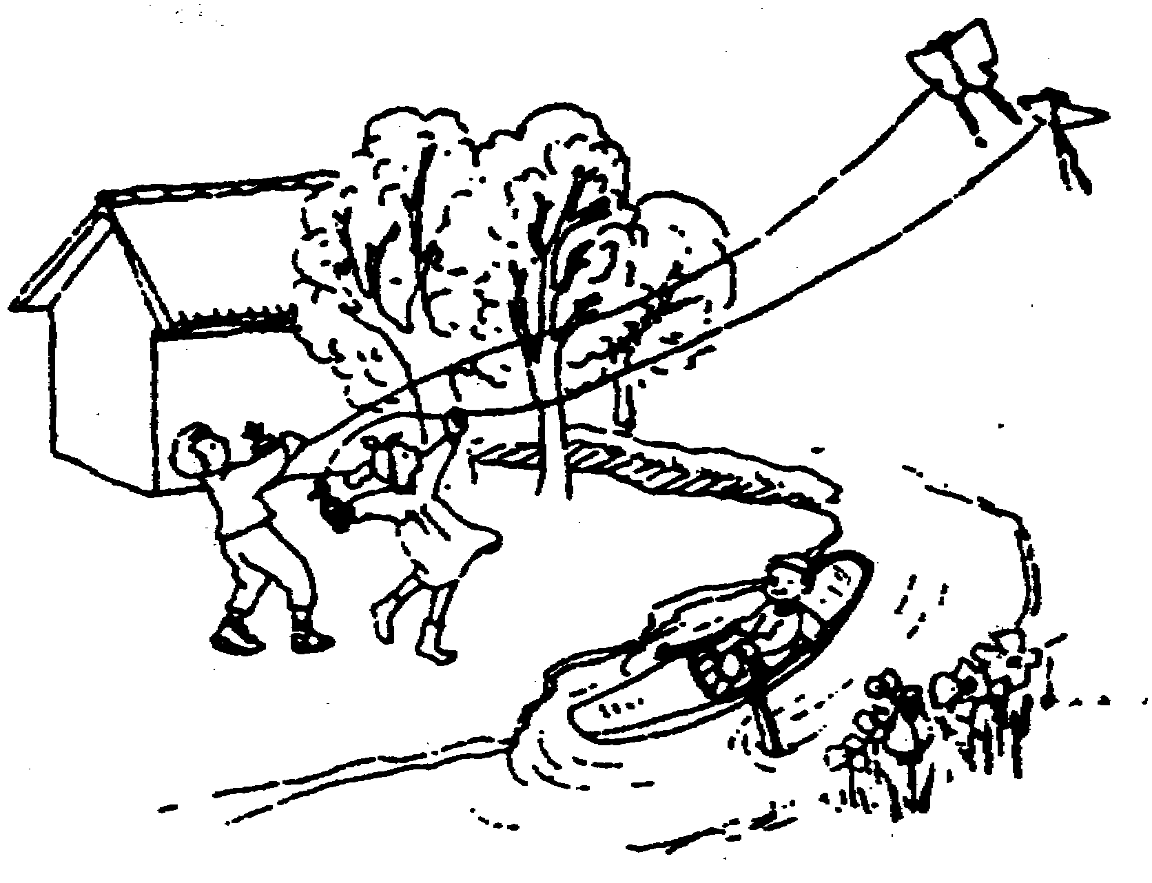
81. Is the boy swimming in the river?

82. How many trees can you see in the picture?

83. What are the two children doing?

84. Where is the house?

85. Can you see some flowers in the picture?

B卷
I.改写句子(共5小题；每小题2分，满分10分)
在下列各题中B)句的横线上填入适当的词，使其与A)句的意思相同或相近。(每空一词)
1. A) What's the weather like in America?
B) the weather in America?
2. A) She studies more carefully than any other student in her class.
B)She studies in her class.
3.A) Mrs Green reached Beijing three days ago.
B) Mrs Green Beijing three days ago.
4. A)We enjoyed ourselves in the People's Park last Sunday.
B)We in the People' s Park last Sunday.
5. A) Tom spent two hours in mending the bike.
B) It two hours the bike.
Ⅱ．完成句子(共5小题；每小题2分，满分10分)
根据汉语句子的意思完成英语句子。(每空一词)
6.天气如此寒冷，以至于我们都呆在家里。
It cold we stayed at home.
7.请你告诉我怎样去邮局，好吗?
Could you me to the post off ice, please?
8.你最好不要在早饭时间去看他。
You to see him at breakfast time.
9.这所学校八点过十分上课。
at eight in this school
10.在中国大多数地区，春天通常从二月开始，持续到四月.
In much of China, spring usually February and to April.
Ⅲ．动词填空(共5小题；每小题2分，满分10分)
用所给动词的适当形式填空.。(每空一词)
11. Dashan Chinese quite well, (speak)
12. Mr King us English last term, (teach)
13. It outside. Please take this raincoat (雨衣)with you. (rain)
14. you ever to London? (be)
15. The homework must by yourself, (do)
Ⅳ．短文改错(共10小题：每小题1分，满分10分)
下面短文中的画线部分是错误的，请改正，并将正确答案写在右边相应题号后的横线上。(每空一词，并不得改变原句意思)
例:We often visit the museum last year. 答案： visited
The animals are use to the desert(沙漠)people 16.
in many way. They eat the meat, drink the milk of 17.
the animals. They use camels(骆驼)to carrying water, 18.
food, tents(帐篷)and another things. The people of 19.
the desert have to keep move from place to place. 20.
They must always watch for grass or desert plants for 21.
their animals. When there is not more food for their 22.
animals, they move to another place. The desert people is 23.
friend. They would never refuse(拒绝)to help people in 24.
trouble, but they would give them food and water. 25.
V．看图写话(共5小题；每小题2分，满分10分)
仔细观察下图，并通读下面短文，掌握其大意，然后按图所示内容，用英语完成下列各空格，使短文通顺。(把答案写在相应编号的空格线上)
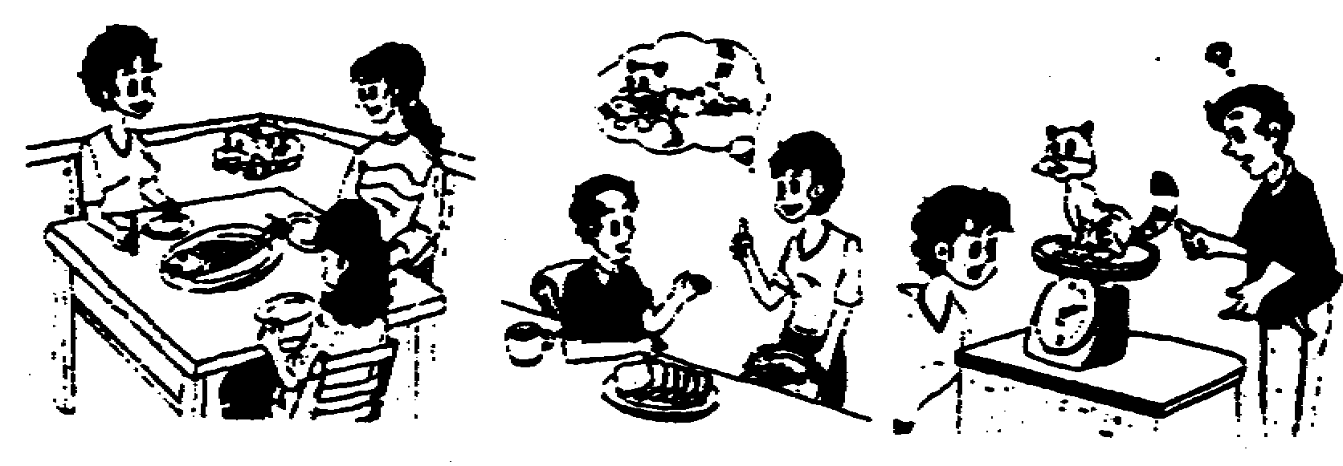
Bob likes fish very much. One day, he bought a fish and took it home. When his wife saw the fish, she said to herself, "Good! Now I can ask my friends to have lunch, and we can 26 . "When Bob 27 in the evening, he found no fish at all. His wife said, "Oh, 28 . "And she gave Bob some bread for supper. Bob was angry. He took the cat and his wife to the shop nearby and weighed (称) the cat. Then he said to his wife," 29 and the fish is also one kilo. The cat is here. But 30 ?"
26. 27. 28. 29. 30.

重庆市中考英语试卷答案
A卷
1. C 2. A 3. B 4. A 5. C 6. B 7. C 8. A 9. C 10. B 11. B 12. A 13. B 14. C 15. C 16. C 17. C 15. A 19. C 20. A 21. B 22. A 23. B 24. A 25. C 26. B 27. A 28. A 29. A 30. C 31. C 32. C 33. B 34. C 35. A 36. B 37. C 38. A 39. C 40. A 41. E 42. E 43. A 44. C 45. A 46. B 47. E 48. C 49. E 50. A 51. E 52. E 53. A 54. C 55. C 56. A 57. B 59. A 59. C 60. B 61. A 62. C 63. C 64. E 65. E 66. C 67. C 68. A 69. A 70. E 71. E 72. C 73. A 74. A 75. E 76. keep 77. much 78. ninth 79. dead 80. music 81. No, he isn' t 82. Three. 83. They're flying kites. 84. It's behind the trees. 85. Yes, I can.
B卷
1. How is/How about/What about
2. most carefully
3. arrived in/got to
4. had a good time
5. took Tom; to mend
6. was so; that;all
7. tell; how to get
8. had better not go 9. Classes begin; ten past
10. starts in; goes on 11. speaks
12. taught 13. is raining
14. Have; been 15. be done
16. useful 17. ways
18. for 19. other
20. moving 21. look
22. no 23. are
24. friendly 25. and
26. have/eat/enjoy the fish 27. came home
28. your cat ate it 29. My cat is one kilo
30. where is my fish
听力部分朗读卷
I.听力测试
A)情景反应(本题有5段对话。根据你听到的交际用语，选择正确答案，并将其字母代号填入题前括号内。每题念两遍。
1. Thank you for your help.
2. How are you?
3. Would you mind if I smoke here?
4. Tom fell and hurt his left leg on his way home yesterday.
5. How about having a drink?
B)对话理解 本题有10段对话。请先听对话，再根据对话内容和所提问题，选择正确答案，并将其字母代号填入题前括号内。对话念三遍。
6. M: Today is Friday. Are you going to leave Beijing tomorrow? W: No, I'm going to leave Beijing the day after tomorrow.
7. M: The telephone number of our home is 5562828. What about yours?
W: Ours is 6652828.
8. W: When Can I go home, doctor?
M: Well, let me see, you can leave tomorrow, but you can' t go back to work at once.
9. W:I' d like to return this blouse. I bought it for my
daughter yesterday, but she doesn't like the colour.
M: What colour does she like? We have blouses in different colours.
10. M: have you heard the weather report? W: Yes, it will be below zero tomorrow.
11. M: Could you go to the party with me tonight?
W: Sorry, I can' t, but you may ask Mary. She is free this evening.
12. W: Do you like eggs or noodles for supper? M: Some potatoes instead of them,
13. M: Hello, Doreen, I haven'1 seen you for ages. Where
have you been?
W:I have been in the USA.
M: How is your son, King, these days? Is he a student now?
W: Not now. He is a doctor.
14. M: I'm late for my bike was broken on the way here.
W: It doesn't matter.
M: When does the film begin?
W: It has been on for 5 minutes.
M: I'm very sorry for it.
W: it's OK. Things like that happen sometimes.
M: Now, let's get in
15.W: Look, Sally. See what I've got for you?
M: Oh, a nice doll. I wanted it for a long time. Thank you, mama.
W: You're welcome. I’ve bought the doll's clothes, too.
M: They are beautiful. Can I take it to school?
W: Yes, you can.
M: Thanks a lot.
C)语篇理解 本题有一篇短文，请先听短文，再根据短文内容和所提问题选择正确答案并将其字母代号填入题前括号内。短文念三遍。
Jack was ten years old and he was a very lazy boy. He didn't like doing any work He had to go to school, of course, but he didn't study hard there and tried to do little work. His father and mother were both doctors and they hoped that their son would become a doctor, too, when he grew up.
But one day Jack said to his mother, "When I finish school,! want to be a cleaner. "
"A cleaner?" his mother asked She was very surprised "That's not a good job. Why do you want to become a cleaner?"
"Because I would only have to work one day a week," Jack answered at once.
"Only one day a week?" his mother said "What do you mean? And how do you know it?"
"Well," Jack answered,"! know that the cleaners come to work on Thursday every week, because I only see them on that day. " And then his mother laughed and said, "The cleaners go to work on Monday, Tuesday, Wednesday and Friday in other streets. "

声明：本资料由 考试吧（Exam8.com） 收集整理，转载请注明出自 http://www.exam8.com
服务：面向较高学历人群，提供计算机类，外语类，学历类，资格类，会计类，工程类，医学类等七大类考试的全套考试信息服务及考前培训.

