声明：本资料由 考试吧（Exam8.com） 收集整理，转载请注明出自 http://www.exam8.com
服务：面向较高学历人群，提供计算机类，外语类，学历类，资格类，会计类，工程类，医学类等七大类考试的全套考试信息服务及考前培训.
宁夏回族自治区2009年初中毕业暨高中阶段招生
英语试题
选择题（共８０分）
一、听力（共25小题，计分25分；其中有5个小题为非选择题，计分5分, 答题位置在非选择题第五题听力题内。）
- 听对话选出正确的图画。（每小题1分，计分5分）
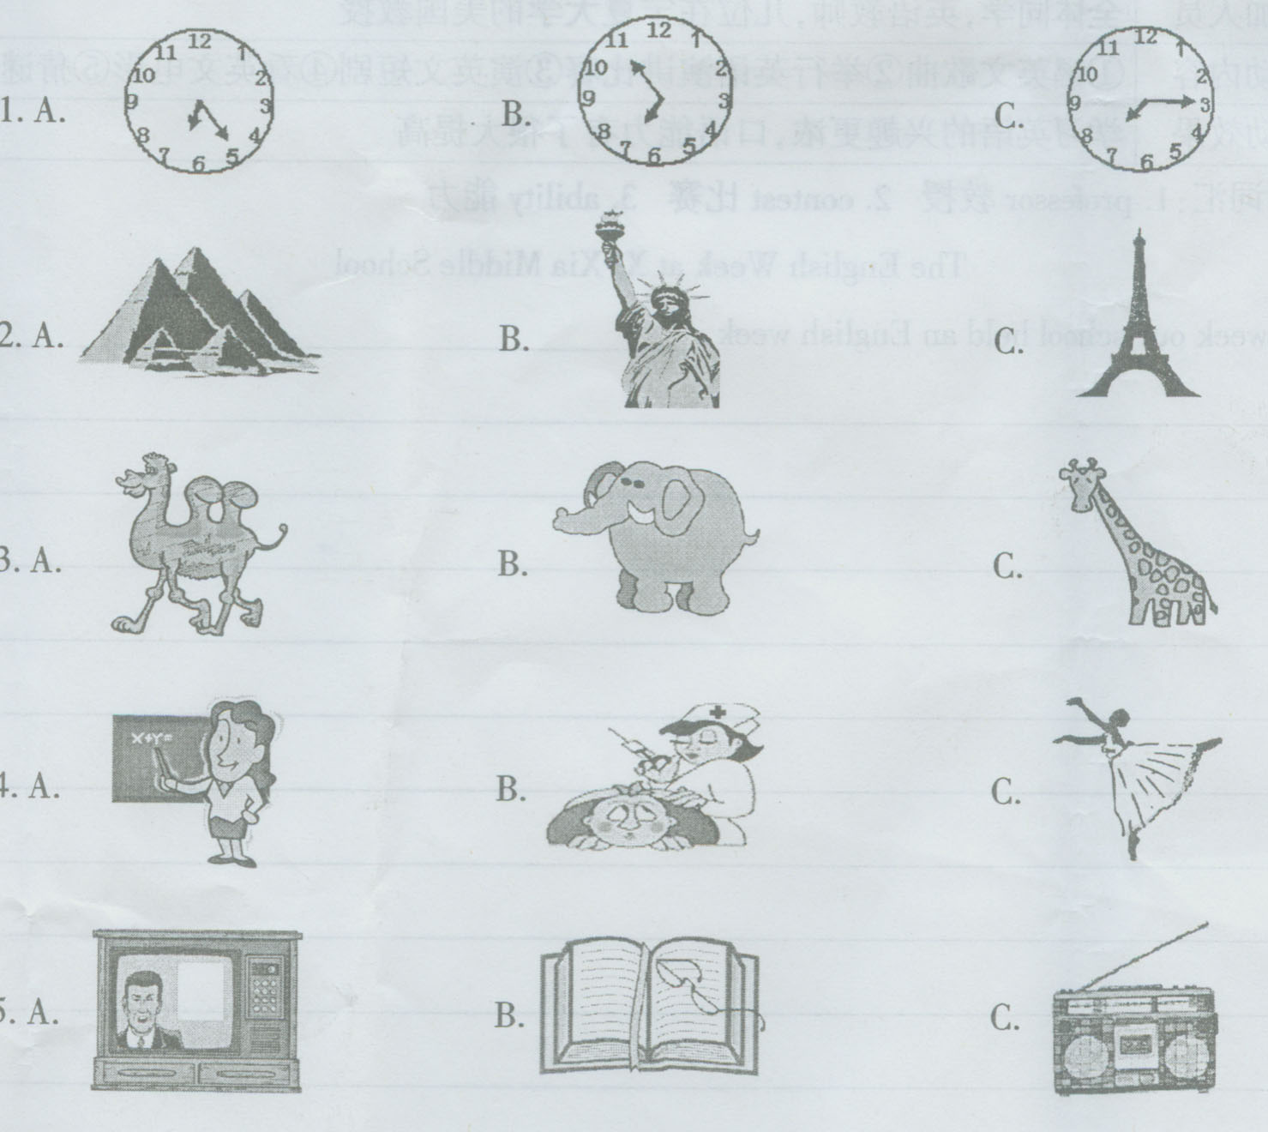
II. 听句子选择恰当的答语。（每小题1分，计分5分）
( ) 6. A. No, it isn’t here. B. No, you can’t get there.
C. No, it’s only about ten minutes’ walk.
( ) 7. A. Thank you. B. No, it’s not good.
C. I don’t think so.
( ) 8. A. He likes music. B. He’s tall and fat.
C. He’s very friendly.
( ) 9. A. Yes, please. B. Yes, I’d love to.
C. Coffee, please.
( ) 10. A. Sure. Go ahead. B. Why not?
C. One minute, please.
III. 听对话及对话后的问题，然后选择正确答案。（每小题1分，计分5分）
( ) 11. A. Right now. B. In the evening. C. In the afternoon.
( ) 12. A. Sunny. B. Rainy. C. Fine.
( ) 13. A. In a shop. B. At home. C. In a library.
( ) 14. A. P.E. B. Math. C. Music.
( ) 15. A. He’ll be fine. B. He’s going to get down.
C. He may fall down and hurt himself.
IV. 听对话选择正确答案。（每小题1分，计分5分）
Conversation 1:
( ) 16. What are they talking about?
A. Shopping. B. Visiting a friend. C. Taking a vacation.
( ) 17. How long will the man be away from home?
A. 10 days. B. 16 days. C. A couple of days.
Conversation 2:
( ) 18. Whom does the man want to talk with?
A. Mr White. B. Jim. C. Dr Black.
( ) 19. Where did Dr Black go?
A. He went home. B. Nobody knows. C. He went to his office.
( ) 20. Which number is correct?
A. 7723-1059. B. 7723-1058. C. 7722-1069.
二、单项填空（共20小题，计分20分）从A、B、C、D四个选项中选出可以填入空白处的最佳选项。
( ) 21. --- What do you think of their school?
--- It’s really beautiful. But I don’t think their school is as big as ____.
A. ours B. us C. we D. our
( ) 22. He used to be _____, but now he likes to meet and talk to new people.
A. busy B. strong C. tall D. shy
( ) 23. When I got there, he _____ them to dance.
A. is teaching B. teaches C. was teaching D. taught
( ) 24. Could you______ these books to the classroom?
A. put B. take C. bring D. make
( ) 25. --- The light in the office is still on.
--- Oh, I forgot to ______.
A. turn it off B. turn it on C. turn it up D. turn it down
( ) 26. --- _______ do you go to the gym?
--- Twice a week.
A. How long B. How soon C. How many D. How often
( ) 27. --- Would you like to go and see the film with me tonight?
--- Thank you, but I ______ it already.
A. saw B. have seen C. see D. will see
( ) 28. --- When will the party be held?
--- ______ two weeks’ time, _____ 15th July.
A. In; on B. In; in C. On; on D. At; on
( ) 29. If you don’t get enough sleep at night, you’ll have _____ energy the next day.
A. fewer B. much C. less D. more
( ) 30. --- Can you tell me when _____?
--- About two weeks ago.
A. does he buy the car B. did he buy the car
C. he bought the car D. he buys the car
( ) 31. --- Can you come on Monday or Tuesday?
---I’m afraid _______ day is possible.
A. neither B. either C. some D. any
( ) 32. Of all the students in our class, she is ______.
A. most careful B. careful C. more careful D. the most careful
( ) 33. --- I’m sorry to keep you waiting.
--- Oh, not at all. I ______ here for only a few minutes.
A. was B. have been C. will be D. am
( ) 34. --- Whose bike is this?
--- It ______ belong to Adam. Look! His bag is on it.
A. must B. may C. will D. can
( ) 35. The woman behind the girls ______ a famous actress.
A. is B. are C. have D. has
( ) 36. She will write to you as soon as she ______ to Guangzhou.
A. got B. will get C. gets D. get
( ) 37. I hate people _______ talk much but do little.
A. whom B. whose C. which D. who
( ) 38. A new cinema ______ in the city last year.
A. built B. was built C. was building D. is built
( ) 39. She won’t let her daughter _____ by the river.
A. play B. plays C. to play D. playing
( ) 40. Things made by hand are usually more expensive than ______ produced in factories.
A. these B. this C. that D. those
三、完形填空（共10小题，计分10分）
阅读下面短文，掌握其大意，然后从41-50各题所给的四个选项中选出一个最佳选项。
A story tells that two friends were walking through the desert( 沙漠). During the trip they had a 41 , and one friend hit the other in the face. The one who was beaten was hurt, but without saying 42 , he wrote in the sand: “ Today my best friend hit me in the face.”
They 43 on walking until they found a lake, where they decided to take a bath（洗澡）. The one, who had been beaten, fell into the lake and started drowning(溺水), but the friend saved him. After he came back to life from the near drowning, he wrote on a 44 : “ Today my best friend saved my life.”
The friend who had hit and 45 his best friend asked: “ 46 I hurt you, you wrote in the sand and now, you wrote on a stone, why?” The other friend 47 : “ When someone hurts us, we should write it down in sand 48 wind can blow it away. 49 , when someone does something good for us, we must write it down in stone where no 50 can ever blow it away.”
( ) 41. A. talk B. joke C. fight D. picnic
( ) 42. A. something B. nothing C. anything D. everything
( ) 43. A. kept B. continued C. lasted D. tried
( ) 44. A. sand B. stone C. tree D. wall
( ) 45. A. killed B. hurt C. saved D. made
( ) 46. A. Before B. While C. Until D. After
( ) 47. A. replied B. asked C. questioned D. required
( ) 48. A. which B. how C. where D. when
( ) 49. A. Although B. Or C. But D. If
( ) 50. wind B. water C. air D. sand
四、阅读理解（共15小题，计分30分）
阅读下列短文，并做每篇后面的题。从各题所给的四个选项中，选出能完成所给句子的最佳选项。

A
A neighbor of mine, while visiting his mother in Boston, took her to a shoe store to buy a new pair of shoes. While she was trying on different styles(款式), my neighbor took the manager aside. “ When she picks out a pair that she likes,” he said, “ just tell her that the price is 12 dollars. I’ll pay the regular(正常的)price. I don’t care how much it is.”
The following week, my neighbor was walking by the shoe store and the manager recognized (认出)him and called him in.
“ What’s the problem?” asked my neighbor as he entered the store.
“ Wasn’t my check any good?”
“ That’s not it,” answered the manager, “ The problem is that your mother is bringing all her friends in for those 12-dollar shoes!”
( ) 51. My neighbor went to Boston ________.
- to buy shoes for his mother
- to see his mother
- to pay for the shoes he had bought for his mother
- to see the manager of the shoe store
( ) 52. The regular price my neighbor had paid must be _______.
A. 12 dollars B. lower than 12 dollars
C. higher than 12 dollars D. unknown to himself at all
( ) 53. It seems very probable that my neighbor wanted to _______.
A. please his mother B. cheat his mother
C. cheat the manager D. please his mother’s friends
( ) 54. The manager called my neighbor in when he saw him because______.
- he didn’t have enough shoes for his customers(顾客)
- my neighbor’s mother had taken a wrong pair of shoes
- there was something wrong with his check
- he found it hard to satisfy his customers
( ) 55. What do we know about the character(个性) of my neighbor’s mother?
- She would like to buy expensive things.
- She would like to buy cheap things.
- She would like to help others when they’re in trouble.
- She would like to have her son pay for her shopping.
B
Here are some tips(建议) on how to stay safe in earthquakes (地震)。
1. Stay inside and duck and cover. Get under a desk or table, or stand in a corner or under a doorway. Cover your head and neck with your arms.
2. Move against a wall if in a high building with no protective desk or table nearby. Cover your head and neck with your arms.
3. Try to get into an open area away from trees, buildings, walls, and power lines (电杆) if outdoors.
4. Pull over (停靠)to the side of the road away from overpasses (天桥) and power lines if driving. Stay in your car until the shaking ends.
5. Get away from shelves or other areas where objects may fall if in a crowded store or public area. Do not run for the door. Lower your body close to the ground and cover your head and neck with your hands and arms.
6. Stay in your seat if in a cinema or a theater. Get below the level of the back of the seat and cover your head and neck with your arms.
7. If you take cover (躲避) under a strong piece of furniture, hold on to it and be prepared to move with it.
8. Try to stay away from kitchens, where there are often many objects that might fall or get burnt.
( ) 56. The best title (标题)of the passage is _______.
- How to protect yourself in an earthquake
- Covering your head and neck with your arms can protect you in an earthquake
- Advice for dangerous situations
- How to stay calm (保持镇静) in an earthquake
( ) 57. The underlined word “ duck” in Tip 1 means _______.
- a water bird with short legs
- some kind of meat for eating
- walk like a duck
- lower your head or body very quickly
( ) 58. Which is the correct way to act in an earthquake?
- Run downstairs and cover your head and neck with your arms.
- Drive your car quickly through the overpass and get out of it.
- When you stay under a strong piece of furniture, you should hold on to it and be prepared to move with it.
- Climb over the back of the seat and cover your head and neck with your arms.
( ) 59. _____ should be the most important part(s) to be protected in an
earthquake,
A. Your head and arms B. Your arms
C. Your neck and arms D. Your head and neck
( ) 60. Tip 3 and Tip 4 give you some advice on what you should do when
you are ______.
A. inside a building B. outside a building
C. in your house D. in a store
C
My granddaughter, 10, was very happy the day before yesterday because her mother and the mother of one of her classmates took them to a park and a Pizza Hut （比萨饼屋）to celebrate Children’s Day. For a whole day, the two girls played heartily – no homework, no extra-curricular(课外) skills training. The happy life lasted only for one day. Yesterday, everything returned to normal: doing homework till late at night and going over lessons learned at last weekend’s English and “ Olympic mathematics” (数学奥赛) courses.
Every time I went to my daughter’s house in the evening, I saw my granddaughter sitting by the small desk in her room doing math exercises or writing a compositions given by her teacher. On the white wall behind the desk are some words she wrote. One sentence reads: “ Why is the exercise endless?”
Poor girl!
Although teachers have stopped giving after-school homework to primary school children, parents have been forcing their kids to take part in different kinds of extra-curricular training courses-learning English, painting, music instrument (乐器), weiqi, “ Olympic mathematics” and so on, every Saturday and Sunday.
Are these extra-curricular courses really necessary in children’s education? The answer is certainly “ No”. Take the so-called “ Olympic mathematics” for example. These courses are very difficult for the children to understand. Often, they are difficult even for adults (成年人).
( ) 61. The writer’s granddaughter celebrated her Children’s Day by _____.
A. playing all day B. doing nothing
C. having a party D. going over lessons
( ) 62. Usually at weekends the girl will _______.
A. stay at home B. play with their classmates
C. do whatever she likes D. go to different kinds of training courses
( ) 63. The writer thinks that her granddaughter ______.
A. lives a happy life B. goes to bed early at weekend
C. has too much homework D. likes to do more exercises
( ) 64. Which is true according to (根据)the passage?
- The “Olympic Mathematics” is too difficult for kids.
- The grandfather thinks playing is more important than learning.
- Teachers often give students useless homework.
- The parents don’t want their kids to do lots of homework.
( ) 65. From the last paragraph(段落) we know that the writer thinks _____.
- only school courses are useful to kids
- some extra-curricular courses kids learn after school are not necessary
- some extra-curricular courses are even more difficult for adults
- kids shouldn’t learn difficult courses
非选择题（共４０分）
五、听力（共５小题，计分５分）
请听一段独白，然后根据所听内容完成第６６－７０小题。在每小题句子空白处填写适当的词语，使句子意思与所听内容一致，每空词数不限。
66. Before the chemistry lesson, the teacher is talking about the lab ______.
67. First, you are not allowed to _________ any food or drink to the lab.
68. Second, ___________ run around when you come into the lab.
69. While doing experiments, you must __________ your teacher and watch carefully.
70. The teacher’s words are very important for the students’ _____________.
六、单词拼写（共５小题，计分５分）
根据下列句子及所给汉语注释，在句子空缺处写出各单词的正确形式（每空只写一词）。
71. Wood has been used to make paper since the 19th __________(世纪).
72. He got up _____________(早) than I did this morning.
73. Sam __________ (遇见) Mary in England and visited her school.
74. A nice hot bath should help to _________ (放松) you.
75. They’re ___________ (计划) to go to Beijing at weekends.
七、综合填空（共５小题，计分５分）
从下面方框中选择适当的词填入短文中，使短文通顺正确（注意有些词要用适当的形式）。方框中有两个多余的词。
elephant rain black grow snow be become
This country is far away from China, Like China, it is also a developing country. It has a population of about 45 million. Of these, 76 percent are (76)____________ and 12 percent white. It has a warm climate (气候). Either it never rains, or it (77) __________ a lot!. It is the world’s biggest producer of gold, and it sells diamonds(钻石) to other countries. It (78) ____________ a lot of fruits, including oranges, pears, and grapes, and it makes wine.
There (79)_________ lots of large forests where you can see a lot of wildlife(野生动物), including lions, (80) ___________, zebras, and giraffes. Many people like to go and travel in this country. Can you guess the name of this country.
八、任务型阅读（共５小题，计分１０分）
阅读下面短文，根据短文内容，在短文后８１－８５小题中句子空白处填入适当的词语或句子。
We know that many animals do not stay in one place. Birds, fish and other animals move from one place to another place at a certain time. They move for different reasons: most of them move to find food more easily, but others move to get away from places that are too crowded.
When cold weather comes, many birds move to warmer places to find food. Some fishes give birth in warm water and move to cold water to feed. The most famous migration is probably the migration of fish, which is called “salmon”（鲑鱼）. This fish is born in fresh water but it travels many miles to salt water. There it spends its life. When it is old, it returns to its birthplace in fresh water. Then it gives birth and dies. In northern Europe, there is a kind of mouse. They leave their mountain homes when they become too crowded. They move down to the low land. Sometimes they move all the way to the seaside, and many of them are killed when they fall into the sea.
Recently, scientists have studied the migration of a kind of lobster(龙虾). Every year, when the season of the bad weather arrives, the lobsters get into a long line and start to walk across the floor of the ocean. Nobody knows why they do this, and nobody knows where the go. So, sometimes we know why humans and animals move from one place to another place, but at other times we don’t. Maybe living things just like to travel.
81. The reason for most of the animals to move is _____________________.
82. Find the word in the passage which means “ the movement from one place to another of a large group of animals” and write it down here: __________.
83. The underlined word “ There” in the second paragraph refers to (指的是)____________.
84. The salmon comes back to its birthplace in order to ____________.
85. The lobsters begin to move to another place when _____________.
九、写作（计分１５分）
假定你是西夏中学的一名学生，你校上周举办了“英语周”。请你根据下列表格中的汉语提示写一篇题为“The English Week at Xi Xia Middle School”英语短文，介绍英语周期间的活动情况并谈谈你的感受。字数“８０－１００字。 文章题目和首句已给出，不计入总字数。
活动时间 | ５月１１日－５月１５日
参加人员 | 全体同学，英语教师，几位在宁夏大学的美国教授
活动内容 | ①唱英文歌曲②举行英语演讲比赛③演英文短剧④看英文电影⑤猜谜
活动效果 | 学习英语的兴趣更浓，口语能力有了很大提高
参考词汇：1.professor教授 2. contest比赛 3. ability能力
The English Week at Xi Xia Middle School
Last week our school held an English week. _______________________
___________________________________________________________
________________________________________________________________________________________________________________________________________________________________________________________________________________________________________________________________________________________________________________________________
听力测试录音稿
Item 1
1. W: Excuse me. What’s the time by your watch?
M: Oh, it’s a quarter past seven.
2. W: Where’s Mr Smith from?
M: He’s from New York, America.
3. W: What do you call that animal?
M: It’s a camel. It helps people a lot in the desert.
4. W: Is your aunt a worker?
M: No, she isn’t. She’s a nurse. She works in a hospital.
5. W: How does Mike learn Chinese?
M: He learns Chinese by listening to the radio.
Item II
6. Excuse me, is the bank far from here?
7. Your Chinese handwriting is wonderful!
8. What does your uncle look like?
9. Would you like a cup of tea or coffee?
10. Mr Brown, can I ask you some questions about your country?
Item III.
11. M: I wonder whether I could borrow your bike now.
W: Sorry. I’m using it myself. But you can use it this afternoon.
M: Thank you very much.
Q: When can the man use the woman’s bike?
12. W: What’s the weather like today?
M: It’s raining now, but the radio says it will be fine tomorrow.
Q: How’s the weather today?
13. W: Can I help you?
M: I’d like to borrow a book called Harry Potter. Can you tell me where to find it?
Q: Where are they talking?
14. W: What’s your favorite subject, Tom?
M: I like PE. What about you, Helen?
W: I like math and music.
M: Math? I think it’s difficult.
Q: What subject does Tom like best?
15. W: Don’t climb that high. You may fall to the ground and hurt yourself.
M: Don’t worry. I’ve done this many times.
Q: What does the man mean?
Item IV
Conversation 1
W: When are you going to take your vacation?
M: I’ve got a sixteen-day vacation starting from July 1.
W: Where are you going?
M: Florida and Hong Kong.
W: That’s interesting. Is your wife going as well?
M: Yeah. We’ll stay in Florida for ten days and spend the rest of the time in Hong Kong. Then we plan to climb some mountain, go swimming and do some shopping.
W: Have a good trip.
Conversation 2
M: Hello, is this Dr Black’s office?
W: Yes, it is. May I help you?
M: Yes, I’d like to speak to Dr Black, please.
W: Dr Black went home this afternoon. May I ask who is calling?
M: This is Jim White.
W: Oh, yes, Mr White. Dr Black asked me to give you his home phone number.
M: Just a moment, please. Yes what’s the number?
W: His number is 7723-1059
M: That’s right. Thank you very much.
Item V
I’m glad that you’ve chosen chemistry. Before our lesson, I’d like to use a few minutes to talk about the lab rules. You’d better take some notes and write the rules down. Ready? OK, let’s begin. First, you are not allowed to bring any food or drink into the lab. You can’t eat or drink here. It’s dangerous. Second, never run when you come into the lab. Third, please don’t touch anything in the cupboards or on the shelves, and don’t taste anything in the bottles and boxes there. While doing experiments, you must listen to your teacher and watch carefully. All these rules are very important to you for your safety. Please obey the rules and enjoy your time in the lab.
That’s all. Now let’s begin our lesson.

宁夏回族自治区２００９年初中毕业暨高中阶段招生
英语试题参考答案及评分标准
选择题 (共80分)
- 听力（共20分，每小题1分）
答案：Ⅰ.1-5 CBABC Ⅱ. 6-10 CABCA Ⅲ. 11-15 CBCAA Ⅳ. 16-20 CBCAA
二、单项填空（共20分，每小题1分）
答案：21-25 ADCBA 26-30 DBACC 31-35 ADBAA 36-40 CDBAD
三、 完形填空（共10分，每小题1分）
答案：41-45 CCABC 46-50 DACCA
四、 阅读理解（共30分，每小题2分）
答案：(A) 51-55 BCADB (B) 56-60 ADCDB (C) 61-65 ADCAB

非选择题（共４０分）
五、听力（共5分，每小题1分）
（一）答案：66. rules 67.bring 68.never /don’t / you mustn’t / you’re not allowed to 69. listen to 70. safety
（二）评分说明： 单词填对，但拼写有误，或词形变化有误（如将rules 写成rule）扣分可从宽处理：每错两个扣1分；如只错一个则不扣分。
六、单词拼写（共5分，每词1分）
（一）答案： 71. century 72. earlier 73. met 74.relax
75. planning
（二）评分说明：1. 单词拼写有错误不给分。
2. 单词用对，但其变化形式有错误每个扣0.5分。
七、综合填空（共5分，每词1分）
（一）答案：：76. black 77. rains 78. grows 79. are 80. elephants
（二）评分说明：单词选对，但其变化形式有错误每个扣0.5分。
八、任务型阅读（共10分，每小题2分）
（一） 答案：81. to find food more easily
82. migration
83. (in) salt water
84. give birth and die
85. the season of the bad weather arrives / the bad weather arrives
（二）评分说明：若有与参考答案不同的其它答案，只要意思相同，句子正确，可酌情给分。
九、写作（共15分）
评分说明：
（一） 评分原则
1. 本题满分为15分，依据内容和语言按五个档次给分。
2. 评分时，先根据文章的内容和语言初步确定其所属档次，然后以该档次的要求来衡量，确定或调整档次，最后给分。词数少于60和多于120的，从总分中减去2分。
3. 本题共有9个内容要点：
    - 活动时间（1个）
    - 参加人数（1个）
    - 活动内容（5个）
    - 活动效果（1个）
    - 个人感受（１个）
内容要点可用不同表达方法，虽与参考答案不同，但只要意思一致，语言正确，不予扣分。对紧扣主题的适当发挥不予扣分。
４． 大小写、标点符号有错误，至多扣０.５分；单词拼写有错误扣分总和不超过２分（５个以内扣０.５－１分，６个以上扣１－２分），同一错误不重复扣分；语法错误每项扣０.５分，同一错误不重复扣分，扣分总和不超过２分。
（二） 各档次的给分范围和要求
第五档（１３－１５分）能写出全部或绝大部分内容要点（８－９个）；语言基本无误，行文连贯，表达清楚。
第四档（９－１２分）能写出大部分内容要点（６－７个）；语言基本无误，行文基本连贯，表达基本清楚。
第三档（６－８分）能写出部分内容要点（４－５个）；语言有较多错误，尚能达意。
第二档（２－５分）只能写出少部分内容要点（３个以下）；语言错误很多，只有个别句子可读。
第一档（０－１分）只能写出与所要求内容有关的一些单词。
（三） 参考范文
The English Week at Xi Xia Middle School
Last week our school held an English week. It started on May 11 and ended on May 15. All the students, our English teachers and some American professors from Ningxia University took part in it. During the week, we sang English songs, joined in English speaking contests, put on short English plays, watched English films and guessed riddles in English. We became more interested in English and our speaking ability has greatly improved. As everyone knows, practice makes perfect. I learned a lot from this activity. I think it’s a good way to learn English. I like it very much.

